Upcoming Programs and Events

February 9-20: RFCI Horticultural display at the Florida State Fair
February 12: Citrus Celebration at the Florida State Fair
March 11: Kathy Fryer will speak on growing Blueberries
April 14-15: USF Botanical Garden Spring Plant Festival

Note: There is no regular February meeting at the Tampa Garden Club.

Citrus Tasting Event at the Florida State Fair
Sunday, February 12, 2012, from 8:00 A.M. to 4:00 P.M.

The date of the annual Citrus Celebration event is fast approaching! If you have citrus fruit to donate or know someone who will donate fruit, please contact Jimmy and Sally Lee (813) 982-9359, Paul Branesky (727) 341-2605, or Charles Novak (813) 754-1399 as soon as possible. We need as many varieties of citrus as possible for the public to sample. We can also use rare and tropical fruits for sampling and for display. The fruit will need to be picked and labeled by variety. If you live in Pinellas County and would like to drop the fruit off at Paul Branesky’s home please contact him for information and directions. In the Seffner area contact Bill Vega (813) 300-7597. In the Plant City/Thonotosassa area contact Charles Novak or Jimmy and Sally Lee.

Citrus Celebration – Calling all volunteers

Thanks to all of you who have signed up to help with this event. Please plan to arrive at the Florida Center Building between 8:00 A.M. and 8:30 A.M. on Sunday, February 12th. We will be very busy cutting up the fruit as we begin offering samples to the public at 10:00 A.M. Members who have signed up to help with this event will receive their Florida State Fair tickets in the mail. If you have questions or need information, please contact Sally Lee, Paul Branesky or Charles Novak (see above paragraph for phone numbers).

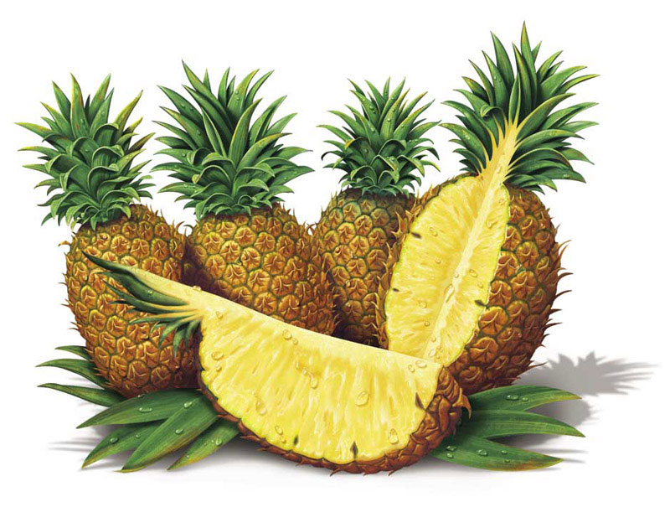

Fruit Washing Party – Saturday, February 11, 2012, 9:00 A.M.

Members who signed up to help wash the citrus fruit on Saturday morning, February 11, please plan to arrive at Jerry Amyot’s home (3410 Blueberry Hill Dr., Plant City) at 9 A.M. The club will provide sandwiches, chips and drinks. Please bring a side dish, salad or dessert.
Directions to Jerry’s home
From I-4 take Exit 22 (Park Road)
Turn south onto Park Road and continue south about 5 miles.
Note: Just past the Plant City Stadium Park Rd. turns west. Don’t turn-
continue south - Jim Johnson Rd. Note: You will pass the Sweetbay Warehouse.
Turn right on Jap Tucker Road.
Note: Before getting to Trapnell Rd. you will cross Sparkman Rd.
Turn left ontoTrapnell Road E. (a convenience store is on the SW corner),
go about 0.8 mile.
Turn left on Blueberry Hill Drive. Look for sign and balloons.
In case you get lost, here’s Jerry’s number: (813)716-1068, or call Sally (813)335-1865.
If you have questions or need information, please contact Sally Lee (813) 982-9359, yukyee@aol.com, or Linda Novak (813) 754-1399, charles.novak@gmail.com

For more on the Florida State Fair, refer to http://floridastatefair.com/state-fair

Tampa Bay RFCI Board of Directors Election
The list of candidates will be published in the March newsletter. The Board of Directors will be elected by a majority vote of the membership present and voting at the March 11, 2012, meeting.
__________________________________________________________________________________

New Members

Tanja Vidoric Tampa
Matthew Murchison-Blake Tampa
Andrew Massaro Tampa
__________________________________________________________________________________

In the News

In the January issue of Farmer & Rancher, a publication covering agricultural issues of interest to Florida farmers, a USDA study published in the Journal of Nematology concerning the use of fescue in peach orchards was described. The use of tall fescue grass as a ground cover helps protect the peach trees from 4 different root-knot nematode species. This practice also reduces the amount of chemicals used to treat the soil against the nematodes, which is good news for the environment.
Also in the same issue, in an article by Ann Perry, was a discussion on the use of biochar in reducing greenhouse gases. When soils, especially glacial soil, is amended with biochar, emission levels of carbon dioxide and nitrous oxide were suppressed. There were also lower volatilization rates for some pesticides. The formation of ethylene, a key plant hormone that regulates plant growth, is twice as high in soils amended with biochar. For more information on biochar, refer to the RFCI September newsletter.
_____________________________________________________________________________________
Pineapples in Florida

At January’s meeting, recognized pineapple expert, Ian Greig, spoke about growing these delicious fruits in Florida. Ian has been a long time member of the RFCI, and has had a long career in researching growing these wonderful fruits.
Pineapples are unusual plants, being epiphytical in nature. Historically, these plants grew in trees while evolving, and the closest relative to the pineapple is Spanish Moss. The roots of pineapples are airborne, and the plants absorb nutrients through their leaves better than they do through roots in the soil. 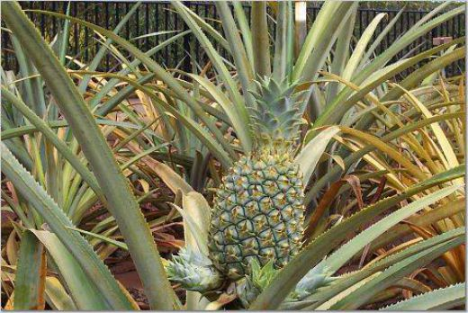
The fruit of the pineapple is a composite fruit, meaning it is many different fruits all together, with 8 spirals going one way, and 13 spirals going the other way. The fruits are extremely influenced by environment and climate, and even the smallest variations in such will affect the quality of the fruit. The ripeness of the fruit cannot be determined by color, as the environment will affect the color depending on where it is grown. The same variety grown in one location may be more gold, but grown in another location, may appear much more green.
Starting your own pineapple plant is easy. Twist off the crown, do not cut it, and then let it dry to cauterize the bottom. Then plant in soil. Pineapples must be started vegetatively, as the fruit is non-pollinating. Use sandy soil; what we have in Florida is fine. Add no more than 10% organic matter, and do not add peat. Peat retains too much moisture and can cause rot. Pineapples prefer acidic soil, 4.5 to 5.0 is best, but the plants have been known to grow very well in an almost pure acid soil of 3.0. Tree leaves, being acidic are an excellent additive to use.
Use a 12” pot to plant your pineapple. Do not plant them in the ground, as the nematodes in Florida will get them. Put a board, and/or weed block fabric under the pots to keep them off the ground.
Getting a pineapple to fruit involves changing it from a vegetative plant to a reproductive one. This can be accomplished in several ways. In commercial fields, plants may be sprayed with ethylene gas at night to trick the plants into blooming. Spraying at night avoids the sun breaking the gas down. This may certainly be impractical for the homeowner, but apples or bananas may be used as they produce this gas. Enclosing the plant with such fruit under a bag may create the necessary environment to cause the plant to begin blooming. Our Florida climate can do this as plants will manufacture ethylene gas when it’s colder, and pineapples can be forced this way.
It is best to plant in February in central Florida. Pineapples have an 18 month growth year. They will grow all summer and into the start of the next year, about 12 months, then the cooler temperatures will force the plant to initiate bloom. This will begin a 6 month stage until the fruit is ready for harvest. It is very important to understand this growth pattern in order to successfully fruit pineapples. Trying to adjust this schedule to go against this natural cycle can cause the fruit, if any is even produced, to taste terrible.
To determine if the fruit is ripe, hold the plant by the crown and bend it sharply, if it breaks, it is ripe, just as it would be in nature. Note the color of the fruit when you picked it, as this will be a guide to determine the ripeness color in your individual environment.
Pineapples are very tough plants, and have been known to survive without water for one year. The leaves will twist and lay down to absorb as little sunlight as possible. However, they prefer about 1 – 1 ½ inches of water per month. Do not irrigate when flowering, as water can enter the fruit and damage or scar the fruit inside. Plants can also be sunburned, so keep them upright as the fruit develops or damage can occur on the side of the fruit that is overexposed to the sun.
To fertilize pineapples in central Florida, use a fertilize that is high in nitrogen, has no phosphate, and has low potassium, such as a 25-0-5, ¾ oz. for the first 4 months after planting. For months 5 through 8, use the same fertilizer that is high in nitrogen, no phosphate, low potassium 25-0-5, but at a 2 oz. rate. Months 9-12 of the growth cycle, use a high nitrogen, no phosphate, high potassium 25-0-20 at 2 ½ oz. Urea makes the best nitrogen. Phosphate is usually not needed in Florida, but if a test shows it is needed, than add it to the soil before planting, as it cannot be absorbed through foliar feeding. Minor nutrients may also be added every 2 -3 months. When applying foliar fertilizer, be sure to cover all the leaves, but try not to saturate the center of the plant. Be sure not to have more than 5% fertilizer salt by weight. Water = 8.3 lbs. per gallon. Do not apply fertilizer after forcing.
Like other bromeliads, pineapples will produce suckers. These may be planted as new plants, as they will make their own carbohydrate reserves, and grow better than if left around the old stump. The fruit of the pineapple does not store carbohydrates. The fruit is as sweet as it will be whether it is unripe or ripe. When you buy it, it is as ripe as it will ever be, and will only begin deteriorating as you store it. Eat and enjoy fresh pineapple as soon as possible.
Interestingly, to pollinize pineapples, hummingbirds must be present. Hence, Hawaii, where so many pineapples are grown commercially, bans hummingbirds so as not to pollinize the pineapples, or the fruit would be seedy.

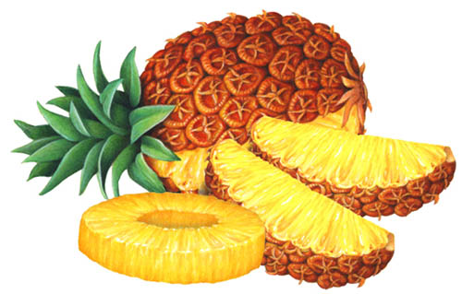

More facts about pineapples:

Pineapples are native to southern Brazil and Paraguay. The fruit has become naturalized throughout Central and South America.
In 1493, Christopher Columbus saw a pineapple for the first time. Spaniards brought pineapples to Hawaii in the 16th century, with the first plantation in Oahu becoming established in 1885.
In 1712, England was successfully growing pineapples in greenhouses.
The Caribbeans were the first to use pineapples at the entrances to their homes as a symbol of friendship and hospitality, a custom that endures in many cultures even today.
Pineapples were first canned in Malaya by a retired sailor.
In Florida, there were once many plantations on the east coast of the state, first establishing on Merritt Island and the Keys, and then spreading up the coast. Shipping to the north began in 1879. Coastal development reduced the acreage devoted to pineapples, and today there are only small scale producers inland.
Hawaii was once the world leader in pineapple production, but due to labor and production costs, they claim only 2% of production today.
Dole, the only remaining commercial producer in Hawaii, created the Pineapple Garden Maze, the worlds’ largest maze, at 3 acres, with 2 ½ miles of paths, created with pineapple plants.
Dole had opened as a fruit stand in 1950, and is now also a premier tourist attraction in Hawaii.
Some varieties of pineapple are grown for their silk, which is made from the fibers in the leaves.
Pineapples contain bromelain, a proteolytic enzyme that is present in the fruit and leaves. Bromelain has many uses, such as tenderizing meat, chill proofing beer, as an additive to gelatin, stabilizer for latex paint, and in the tanning of leather.
Because of bromelain, if your pineapple recipe calls for adding milk products, do not add them until just before serving.
Pineapple does not freeze well, and is primarily eaten fresh. It can also be used in pies, cakes, puddings, sauces, preserves, curries, and as a garnish. In the Philippines, the fermented pulp makes a sweetmeat call nata de pina. Canned pineapple is consumed throughout the world.
There are also medicinal uses for bromelain as a digestive aid, and an anti-inflammatory.
Pineapples are high in vitamin C and manganese.

For more information on pineapples,
www.hort.purdue.edu/newcrop/morton/pineapple.html

If you are planning a trip to Hawaii,
www.dole-plantation.com

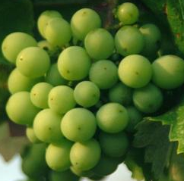  Freefoto.com | January Tasting Table  Thank you to the following folks for their tasty offerings and to all those who did not sign the sheet. Members who donate food may now receive a ticket for the raffle. | 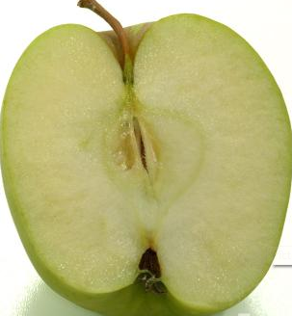

Name | Item | Name | Item
Vega | Chicken and pasta | Shigemura | Guanabana kanten, custard mochi
Coronel | Pitsi- Pitsi | Golden | Marshmallow salad
Scott | Cole slaw | Davies | Brownies
Sawada | Hayashi rice (Japanese beef stew) | Payne | Banana cookies, biscotti
Novak | Guava banana nut bread, banana strawberry nut bread | Ross | Baked eggplant, pasta salad
Branesky | Pancit, cucumber salad, fried banana | Starnes | Spice Indian curry rice
Clarke | Shrimp, cranberry bread, yellow rice | Lavesque | Carambola
Whitfield | Salad | Kirby | Pumpkin fritters
Badias | Scones | Male | Rice soup
Young | Pineapple | Lee | Apple slices
Oneal | Cookies | Newcombe | Carambola
Ferst | Cinnamon muffins | Baker | Blueberry muffins
Bigelow | Pancit | Chapman | Chicken salad and chips
Gamboni | Sweet potato casserole | Branesky | Variety of fruits
Terenzi | Peanut butter cake | Rivera | Citrus, carambola
Sweet | Key lime pie | Novak | 6 gallons of juice
Baker | Oatmeal chocolate chip cookies | Aguire | Chili

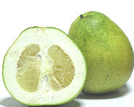 | January Plant Exchange  Members who donate plant(s) may now receive a raffle ticket. Please remember to sign the sheet when picking up your plants. | 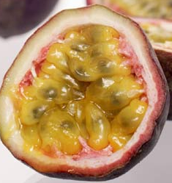

Plant | Donor | Winner
Abacca pineapple | Bob Heath
Abacca pineapple | Bob Heath
Chaya spinach | Bob Heath
Chaya spinach | Bob Heath
Chaya spinach | Bob Heath
Surinam cherry | Bob Heath
Loquat | Bob Heath
Jackfruit | Branesky | Hanck
Jackfruit | Branesky
Jackfruit | Branesky
4 Kei apple | Scott
4 Kei apple | Novak
Miracle fruit | Schaefer
5 Culantro | Vega | Payne, Kirby
5 Red Papaya | Vega | Newcombe, Ross
5 large fruit white guava | Novak
Citrus fruits | Novak
Korean perilla | Brandt | Shigawa
5 green papaya | Brandt
2 yellow dragonfruit | Brandt
Tillie seedless papaya | John Erb | Miller
Succulents | Levesque
Paper white | Ross
White sweet potatoes
Curry tree | Payne
5 rosemary | Zmoda
Pineapple | Phillon
Sunflower | Phillon

_____________________________________________________________________________________

What’s Happening

by Paul Zmoda

Winter means outdoor cooking over hardwood fires in a big fire pit. That’s what my neighbor does on a regular basis (with my assistance, when possible). Good food around a warm fire is a really enjoyable experience. After many fires, there are lots of ashes to deal with. Why not use them? When they are surely cool, I scatter them all over the orchard and along the grape trellises for the rain to wash in. This provides a dose of potassium for the plants just as Toppy Feil told us at our December meeting.
Potassium is an essential, major element for plants that contributes to their health by promoting leaf and stem strength, flowering ability, and ability to withstand drought. Wood ashes are also quite alkaline, which might help with soils that are a bit too acidic. Don’t forget that the unburned charcoal bits in the ashes are also useful. (Refer to Wae Nelson’s lecture on biochar in the September newsletter.
Member Monica Brandies recently wrote about a nasty experience with yellow jacket wasps stinging her while gardening. I always steer clear of known nests – usually located underground. As a past pest control technician, I can deal with these with little trouble as long as I work at night. I use an old-fashioned hand plunger duster to apply sevin dust into and around the nest entrance. That should do it in a few days. If not, I will use an aerosol “bug bomb” directed into the hole. The problem is usually then solved.
New plantings: carrots and daikon radishes.

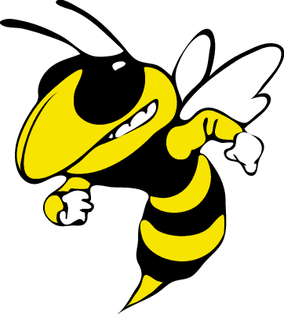
__________________________________________________________________________________

Notes

Does anyone need 1, 3, 15, and 30 gallon size black plastic nursery pots? Contact me at 813-715-0200, Denise Provencher. I have located a large source of these pots, very reasonably priced.

Oops! The word puzzle in January’s newsletter experienced some technical difficulties at publication. The problem has been corrected, and the puzzle will run again in a future newsletter.

For contributions to the newsletter, notes on what you are growing, successes, failures, pictures, etc. we would love to hear what’s going on with fruit growers all through the Tampa Bay area, send to bdprovencher@tampabay.rr.com




