Upcoming Programs and Events

March 11: Kathy Fryer will speak on growing Blueberries
April 14-15: USF Botanical Garden Spring Plant Festival
May 13: Gene Joyner of Unbelievable Acres

USF Botanical Garden Spring Plant Festival, April 14 - 15.
We will need club members to help with this event. It is an important fundraiser for the club. Members are invited to attend, help with set up on Friday, to assist in the sale on Saturday and Sunday, to donate or sell fruiting plants, to enjoy the camaraderie and to visit other exhibits.

If you plan to sell plants, please note that members cannot sell citrus, non-fruiting plants or herbs. Members selling plants must submit a manifest listing their plants and prices. Manifests will be available at the March 11 meeting. Plants must have a label with the name of the plant, the price and the seller’s initials.
There will be more information at the March meeting and in the April newsletter.
If you have questions: Jimmy & Sally Lee (813) 982-9359, Charles Novak (813) 754-1399.

USF Botanical Garden website: http://gardens.usf.edu/

______________________________________________________________________________

New Members

Welcome New Members: Brett Reed Brandon
Tom & Elsa Maroon Thonotosassa
Beth & Dave Mauger Kenneth City
Pam & Randy Knight Zephyrhills

Welcome back: Yoshimi Tamura Tampa
Yuko Topping Tampa

Tampa Bay RFCI Exhibit Wins Third Place at the Florida State Fair
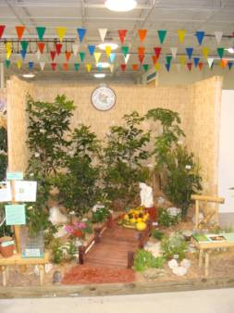 |   Our exhibit received ‘Third Place’ in the Plant Society competition. THANKS to Thom Scott for designing the exhibit, and to Bill Vega, Charles and Linda Novak, Fred Engelbrecht, Adam Zaidan, Ron Shigemura and Shige Sawada for helping to set up the exhibit. A special “Thank you” to all the members who manned the exhibit. The public is always interested in our display of fruit trees and the unusual fruit we exhibit.

Citrus Celebration 2012: Our 11^{h} Citrus Celebration at the Florida State Fair was very successful. Even though the weather was on the chilly side the turnout was great. Fair attendees enjoyed a bowlful of the many varieties of citrus (cut into sample size) and cups of fresh squeezed citrus juice.
A huge “THANKS” to everyone who helped make the Citrus Celebration a success – donating fruit, picking and washing fruit, delivering the fruit to the fairgrounds and helping with the event on Sunday. A special “Thanks” to Jerry and Londa Amyot for hosting the ‘citrus washing party’. Everyone worked hard to get the citrus washed, dried, placed in boxes and loaded into vehicles. There was a lot of talk and laughter and we were rewarded with a fabulous lunch.

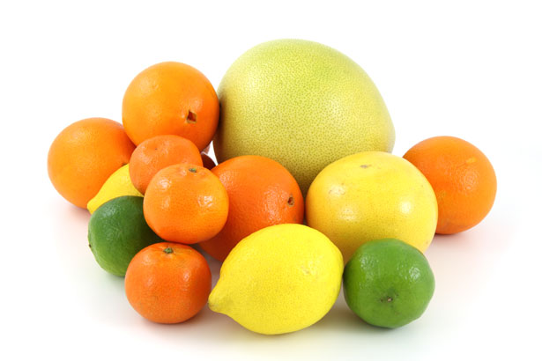
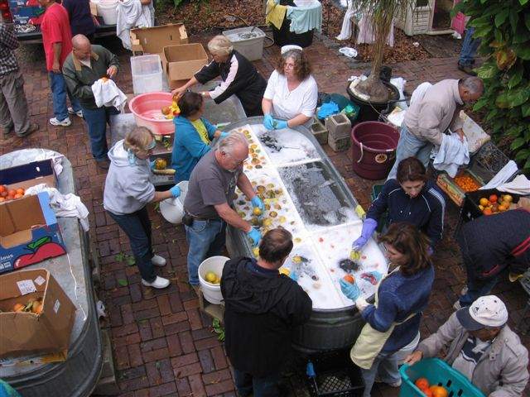
There was a great turnout for the citrus washing.

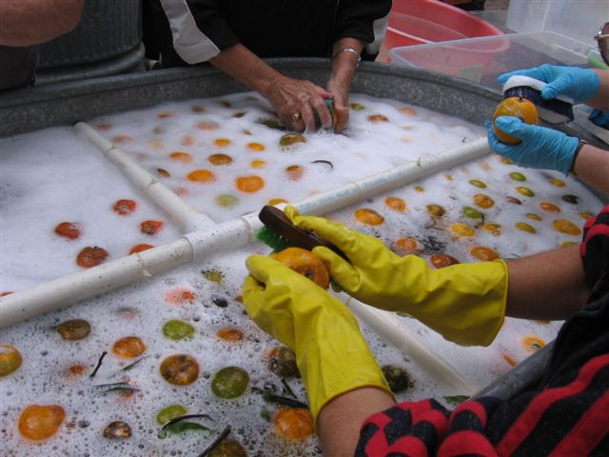
Rub-a-dub-dub!!
Citrus in a tub!
There was a lot of fresh fruit to be cleaned.

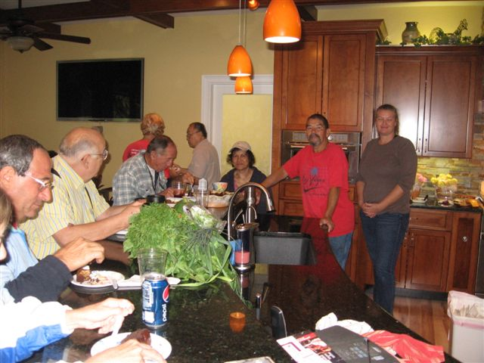
A delicious feast was the reward for those who helped with the citrus washing and preparations.

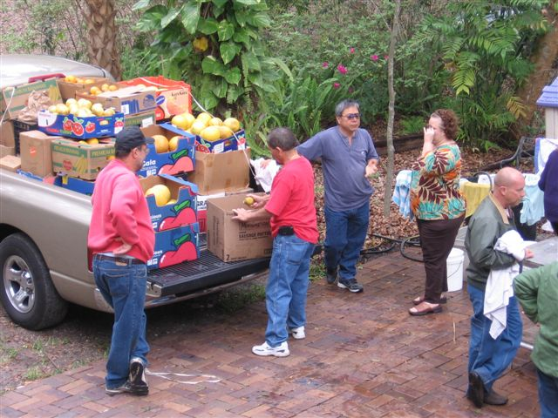
Hope this truck has good springs! What a wonderful and delicious load.

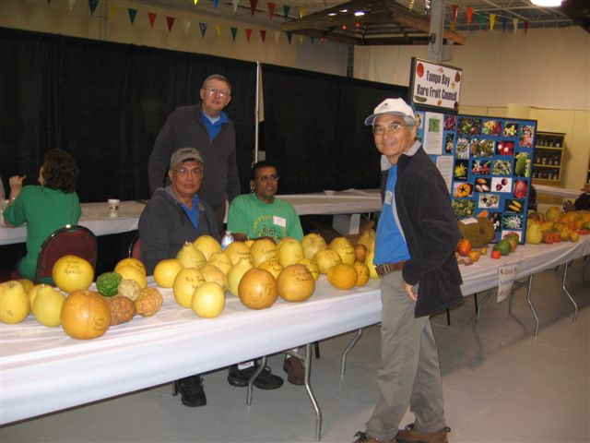
The display of many kinds of citrus, from the smallest to the largest, and all sizes in between.

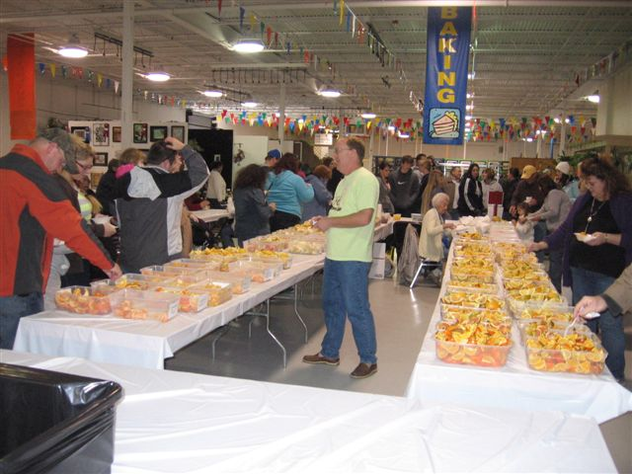
The prepared samplings at the Fair. People enjoyed the tastings. Many were unaware of the great variety of citrus available.
_______________________________________________________________________________________

Important Club Business

Board of Directors Election: At the March meeting the general membership present will elect the Board of Directors for a one-year term. The Board then elects the executive officers. Directors must be willing to make a significant commitment of time to the club. The Board meets monthly or at such times deemed necessary. The Board is responsible for the policies, finances and direction of the Chapter. The Board meetings are open to the entire membership and members are encouraged to attend.

The following members have been selected for your consideration as the next Board of Directors:
Paul Branesky Thom Scott Verna Dickey
Bob Heath Carolyn Haack Bob Gerstein
Fred Engelbrecht Susan McAveety Andrew Hendrickson
Jimmy Lee Jerry Amyot Charles Novak
Sally Lee Bill Vega Linda Novak
Judy Cimafranca

Please plan to attend and vote.

__________________________________________________________________________________

Facts on Citrus

.
It is believed Citrus originated in Southest Asia, in the areas of China, Burma, and India. The cultivation of Citrus rapidly spread throughout the world.

The first orange trees were planted in St. Augustine, Florida in the mid 1500’s.

Today, there are 569,000 acres in Florida under citrus production, providing 80% of the U.S. supply. Florida’s sunny, subtropical climate and sandy soil produce some the juiciest and most flavorful fruit in the world. The industry employs 76,000 Floridians, and is worth $9 billion.

Citrus refers to plants in the genus Citrus, a group of flowering and fruiting plants in the Rue family.

Citric acid is the acid in citrus fruits.

Commonly known citrus fruits include grapefruits, oranges, lemons, limes, tangerines, tangelos, minneola, pummelo, and ugli fruit.

Kumquats are not a true citrus; they belong to the closely related Fortunella genus, but are generally grouped with citrus, not only because of similar taste, texture, and appearance, but also because they are able to be hybridized with certain other citrus to produce a hardier tree.

Like many modern fruits, most citrus are hybrids, bred for particular taste, or juice qualities.

Researchers in February of 2012 discovered that flavanones in citrus fruits may help lower a woman’s risk of stroke. The 14 year study revealed that women who ate the most grapefruit and oranges realized a lower risk of stroke.

Citrus fruits are packed not only with great taste, but important vitamins, minerals, and fiber.

Go to www.floridajuice.com for a free citrus cookbook, children’s games, recipes, and more facts on citrus.

_____________________________________________________________________________________
Word Game

Word Find - Rare Fruit Names

M D E O Z I M C P A B I U Y N B D G K S
Z A I J K C I K X O G A V O M L W E J J
I A R L O W M A M M E A B N H E I Z O O
U G N A K W B L A W O M N S K I U G V C
Y B V M C I E A I G H P B A K U L S I O
D O C B I U O E C X O H T I M G S O E T
N G S A I K Y B W E L U G O H U D F O E
O Q W R C I S A O I K A I E C B V S Y C
N C T E P U A C K I T D F V E P A A Y X
I S D L O S D U H E T V K M M B U N G U
C G O L I E C P I V E B I Q X I D T I W
M A N A I G U A H A L O T E H V I O Z P
J M S F E I O R B U G O W B K L S L S C
O B M T G R C I R N G H C E A I P X I L
C O B I E R T V H X O U Q I G A I S F D
W D B G T I E C H A C R U N G P M B E R
P I X C I U Y T G Y M P E R W N I L R T
V A P O D R T G L K O U E F E I J O A W
Y U G E N I P D S C H G I N M E E N O K
W I F C U J O X F U N N Y P O N D O H I

abiu ambarella amlak bacupari
bakul chacrung feijoa gambodia
genip guahalote imbe jacote
katuk mammea maracuya mbungu
noni pondoh santol ugu

_____________________________________________________________________________________

What’s Happening

by Paul Zmoda

On January 20th, my wife and I visited the Citrus Research Station in Lake Alfred to meet with Dr. Bill Castle. We talked about potential new fruit crops for Florida. He drove us out to the test orchards and showed us a huge trial planting of pomegranates. The hope is to determine which cultivars might be best for larger plantings, as well as breeding better varieties.
Afterwards, we drove to Lakeland to attend the annual 2 day Florida grape growers conference. This year’s theme was “Grapes and Wine for Fun for Profit.” The many seminars held presented such topics as: newly released muscadine cultivars (Delicious, Southern Jewel, and Eudora), maximum care for premium grape quality, chemical analysis of grape juice and wine, detecting wine faults and flaws, and how to establish and maintain a successful wine guild (club).
There was also an interesting, and tasty, wine demonstration for Saturday’s breakfast!, that showed how different yeast strains affect a wine. The food was great, the social interaction was very rewarding and a copious amount of great Florida wines were enjoyed by all.
Pruning our fruit trees, shrubs, and vines is taking longer this year, as everything is growing larger. This important task must be done yearly to ensure healthy plants which will bear good loads of quality fruit.
I’m propagating lots of grape cuttings and tried out my new Omega grafting tool on some grapes as well.

_______________________________________________________________________________________

The Simple Joys of a Greenhouse
By Denise Provencher

Last fall we decided to put up a 10’ x 20’ greenhouse to house our rapidly growing collection of cold-tender plants. For only $300, it has allowed us to keep that tropical feel all winter. We would recommend a greenhouse to anyone who wants keep their plants going strong through the winter. It is most pleasurable to walk in and smell intoxicating citrus blooms, grab a fresh, warm tomato, and smile at all the brightly colored flowers. The containerized papayas, mangoes, and bananas that were all in fruit in the fall, were simply brought in to continue growing and supplying us with fruit all winter. Had they remained outside, they would have all frozen to the ground.
This winter has been far kinder than the previous three winters were. The coldest temperature in our backyard in Zephyrhills this winter was a mere 27 degrees, compared to numerous occurrences of 18-22 degrees the previous winters. However, this cold snap was enough to kill back our newly planted citrus trees. Each year we have planted several new citrus trees only to have the cold either outright take them, or damage the young branches so badly they never really recover well. We’re careful to cover them too, so it’s especially disappointing.
Trays of fresh greens have allowed us to create some tasty salads. Favorite salad at this time of the year is a bed of fresh lettuces and greens topped with sliced strawberries, kumquats, and Florida sweet onion. A good hearty dollop of garlic hummus completes this salad. All these items are in season right now and are Florida fresh at your local market.
____________________________________________________________________________________

Notes

For contributions to the newsletter, notes on what you are growing, successes, failures, pictures, etc. we would love to hear what’s going on with fruit growers all through the Tampa Bay area, send to bdprovencher@tampabay.rr.com

