Upcoming Programs and Events

Upcoming Events/Speakers:

May 13: ‘Plant Doctor’ by Gene Joyner of Unbelievable Acres Botanic Gardens in West
Palm Beach. The Garden was established in 1970 by Gene and is one of
Florida’s largest private collections of tropical fruit trees. The Garden has
some 2000 varieties of plants, including over 170 varieties of fruit trees. It also
has orchids, bamboo, bromeliads, palms and ferns. Gene will answer your
questions about growing fruiting plants and the problems you have with your
plants. You may bring your plant specimens for Gene to diagnose. If you
suspect Canker-bring the specimen in a sealed, clear, plastic bag.
June 10: Dr. Matthew Snow, Pres., Miami RFCI, Topic: Dragon Fruit (Pataya)
July 8: Our July 8 meeting will be very special. We are hosting a joint meeting and
are inviting members from the Brevard RFCI, Manatee RFCI, Sarasota Fruit
and Nut Society and the Tropical Fruit Club of Central Florida to join us.
Please plan to attend and enjoy the camaraderie and the presentation by
Chris Rollins, director of the Fruit and Spice Park.
August 12: Adam Shafran: A presentation on the many species of Jaboticaba
_____________________________________________________________________________

New Members

Reed Venrick - Tampa Lorraine McCraken - Tampa
Richard Duncan - St. Petersburg Margie Campbell - Plant City
Nenita Santos Garcia - Brandon James Davis - Crystal River
Kishore Sirivelu - Tampa J. Nolan - Tampa
Joseph Ciccilini - Clearwater Gary Krotz - Lutz
Jennifer Eichenberger - New Port Richey Mat Kirouac - Lutz
Ron Brinsko - Winter Haven Robert Apholz - Safety Harbor
Marina Welch - Tampa Clarissa Allen - Land O’ Lakes
Mike & Dayle Lewandowski - Odessa Edward Niklas - Tampa
Dana DeWitt - New Port Richey Janet Cordero - Wesley Chapel
Josh Marr - Tampa Mary Derrick - Tampa
Philip & Tina Waisman - Safety Harbor

Welcome Back: Michelle Doll
Kris Aguire

_____________________________________________________________________________

The USF Plant Sale was a success!
A special THANKS to all the members who helped with the USF Botanical Garden Spring Plant Festival. The weather was perfect and many fruiting plants were purchased by the public. We served 784 cups of fruit juice to the thirsty crowd.

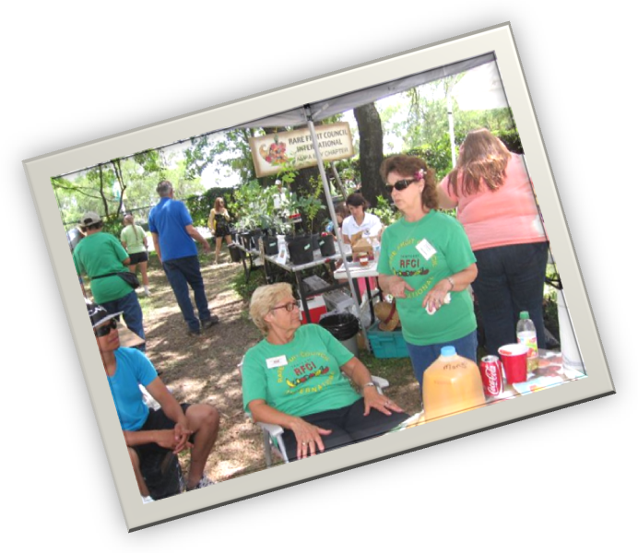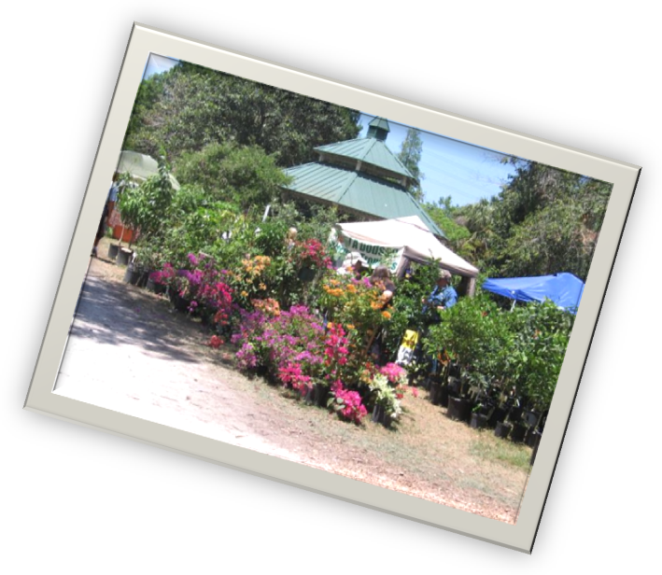

Here are some colorful pictures of the USF
Plant Sale. Activity was brisk, and there was so much to see and buy.

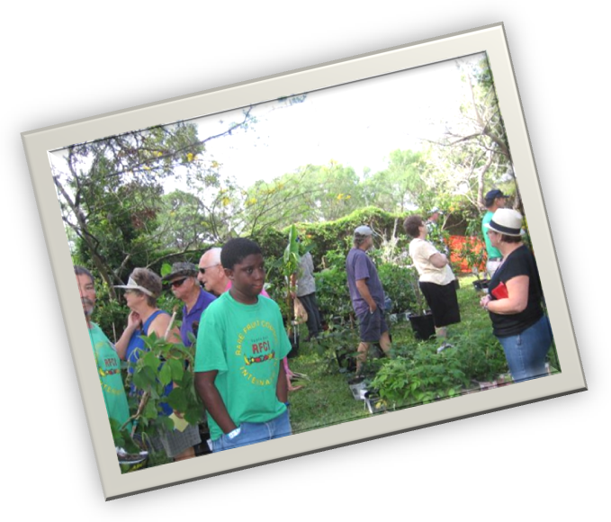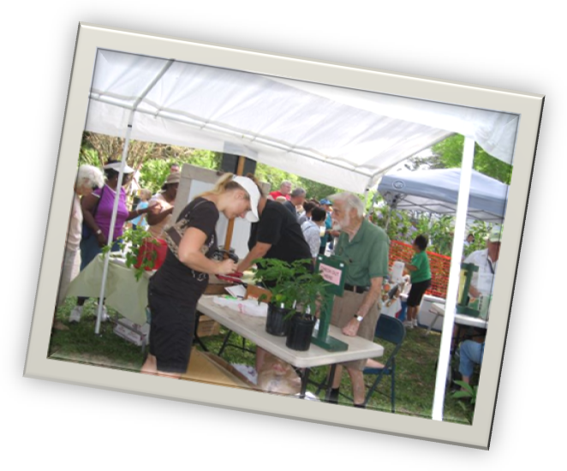

___________________________________________________________________________________

_____________________________________________________________________________________
Germination Aids from the Kitchen

Starting seeds can surely be fun and rewarding, but not all seeds are as easy as green beans to grow. There are a number of additives one can use in or on the soil to help increase the odds of a seed surviving. Some of these you probably already have in your kitchen cabinet.
Ground Cinnamon. The cinnamon you find on your grocery store spice rack. Cinnamon has excellent anti-fungal properties and will help ward off damping-off, a major disease that kills so many seedlings.
- Simply sprinkle the surface of the potting medium with the ground cinnamon, or dust areas that are infected with damp off. The area must be damp so the cinnamon will stick. Use lightly, do not pour it on in clumps. Too much can be damaging.
Chamomile Tea. You may have heard of chamomile tea on your roses to prevent fungal diseases, and you certainly can use the same to help your seedlings.
- Once seedlings are up and growing, use the tea in a sterile spray bottle, and just spray a mist on the soil and the seedlings. Chamomile is also an excellent source of calcium, potash and sulfur.
Skim milk. This provides a useful, low-cost additive in seed-coating material, as it induces high rates of endospore germination and proliferates vegetative cells.
Garlic. Garlic, with its sulphur content is an excellent anti-fungal, and useful for soaking seeds in before planting.
Seaweed spray. Seaweed is very rich in nutrients, and helps prevent damp-off. Make a strong mix of 2/3 cup of kelp concentrate to 1 gallon of water, and use as a spray.
Horsetail Tea. (Equisetum arvense) The common horsetail plant is rich in silicon, and increases the light absorbing capabilities of plants, thereby helping them resist fungal diseases. Use on peach trees to control peach leaf curl.

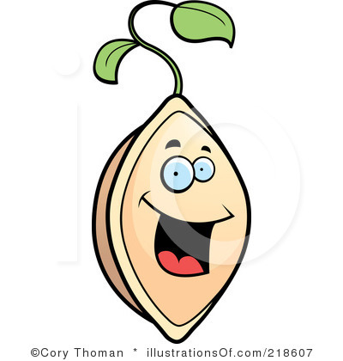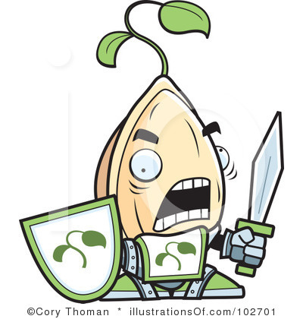

______________________________________________________________________________________

Melons in Florida

Melons are members of the plant family Cucurbitaceae, which consists of various squashes, melons, and gourds, including crops such as cucumber, pumpkins, luffas, and watermelons. Many of these fruits are notoriously difficult to grow in Florida’s humid climate, as a wide variety of insects and diseases affect the leaves and fruit. It is surprising to learn that these fruits originate from, or thrive in drier climates, even deserts. The drier climate eliminates many of the fungal diseases that are problematic for these plants. However, Florida still manages to produce quality fruits. There are many varieties suited for our climate, and that can be grown commercially or by the home grower.
Watermelons. When many people think of watermelons, they probably picture summer days and children with smiles on their faces and watermelon juice dripping off their chin. These succulent, delicious fruits that can weigh up to 30 pounds each have been enjoyed the world over for a very long time. The first harvest of watermelon was recorded 5,000 years ago in Egyptian hieroglyphics.
Florida is a leader in watermelon production. In 2002, Florida was 1st nationally in the production of watermelons, covering 25,000 acres, with 526 farms growing them. Florida is also the nation’s only supplying state of watermelons from December to April, although they are harvested throughout the year. Watermelons are grown in all counties, but the majority of large growers are in the north to north central counties.
Consumption of watermelon has increased due to the introduction of seedless varieties. In addition to being easier for the consumer, seedless fruits are sweeter and have longer shelf life. Seedless watermelons are sterile hybrids, a cross between a normal watermelon, and one that has been changed genetically with chemical treatment as a seedling. Seedless fruits produce soft tasteless white, undeveloped seed coats that are easily eaten with the rest of the flesh.
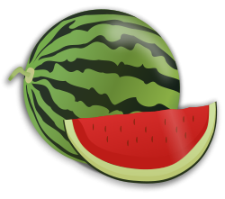 Planting dates for central Florida are January 15 to March 15, with 80-100 days required for maturity. Plants have both male and female flowers, and honeybees are the principal pollinators. Local research has shown that at least 8 visits by bees must occur for adequate fruit set. The window for germinating watermelon seeds is a short few weeks. Germination occurs best at 70 degrees, but cold can damage or kill the plants. It is desired to have the majority of the growing occurring while the weather is still dry to prevent disease from getting a foothold.
Watermelons require a long, warm growing season, growing best at 70-85 degrees, but tolerating up to 90 degrees. They also are tolerant of high humidity, and a variety of soils, except for muck. The best PH is between 6 to 6.5. Both seedless and seeded varieties must be interplanted to ensure adequate fruit set on the seedless varieties.
Seeded varities doing well in Florida include: Celebration, Fiesta, Mardi Gras, Regency, Royal Flush, Royal Star, Royal Sweet, Sangria, Sentinal, Starbrite, Stars-n-stripes, and Summer Flavor 800 or 900.
Seedless varities include: Freedom, Genesis, Millionaire, Rever, Summer Sweet 5244 and 5544, and Tri-x-313.
For more information on growing watermelons in Florida check out the University of Florida publication:
http://edis.ifas.ufl.edu/pi031 on watermelons.

Cantaloupes, (Muskmelon actually). Cantaloupe is actually the incorrect, although consistently popular name for the fruit of the muskmelon. True cantaloupe actually are small, hard, scaly or warty fruits grown in Europe, and do not much resemble the tasty, juicy fruits of the muskmelon. Musk comes from the Persian, meaning perfume, and melon from the Latin “melopepo”, meaning apple shaped melon. The first seeds came across the sea with Christopher Columbus on his second voyage. Muskmelons were first grown all over the Eastern states of America, where considerable acreage in the early 1900’s was devoted to growing them, but destructive diseases and insects reduced that very quickly. Muskmelons just do not grow as well in our moist climate as they do in their native, hot, dry Persia. Muskmelons are a popular crop in our Western states, which have a much drier climate. There, the lower humidity, and heat produce better quality fruit, without the rotting and cracking so prevalent in a wetter climate.
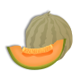 Muskmelons prefer fertile, well-drained, slightly acidic soil. The male flowers on muskmelon plants appear first. Pollination is by bees. Some popular varieties in Odyssey, Vienna, Athena, and Eclipse.

For more information on growing muskmelon in Florida, check out the University of Florida publication:
http://edis.ifas.ufl.edu/pi047 on muskmelons, and http://edis.ifas.ufl.edu/fy1101 on cantaloupes.

Also, check www.Florida-agriculture.com , which has maps of where fruits are grown, and available dates, as well as coloring pages for the kids, and nutritional information, and recipes.

Honeydew Melon. The Honeydew melon is one of the most popular melons, however, as with other melons, the disease and insect problems so prevalent in our humid climate have made growing honeydews a poor choice for both commercial and home growers. 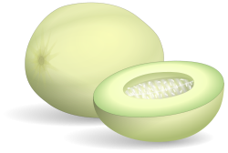
A breakthrough for Florida gardens came with Floridew in 1962, Morgan, and then Earlidew and Tamdew varieties. Morgan is a cross between a honeydew and a cob melon, and has better mildew resistance. Gardeners still find their success with these varieties ranging from poor to outstanding on any given year. The fruit still needs to be ripened with ethylene gas. To ripen any honeydew fruit you grow at home, put it in a bag with ripening apples or tomatoes. These fruits give release natural ethylene gas, and will trigger ripening the honeydew.

For more information on growing honeydews in Florida, check out the University of Florida publication:
http://edis.ifas.ufl.edu/mv093 on honeydew melons.

Galia. Another melon grown in Florida, especially for greenhouse and hydroponic production is the Galia muskmelon. The aroma is bold, and the fruit has a high sugar content, making this succulent melon intensely sweet. The galia melon is a cross between the honeydew and the muskmelon, and was one of the first hybrid dessert melons. It is more expensive than other melons.
For more information on growing Galia muskmelon in Florida, check out the University of Florida publication:
http://edis.ifas.ufl.edu/hg147
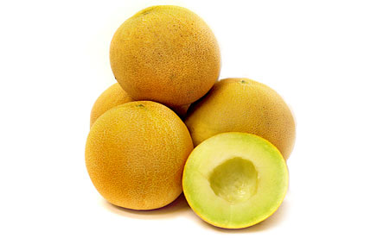

_____________________________________________________________________________________
_______________________________________________________________________________________
What’s Happening

by Paul Zmoda

A place called “The Natives”, and based in Texas, shipped me some seeds and some persimmon budwood in March. The species is Diospyros texana or Texas Black Persimmon, a native fruit tree in Texas. I have had a large specimen growing for many years, and every spring it flowers profusely. It is a strong, healthy tree. This species is dioecious however, and being a male, it provides no fruit. It took me many years of searching to find female budwood, and I finally obtained some.
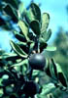My plan is this: graft the female wood onto actively growing water shoots on the male tree. I should be able to then air layer the grafted shoot later and have a separate fruit-bearing tree to plant. I did some cleft grafts and they are taking. The seeds are also coming up in case I need some similar rootstocks to graft later if all goes well. I may try grafting some more scions to our native Diospyros virginiana to hurry things along. I have yet to see or taste these fruits, said to be dark, sweet and chewy like dates.
The grafted grapes are growing out well. This project involves using Blanc Du Bois, which won’t grow well in wet areas, as a scion upon Il Primo rootstocks. These rootstocks have already proven their success in wet, heavy clay soils. As proof of this, I still have several rooted specimens in a bucket of water surviving since December of 2010. This grafting experiment may prove to allow growers to plant Blanc Du Bois, and other grapes, in very wet areas which would otherwise be satisfactory.
New plantings: Orlando and Minneola Tangelos.

______________________________________________________________________________________

A MOTHER...
When you're a child she walks before you,
To set an example.
When you're a teenager she walks behind you
To be there should you need her.
When you're an adult she walks beside you
So that as two friends you can enjoy life together.
~Author Unknown~

SAYINGS AND QUOTES
"God could not be everywhere
and therefore he made mothers."
~Jewish proverb~
"Of all the rights of women,
the greatest is to be a mother."
~By Lin Yutang~
"The heart of a mother is a deep abyss
at the bottom of which you will always
find forgiveness."
~By Honore' de Balzac (1799-1850)~
"The mother's heart is the child's schoolroom."
~By Henry Ward Beecher (1813-1887)~
"Youth fades; love droops,
the leaves of friendship fall;
A mother's secret hope outlives them all."
~By Oliver Wendell Holmes (1809-1894)~
"The joys of motherhood
are never fully experienced
until the children are in bed."
~~Author Unknown.~~


______________________________________________________________________________________
Notes

For contributions to the newsletter, notes on what you are growing, successes, failures, pictures, etc. we would love to hear what’s going on with fruit growers all through the Tampa Bay area, send to bdprovencher@tampabay.rr.com
______________________________________________________________________________

Local Area Events

Manatee Rare Fruit Council Annual Rare Fruit Tree Sale, Sunday May 20 from 10am – 4pm, at the Manatee Civic Center, Haven Blvd. And US 41/301, Palmetto, www.mrfc.org, 941-776-0222.
This is their biggest sale ever, 3000 plants for purchase, in air-conditioned comfort.
______________________________________________________________________________________



