Upcoming Programs and Events

Upcoming Events/Speakers:

June 10: Dr. Matthew Snow, President, Miami RFCI.
Topic: Dragon Fruit (Pataya).
July 8: Joint Club meeting. Members of the Brevard Tropical Fruit Club,
Manatee RFCI, Tropical Fruit Club of Central Florida, and the Sarasota
Fruit & Nut Society will be joining us for a multi club meeting.
Speaker; Chris Rollins, Director of The Fruit & Spice Park, Homestead.
**Time: 1 PM – 4 PM

August 12: Adam Shafran. Topic: The many species of Jaboticaba.

_____________________________________________________________________________

New Members

Russel & Carol Van Cleave Tampa Wayne Smith Brandon
Mildred Duncan Tampa Vivian Wilson Tampa
Ryley & Doug Marchion Seminole

_____________________________________________________________________________

Linda Novak received a plaque honoring her 14 years of dedicated and outstanding service as the Secretary for the Tampa Bay RFCI chapter at the May meeting. Thank you Linda!
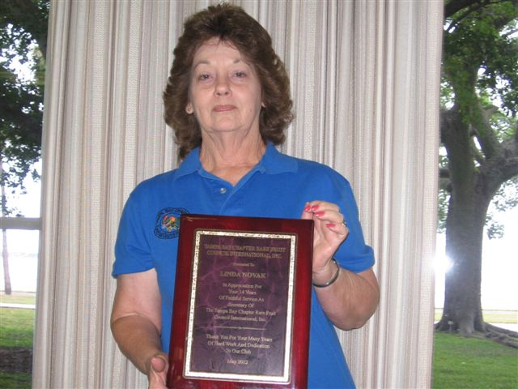

_____________________________________________________________________________________
Gene Joyner’s Plant Doctor Clinic

Gene Joyner, creator and owner of the renowned “Unbelievable Acres Botanic Garden” in West Palm Beach, was the speaker at the May monthly meeting. Gene in his “Plant Doctor” capacity, answered many, many questions, and examined sick plant material brought in by members. Here are highlights of his very informative talk.
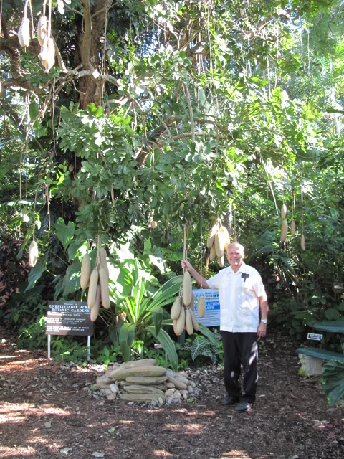
Question: Why does everything look so perfect at the Gardens?
Gene: People are always amazed, and can’t believe that no chemical fertilizers are used at the Gardens. Mulch is the best fertilizer. Just like the rainforest, everything breaks down and nourishes the soil. At the Gardens, no trimmings or leaves leave the property. They are all recycled, from all kinds of trees; none have been found to harm garden plants. Decades of building the soil this way keeps all the plants very healthy, just as in nature. If you use chemical fertilizers, your plants will get dependant on them. Mother Nature takes care of the plants. There is no spraying of chemicals at the Gardens, we just ‘let them alone’. Another important benefit is the decaying matter releases acids as it breaks down, continually reducing nematodes in your garden.

Question: What are some other additives for my soil?
Gene: If you utilize fresh manures, be sure to let the material sit for a while before using, or you could burn the plants. Using peat moss can help retain moisture.

Question: How can I improve my hardpan soil?
Gene: Rototill it to a depth of 12-14”, and add lots of organic matter in.

Question: Are marigolds a good plant to help fight nematodes in the soil?
Gene: Yes, just remember a growing plant will compete for the same resources as the plants you are trying to grow, so growing the marigolds along the edge of your garden plot is a good way to keep out nematodes.

Question: What is the best insecticide?
Gene: A little dish soap and water will control 90% of insects and is much less expensive and safer to use than chemical insecticides.

Question: How do I solarize my garden soil?
Gene: Use a plastic cover for 2 months to solarize the soil, but remember, this process affects the soil only 2” in depth. Your plants roots will go deeper than that. To compensate you may till and repeat the solarization process again before you plant.

Question: Do you still buy citrus trees with all the diseases around?
Gene: Yes, I still take my chances. If I see a tree I like I will buy it.

Question: Why didn’t get good fruiting on my lychees this year?
Gene: No winter is good for every single plant. Some prefer more cold hours than we had this past winter, and will not set fruit as good without adequate cold hours. Lychees and Longans were affected by the warmer winter this past season and didn’t fruit as well. The dryness has affected fruiting plants as well.

Questions: What is wrong with my citrus tree? (possible diagnosis from plant sample.)
Gene: Citrus greening must be considered. This disease is now everywhere in the state of Florida. Death of the tree usually occurs within 5 years. Pulling out affected trees is no longer required. Keep them as long as you can, then remove them. There are several strains of the disease.
Citrus canker is another possible problem. Canker does not make pretty fruit. Do not send fruit out of the state, not even your backyard fruit to your friends up North. All fruit leaving the state must be inspected.

Question: Why didn’t I get fruit from my kiwi?
Gene: Kiwis need a certain amount of chill hours, and a period of dormancy. Male and female plants are also needed.

Question: How can I get my marginally hardy plants through the winter better?
Gene: There are several things you can do to help tender plants survive the winter. Don’t fertilize too late in the season. The tender growth is more likely to be damaged. A canopy of trees can help. You probably have observed on a frosty morning how the frost line stops at the edge of the trees canopy line. This protects plants underneath by keeping the ice crystals off the plants. The area under the tree canopy can be 5-7 degrees warmer as the soil is always giving off heat. Placing your plants in micro climates around your property can help too, such as near a warm sunny wall. There are many fruits growing under the oaks at the Gardens, and this hasn’t affected production.

Question: Why does one citrus tree fruit and flower very well, and the other one does not?
Gene: The lesser fruiting one may need better or more regular fertilizing, or it could be genetics.

Question: The ends of my tomato fruits are rotted, what’s wrong?
Gene: Blossom-end-rot. That is a calcium deficiency initially. Fungus will later move in and rot the fruit. Treat with dolomite to provide calcium.

Question: What causes fruits to drop prematurely?
Gene: Usually it is weather conditions that cause fruits to be small, yellow, and drop off prematurely. It may not be a problem for the tree. Mother Nature knows how many fruit a tree can handle. It is typical to lose 25-30% of a crop, especially if weather conditions are not favorable at the time the fruit is trying to grow. If the dropping off fruit has brown spots, you may try an application of copper.

Gene Joyner may be reached at 561-242-1686.
The Gardens are located at 470 63rd Trail North, West Palm Beach, Florida 33413
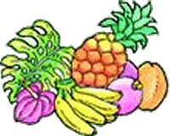
______________________________________________________________________________________
_______
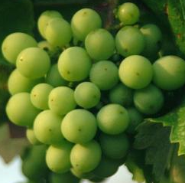  Freefoto.com | May Tasting Table  Thank you to the following folks for their tasty offerings and to all those who did not sign the sheet. Members who donate food may now receive a ticket for the raffle. | 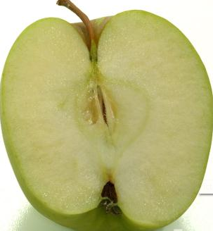

Name | Item | Name | Item
Vega | Chicken fricassee | Shigemura | Daikon kimchee,
Lavalette | Dark chocolate cake | Reddicliffe | Tropical ambrosia salad
Scott | Cucumber salad | Orr | Bread, salad
Sawada | Black bean & corn salsa with chips, | Payne | Strawberry pie
Novak | Pineapple/mango upside down cake | Orr | watermelon
Branesky | Pancit, cucumber salad, fried banana | Susana | salad
Clarke | Baked chicken, plantains | Levesque | Cherry pie
Sawada | Pineapple pork | Kirby | Plantain meat pie
Novak | Banana chocolate chip bread | Novak | Guava banana nut bread
Clarke | Sweet bread | Lee | Apple pie
Shigemura | Double banana cake w/pecans | Clarke | Mushroom patties
Novak | Gallons of juice | Rivera | Strawberry pie
Bigelow | Vegetable casserole | Rivera | Vegetable casserole
Gamboni | Green bean casserole | Branesky | Pancit, noodles, rice
Rivera | Vegetable casserole | Shigemura | Cuke kimchee
Vega | White rice

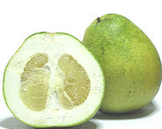 | May Plant Exchange  Members who donate plant(s) may now receive a raffle ticket. Please remember to sign the sheet when picking up your plants. | 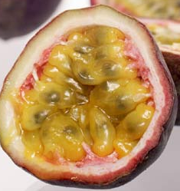

Plant | Donor | Winner
Cherry of the rio grand | Bob Heath
Abacca pineapple | Bob Heath
Chaya spinach | Bob Heath
Chaya spinach | Bob Heath
Chaya spinach | Bob Heath
Surinam cherry | Bob Heath
Texas Ebony | Novak | Whitfield
Texas Ebony | Novak | Engelbrecht
Texas Ebony | Novak | Sumner
Texas Ebony | Novak | Provencher
Dragon fruit | Vega | Tavella
Cuban oregano | Vega
Tabebuea ipe pink | Reddicliffe | Mcculough
Malanga | Newman
Oregano | Musgrave | Hunter
Red Malabar spinach | Musgrave | Levesque
Flowering spinach | Musgrave
Surinam cherry | Musgrave
Green Malabar spinach | Musgrave
Curry tree | Musgrave
Lilly pilly tree | Musgrave | Haack
Kapok tree | Bigelow
Papaya | Payne | Haack
Basil | Orr | Shigamura
Basil | Levesque
Topsy turvy spider/coleus | Clarke
Lychee | Cimafranca
Plumbago | Lavalette | Payne
Hot pepper | Lavalette | Pantricas
Edible hibiscus | Lavalette
Calamondin | Schavey
Black Surinam cherry | Shenoi
Edible hibiscus | Conradt | Haack
Chayote | Conradt | Levesque

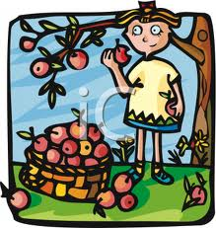
_____________________________________________________________________________________

What’s Happening

by Paul Zmoda

I’m so excited to finally have a fruiting Atemoya tree. I had successfully protected this “Geffner” from freezes this past winter. Now that it is warmer, the tree has been flowering and setting fruits well. Pollination is essential for fruit to form. As with other members in the Annonaceae family, the Atemoya flowers are receptive to pollen the day before the pollen is shed. These are known as protogynous flowers. The following day, those flowers shed ripe pollen. For best results, it is nice to have lots of flowers in both stages – the more, the merrier! Natural pollination is accomplished by certain insects. Small sap beetles (family Nitidulidae) will do the job on not only Atemoyas, but also Sugar Apples, and probably Custard Apples as well. You can encourage them to congregate near your trees by scattering sliced citrus fruits around the bases. These insects feed on the rotting citrus and appear on the scene rather quickly. Many of them will also enter the flowers. If there are enough flowers in both female and male stages, the beetles will transfer the pollen. 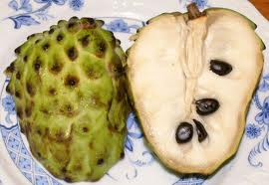
Although I had found this out many years ago, I always hand pollinate my flowers just in case the beetles had other plans that day. You only get one chance to have a flower pollinated; if it’s not done, it aborts. With any Annonaceous flowers you can hand pollinate – just to be sure.
I collect pollen in a small vial, teasing it out of the flowers with a small, soft, artist’s brush. I then apply the dusty pollen into female stage blooms, gently propping open the petals as I do this. If successful, the tiny fruits will begin to enlarge in a few days. Now, your job is to protect them until they are mature enough to pick.

New plantings: Pole and Yardlong beans.
______________________________________________________________________________________
Enjoying Atemoya Fruit

The Atemoya is a cross between the sugar apple and the cherimoya. The Atemoya is a pinecone shaped fruit that has a pale green bumpy outer skin with a creamy, sweet, pudding-like inner pulp. When ripe, the fruit can be scooped out of the shell and eaten chilled. The fruit can be used in many dessert recipes that call for a sweet fruit.
One Atemoya fruit has about 80 calories, provides about 50% of your daily vitamin C requirement, and is loaded with dietary fiber.
______________________________________________________________________________________

________________________________________________________________________
Did you know?

(from www.fruitsinfo.com)

- Apples float because they are 25% water.
- Cashews have their seeds on the outside.
- There were more than 300 accidents in London in 2001 involving bananas, mainly people slipping and falling on banana skins.
- The fruit of the Osage orange is said to repel cockroaches.
- Cherry seeds have satanic powers according to the Dead Sea Scrolls.
- The sugar in an apple is more potent than the caffeine in a cup of coffee, and will keep you alert much better.
- Need an antacid? Try a banana, they contain a natural antacid.

Check out this website for tons of facts on all kinds of fruits, online games for the kids, quizzes, recipes, a gardener’s forum, and a whole lot more.

__________________________________________________________________________
Local Area Events

July 14-15 10-4 Sat., 10-3 Sun. Tropical Plant Fair Admission $5. USF Botanical Gardens 4202 E. Fowler Ave, Tampa. 813-974-2329 www.cas.usf.edu

July 21-22 from 10-4. Tropical Fruit Tasting. Exotic fruits from all around the world. Free. Jene’s Tropicals, 6831 Central Ave. St. Petersburg 727-344-1668 www.tropicalfruit.com

July 27-29 9–5. Mango Festival. Mango trees, tasting, other fruit trees, educational demonstrations, guest speakers, lots more. Admission $5. Colorfield Farms, 8221 Hwy 674 Wimauma, 813-833-2545, www.colorfieldfarms.com

______________________________________________________________________________________

______________________________________________________________________________________
Notes

***Please take note! New Membership Directory: A new membership directory will be available at the July meeting. Please contact Charles Novak to make name, mailing address, phone number or e-mail address changes. (813) 754-1399 or charles.novak@gmail.com.

For contributions to the newsletter, notes on what you are growing, successes, failures, pictures, etc. we would love to hear what’s going on with fruit growers all through the Tampa Bay area, send to bdprovencher@tampabay.rr.com
______________________________________________________________________________





