Upcoming Programs and Events

Upcoming Events/Speakers:

August 12: Adam Shafran, member of the Tropical Fruit Club of Central Florida.
Topic: The many species of Jaboticaba

September 9: To be announced.

October 13-14: Fall USF Botanical Garden Plant Festival

_______________________________________________________________________________________________________________________

Celebrations

Several RFCI members wished Happy Birthday to longtime member George Riegler at his party.



______________________________________________________________________________________

July Joint Club Meeting – A Big Thank You

The Tampa Bay Chapter of the Rare Fruit Council International would like to thank all members of the Brevard Tropical Fruit Club, the Tropical Fruit Club of Central Florida, the Manatee RFCI, the Sarasota Fruit & Nut Society, and the Tampa Garden Club who assisted before, during, and after the most recent inter-club meeting. To the members who prepared the fruit for tasting, who cooked, who brought their favorite dishes to share, who lent a hand wherever needed, a very big “Thank You”! Without your help we couldn’t have gotten it done. A special “Thank You” to Chris Rollins for his interesting and informative presentation on the fruit of SE Asia and for his donation of fruit for the ‘fruit tasting’.

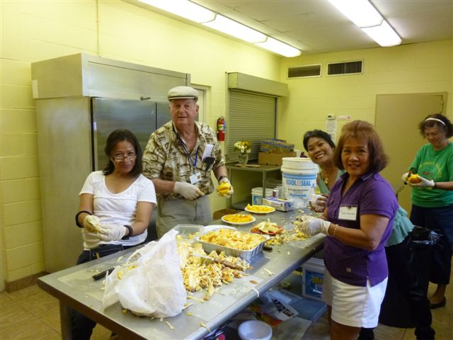

There was a whole lot of food to prepare. Everyone worked hard to make a beautiful spread.

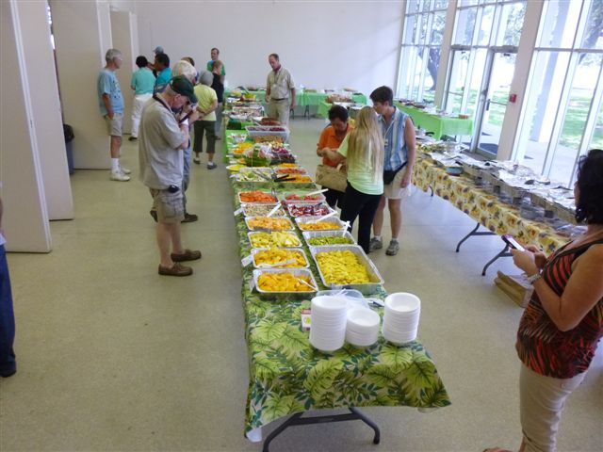

The fruit tasting table was amazing! There were so many kinds of fruits, many mangoes, and rare delights you just will not find in your local grocery store.

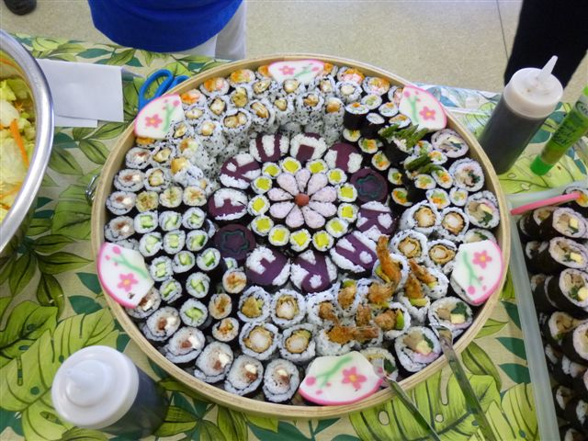

Gorgeous sushi platter: Note the words
“Rare Fruit” outlined in the design of the sushi itself.

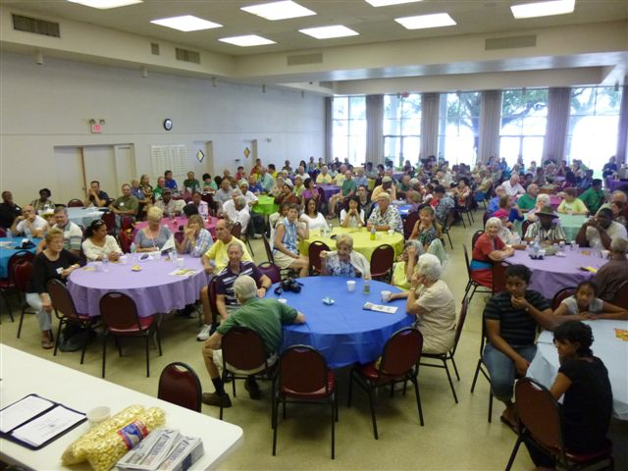 There were over 200 people at July’s meeting, rare fruit tasting, and to hear Chris Rollins speak.

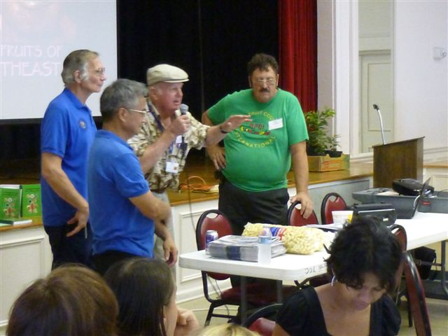
Chris Rollins speaking to the group about the rare fruits in his many travels throughout Southeast Asia.
______________________________________________________________________________________
______________________________________________________________________________________

Southeast Asian Fruits
By Chris Rollins

July’s meeting was a packed house with several other groups in attendance, and the speaker was the well-traveled and delightfully humorous Chris Rollins from the Fruit and Spice Park in Homestead, Florida. He spoke on fruits in the southeast areas of Asia.
There are so many wonderful fruits in the Southeast Asian parts of the world, I can’t speak about them all, so I’ll pick some of my favorites. Fruit is a very important part of everyday life in Asia. People there don’t crack open a packaged snack when they are hungry as Americans do, they actually eat real food. There aren’t 25 cubic foot refrigerators in every home; instead the local Food Market is where people get their food. People go to the Market as a part of their daily routine. It’s a wonderful and socially enriching aspect of their culture. If you travel to these countries, you absolutely must visit the local Food Markets. They are a tremendous place to interface with the local culture. Let them show you the produce, and demonstrate how they prepare and use it. They may laugh at you a bit, but that’s perfectly alright, as the people truly enjoy sharing this knowledge with you. 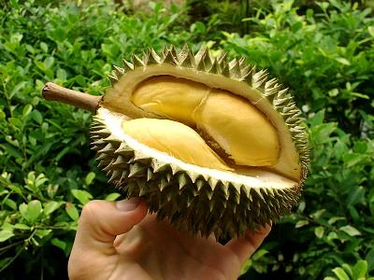
The Durian is a very serious fruit in Asia. It’s highly esteemed and loved. There is more folklore and legend concerning Durian fruit than any other fruit. The Durian is an amazing ball of chemical compounds that do things to you. They can make you sweat. If you study the concepts of yin and yang, the Durian is considered to be hot. It’s also considered an aphrodisiac. If you believe in the aphrodisiac powers of Durian, you can find this fruit for sale late into the night, just in case you, well, need the powers therein.
There is even a bit of lore that says if drink alcohol and have Durian, you will die. The group I was travelling with at the time explored this issue, and luckily no one died!
The Durian tastes like custard, almonds, onions, garlic, and funky cheese, a most unique combination indeed. The Asian varieties are the nastiest. These are so pungent, and aromatic, they are very difficult to even bring into an enclosed area. If you take a taxi or a bus, you will have to hang your Durian fruit outside the vehicle. And don’t bring them to your hotel, as the odor can travel through the entire duct system, and stink up the entire building.
Our group had travelled to Asia to get seeds, and the best way to do that was eat lots of the fruit. We couldn’t eat that much fruit ourselves, but the locals were more than happy to help. Having them spit the seeds into bags after eating the fruit proved to be an easy way of getting plenty of seed.
Another interesting fruit is Gak. Gak is a squash, considered invasive in some areas, like kudzu. The red goo within the Gak fruit is what makes red rice red. In Vietnam, a lack of Gak once caused a vitamin A deficiency in children when an artificial red dye was substituted in place of the Gak. Gak fruit is a powerhouse of vitamins, including vitamin A.
Nutmeg is another interested plant, and certainly of economic importance as a spice. Eating large quantities of it will cause hallucinations. Nutmeg has never been allowed in prisons for this reason. Bored Victorian housewives have been known to take a trip on Nutmeg. There is even a history of use by prostitutes for causing abortions.
Jackfruit is like mother’s milk in Asia, like apple pie is to Americans. Millions eat it every day. If you ever prepare one, be sure to put oil on your hands, as it is very sticky. I had to use turpentine on my moustache once to loosen it up after a Jackfruit experience. Not pleasant. The fruits are so large, they are butchered like a steer and the parts sold. Rarely does anyone buy a whole Jackfruit, as they can weigh up to 80 pounds.
Betel nut, the areca palm fruit, is very common in Asia. They have a narcotic affect, and are used to increase stamina. Using betel nut has interesting affects however. The powdered lime that is mixed with the nut eats away the enamel of the teeth and turns them black. Saliva is also turned red, making for some interesting smiles.
The Fruit & Spice Park is the only tropical botanical garden of its kind in the United States. The unique 37-acre public facility is owned and operated by the Miami-Dade County Park and Recreation Department. Located in South Florida. The Park's tropical climate can be found nowhere else in the continental U.S. and hosts over 500 varieties of fruits, vegetables, spices, herbs, and nuts, and other commercially important plant specimens from around the world. The Park showcases 150 varieties of mango, 75 varieties of bananas, 70 bamboo varieties, and numerous other exotic edibles. Visitors are invited to munch at our tasting counter inside our Park Store or enjoy lunch at the Mango Cafe. 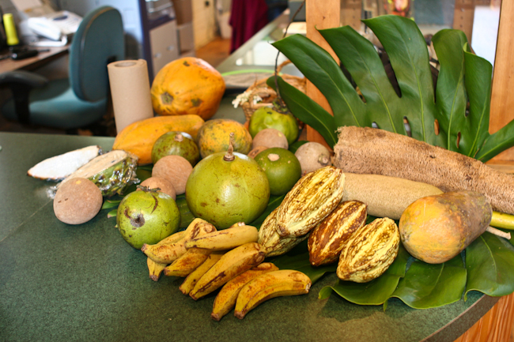
24801 S.W. 187th Avenue
Homestead, Florida 33031
305-247-5727
_____________________________________________________________________________

What’s Happening

by Paul Zmoda

First came tropical storm Debbie with just over ten inches of rain, and more recently wave after wave of heavy rain showers bringing many more inches. The first deluge soaked in just fine, but now we are positively over-saturated in the lower portions of the orchard. Back in the woods, the “sometimes” stream is now a rushing brook. You can actually hear it! We were in serious drought mode prior to all this. Thanks to the rains, our chestnut trees are blooming – two months late. Our Chinese mulberry (che) is fruiting again for the second time this year.
Dr. Matthew Snow gave us a wonderful talk on dragonfruit cacti at our June meeting. A great place to plant them is around the base of large tree stumps. Here in Riverview, we are experiencing an alarming die-off of oak trees. This seems to be happening, in part, due to tiny beetles boring into the trunks. The holes going into the tree’s vascular system mean that water cannot be pulled up into their canopies, just as you cannot drink liquids through a straw having perforations. These laurel and water oaks may decline quite suddenly and turn brown in as short as a week’s time. Observe your trees often. Look at their bases for brown, granular piles of “sawdust”. If caught early enough, you may be able to save them by spraying with Imidicloprid, s systemic insecticide. Should your tree expire and need to be removed, consider leaving a stump seven feet tall or so. These stumps are an excellent place to grow dragonfruit cacti, especially in full sun.
New plantings: one pawpaw grown from seed distributed at our September 2011 meeting.

_______________________________________________________________________________________
_______________________________________________________________________________________

Notes from the Seed Chairman
By Bryon Provencher

There are times when it would be handy to have an elephant. I recently acquired some
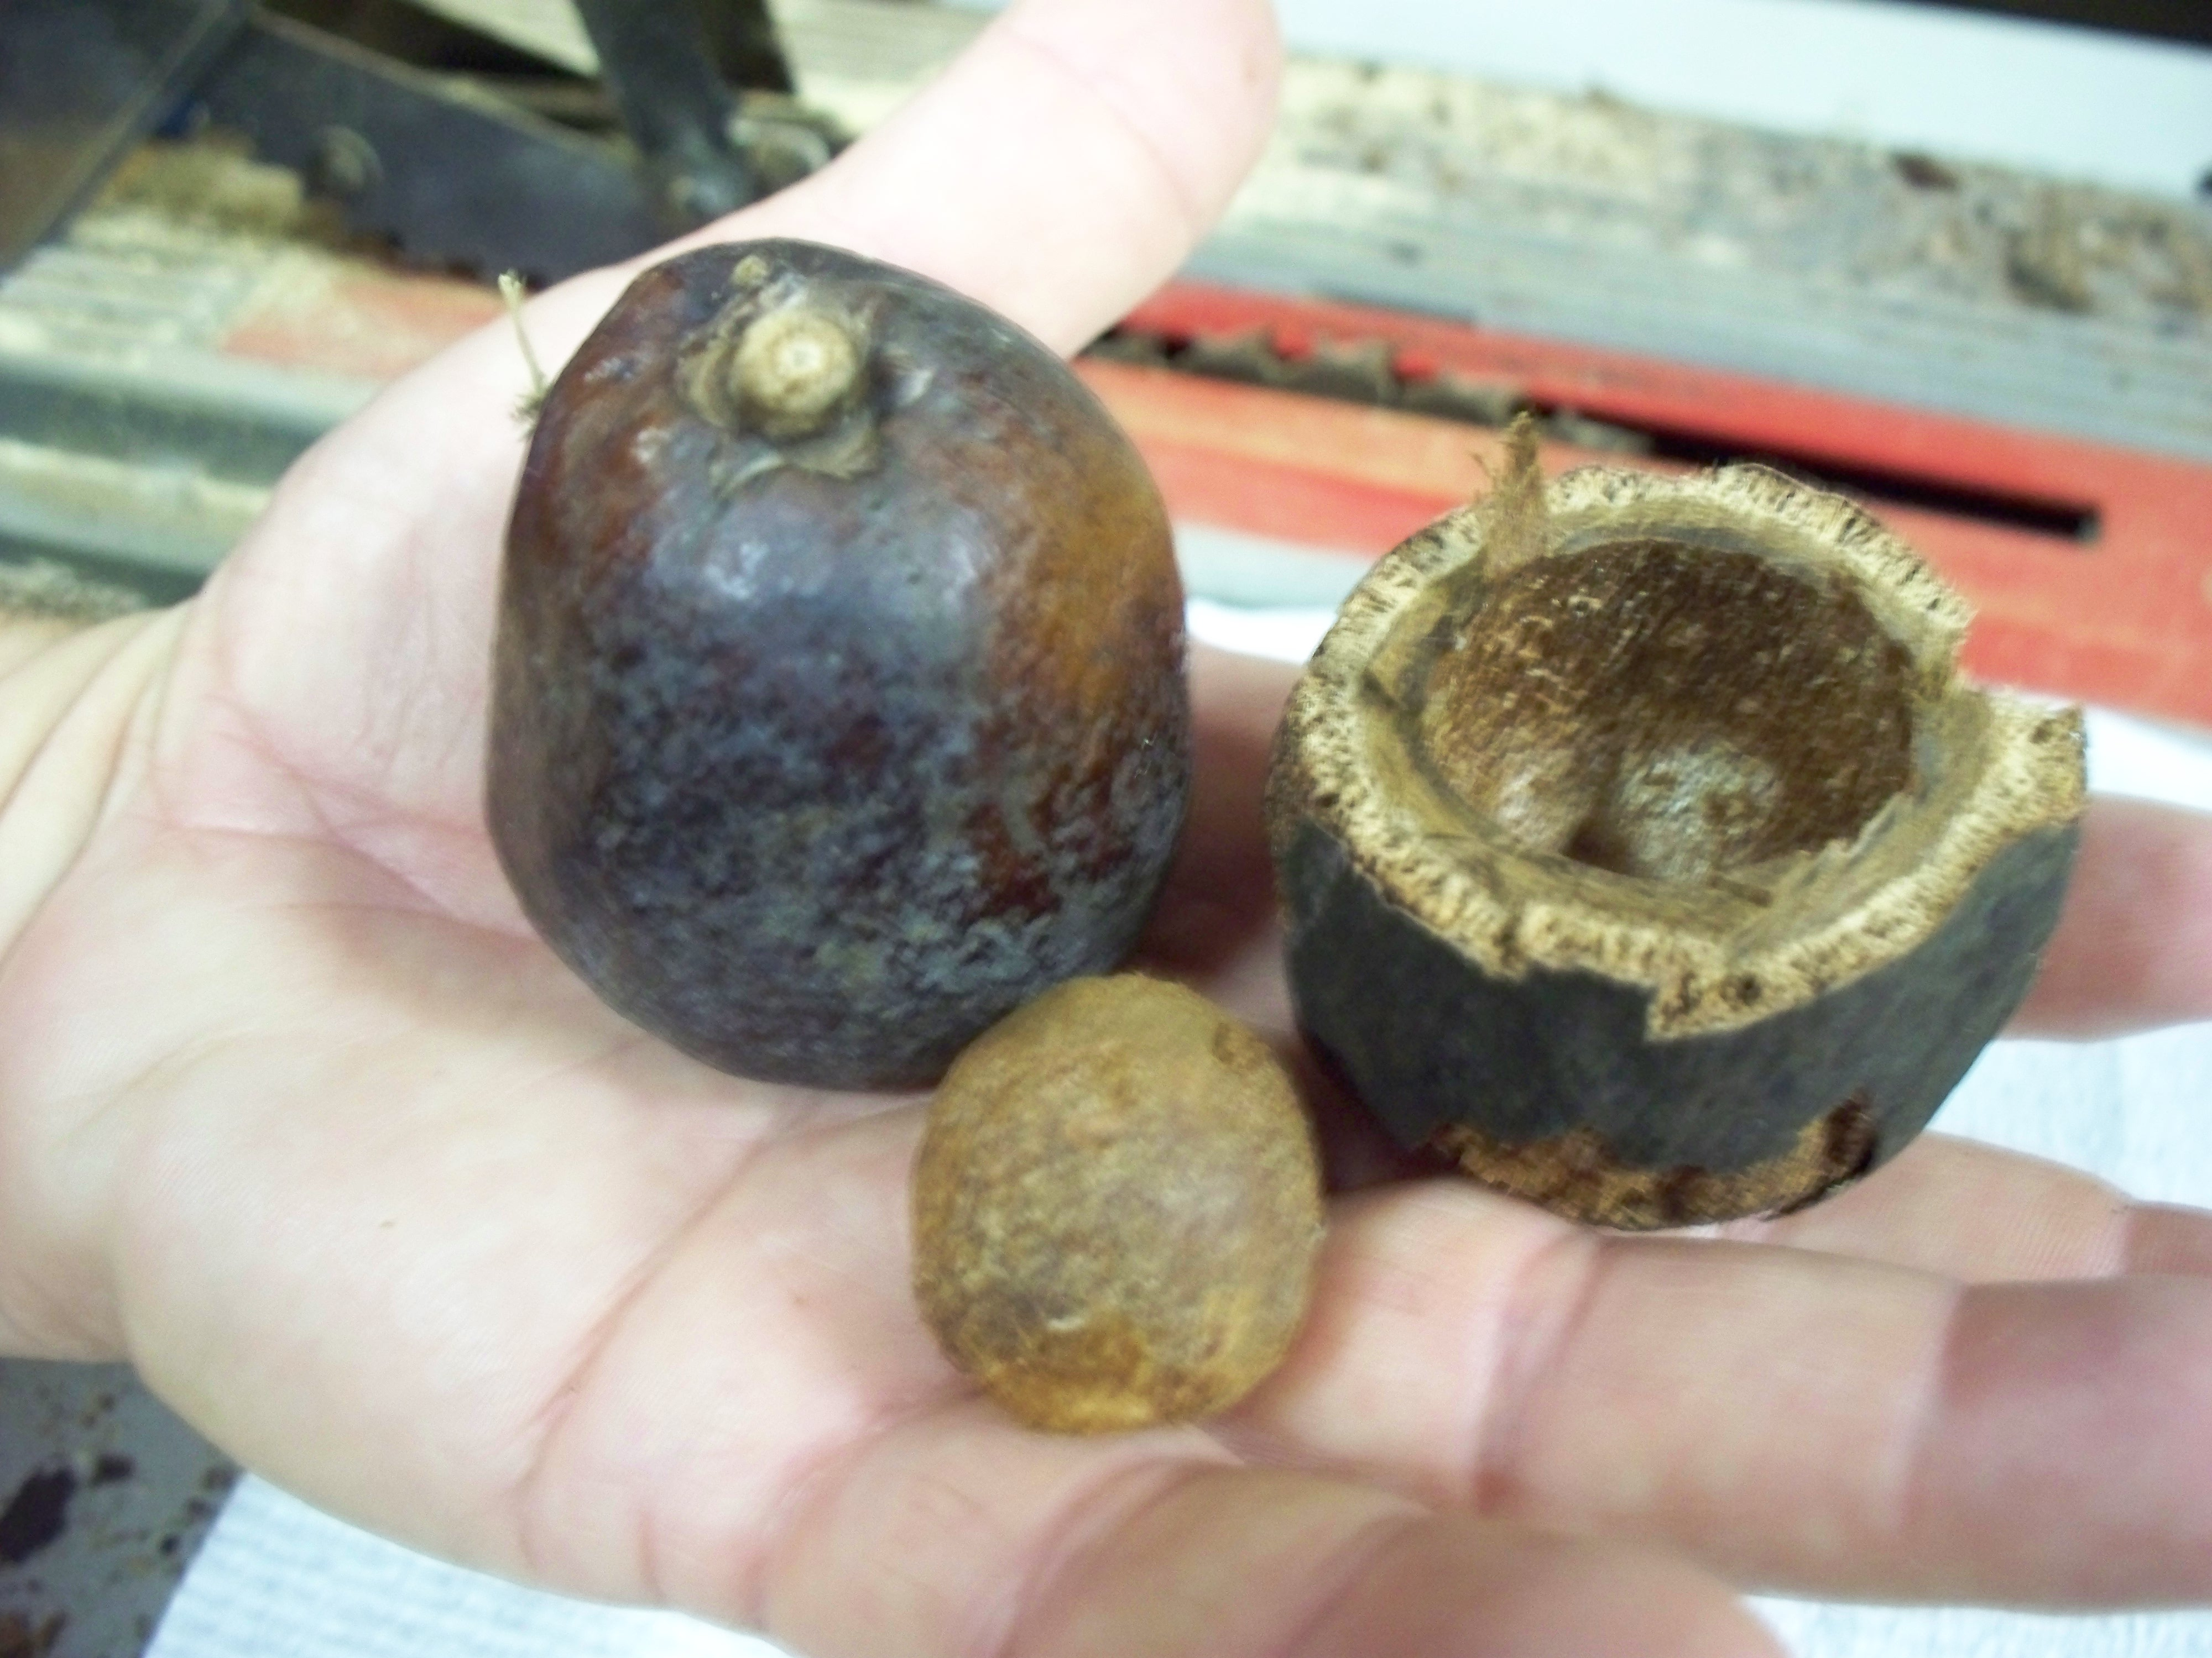Hyphaene coriacea (Gingerbread palm) seeds that came with no instructions. Upon researching the internet, I discovered that these rock hard orbs the size of a small orange are notoriously difficult to crack open. In native Africa, the locals use elephants to accomplish this task, but clearly, an alternative would need to be found. Several palm growers recommended various methods of removing the 1/4 inch thick exterior covering to get to the seed within. The most practical appeared to be a table saw, adjusted to the proper depth. I took several of the giant orbs and circled around them with the saw. Then, prying at the two halves with still some effort, the walnut sized seed within was revealed. There is still a very hard layer covering the actual endosperm itself, but high heat and moisture is supposed to be able to break this down to allow germination. We shall see. These seeds are intended for distribution at the Seed Table, but it will certainly take me a while to go through 200 seeds in this manner, but I will have some at the next meeting. Gingerbread palm has edible fruit and a wine is made from the plant as well.
Often, the timing of acquisition of tropical seeds can prove difficult, as many need to be kept moist and planted within a rather short time period. They cannot be kept for one or two months until the next meeting. Some even start growing in the mailing bag! We’ve filled our greenhouse with a number of such seeds that just would not wait, and will be bringing some young plants in as they are available.
There have been approximately 8750 seeds offered at the seed table from aquisitions I have made since becoming seed chairman. That does not include seeds already in the seed program, or the many that have been donated by members.

Photo by D. Provencher __________________________________________________________________________

Recent Local Events

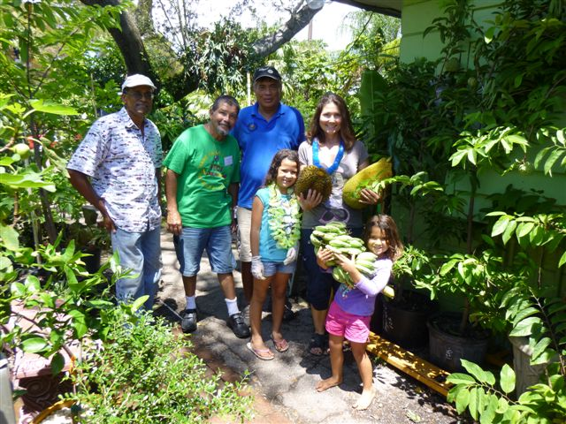Members of the Tampa Bay RFCI helped out at the
annual fruit tasting event at Jene’s Tropicals located
at 6831 Central Ave., in St. Petersburg.
The tasty event was held on July 21st and 22nd, and featured many varieties available at the retail shop.
______________________________________________________________________________________
______________________________________________________________________________________

FreezPruf

Freezpruf is available at an amazing price! If you would like to purchase Freezpruf concentrate for only $20 per gallon, please contact Charles Novak to sign up for the number of gallons you want. Charles has tested this product, which is a natural, ecosafe product, and found it to work very well. For example, a test on Elephant Ears, a plant that frost damages easily, resulted in the leaves holding up very well even at 26 degrees after an application of Freezpruf. Here is some information from the website. 
It’s like anti-freeze, for your plants.
A scientific-breakthrough – this eco-safe spray actually improves healthy plants’ natural cold tolerance by approximately 2° to 9° F, depending on the variety of plant and the duration/intensity of frost or freeze event. Developed by botanists, FreezPruf protects the plant externally and internally by enhancing both its natural “anti-freeze” like properties and its ability to survive ice crystal damage. The biodegradable formula is designed to resist washing away by rain or snow and application lasts up to four weeks with normal precipitation.
It’s like moving your temperature zone 200 miles south!
FreezPruf’s easy-to-use, biodegradable formulation and mode of action adds a half-USDA Zone equivalent or more to the cold tolerance range of all major ornamentals and crops. So, a plant that is hardy to the low-to-mid teens Fahrenheit (Zone 8a) can be grown with little or no damage in Zone 7b.
Plant earlier, harvest later
You can play the guessing game as to when the last Spring, or the first Fall frost will occur and arm yourself with everything from smudge pots to blankets to protect your plants, often with poor results.
Or, you can stop guessing! Although FreezPruf may be applied at any temperature above freezing and will produce benefits as soon as plant surfaces dry, best results will be obtained when applied at temperatures above 50˚F and a minimum of 8 to 12 hours before an anticipated freeze. FreezPruf may also be applied seasonally, in anticipation of future cold events within the upcoming four weeks. Since FreezPruf extends the growing season, it’s perfect for perennials as well as fruit and vegetable plants. The guaranteed protection lasts up to four weeks.
Easy-to-use
Spray liberally to entire plant. Protection lasts up to four weeks with normal precipitation. If frequent heavy rain or snow events have occurred, FreezPruf should be reapplied after two to four weeks. For added protection, reapply as new growth appears.
Protects foliage and flowers
FreezPruf is a water-based, eco-safe spray that enhances the plant’s natural mechanisms to resist freeze damage, shielding it from ice crystal damage, and increasing its ability to survive cold temperatures by reducing the freezing point of water inside the tissues of the plant.
We need to have purchases totaling 260 gallons to get this special price!!!! So far, we have about 60 gallons signed up for, so please contact Charles and order some of this wonderful product.
Website: http://www.liquidfence.com/FreezePruf
Contact Charles Novak PHONE: 8137541399 EMAIL: charles.novak@gmail.com

_________________________________________________________________________________
______________________________________________________________________________________

Notes

Visit Facebook and see us there! Treasurer, Susan McAveety set up the Facebook site. Go to Internet Explorer and type in Facebook Tampa Bay Chapter, Rare Fruit Council Int’l, Inc. and it will take you right to the Facebook page. You must register to view. It’s very easy.

If you didn’t get the New Membership Directory at last month’s meeting, you may do so at the August meeting.

For contributions to the newsletter, notes on what you are growing, successes, failures, pictures, etc. we would love to hear what’s going on with fruit growers all through the Tampa Bay area, send to bdprovencher@tampabay.rr.com






