Upcoming Programs and Events

October 13-14: Fall USF Botanical Garden Plant Festival. Sat. 10-4, Sun. 10-3

November 11: Propagation and Plant Protection.

December 9: Holiday Social. Starting at 1pm.

January 13, 2013: Dr. William Castle – specializes in Horticultural Science at UF’s Citrus Research and Education Center in Lake Alfred and is a member of UF’s Institute of Food and Agricultural Sciences. Topic: Pomegranates (rescheduled from September’s meeting.)
______________________________________________________________________________

New Members

Hazel Robles Tampa Sugako McDaniel Riverview
Susan Ogle Tampa Roger & Jane Johansson St. Petersburg
_____________________________________________________________________________________

Local Events

With the weather turning to cooler fall days and Halloween coming, it’s time to take a short drive and visit our local farms. There are not only pumpkin patches, but lots of other fun activities for the family to enjoy that represent autumn, like getting lost in a corn maze, hitching a ride on a hay cart, picnics, and haunted houses. Have fun!
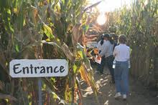
Ergle Farm – pumpkins, pumpkin patch- already gathered from the field, train rides, we also have pie pumpkins, gift shop, concessions / refreshment stand, picnic area, farm animals, school tours
3325 Treiman Boulevard, Dade City, FL 33523. Phone: (352) 583-3647. Fax: (352) 583-0591. Email: info@ergletrees.com. Open: The Pumpkin Patch is open every day from 9:00am to 5:00pm October 1st to October 31st.

Sweetfields Farm – follows organic methods, Pumpkin patch, hay rides, Harvest Festival, corn maze, straw or hay bale maze, child-sized haybale maze, picked pumpkins produce for sale, parking provided free, snacks and refreshment stand, picnic area, face painting. 17250 Benes Roush, Masaryktown, FL 34604. Phone: 352-279-0977. Fax: 352-597-8680. Email: updates@sweetfieldsfarm.com.

Horse Power for Kids – pumpkin patch- already gathered from the field, cow train rides, train rides, corn maze, straw or hay bale maze, child-sized haybale maze, corn cannon, goat walk, horse-drawn hay rides, concessions / refreshment stand, porta-potties, restrooms, picnic area, face painting, pony rides, petting zoo, farm animals. 8005 Racetrack Rd, Tampa, FL 33635. Phone: 813-855-8992. Email: 4dreams@horsepowerforkids.com. Open: October 6 thru 28 Saturday and Sunday 11 am to 5pm.
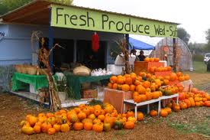
Hydro Harvest Farms – Uses integrated pest management practices, pumpkins for sale in the shop or farmstand, pumpkin patch- already gathered from the field, Fall festival, we also have pie pumpkins, Honey from hives on the farm, Fresh eggs, farm market, concessions / refreshment stand, porta-potties, picnic area, school tours, events at your location (call for info)
1101 Shell Point Road E, Ruskin, FL 33570. Phone: 813-645-6574. Email: john@hydroharvestfarms.com. Open: Pumpkin Patch and Farm open every day; Monday – Saturday from 10 am to 5 and Sunday from 11 am to 4.

Sarasota Pumpkin Festival – pumpkins for sale in the shop or farmstand, pumpkin patch- already gathered from the field, Fall festival, kiddie (mini) corn maze, straw or hay bale maze, child-sized haybale maze, pig races, tractor-pulled hay rides, Bounce house, haunted house, restrooms, face painting, Bounce house, pony rides. 3000 Ringling Blvd, Sarasota, FL 34237. Phone: 941-706-3102. Fax: 941-487-8158. Email: Lazarus@SarasotaPumpkinFestival.com. Open: Friday October 26th 2012: 12pm to 10pm Saturday October 27th 2012: 12pm to 10pm Sunday October 28th 2012: 12pm to 10pm.

Fox Squirrel Corn Maze, 3002 Charlie Taylor Rd, Plant City, FL 33565. Open October 13 – November 11th, Saturday 10am -6pm, Sunday 12pm – 6pm. The first corn maze in Hillsborough County, pumpkins, general store, lots of things for kids. Admission $8.50 adults, $7.50 for kids, bring a flashlight if you go after 5pm. For more information go to: http://foxsquirrelcornmaze.com

For more fall events, check out: www.pumpkingpatchesandmore.org/FLpumpkins.php ______________________________________________________________________________

Special note regarding the November bus trip!!!!

Hello Members From your RFCI President Paul Branesky.
It seems like we had an overwhelming number of members that want to go on the bus trip in November. We have chartered a second 54 passenger bus, and we will now have two pick up points, one in Hillsboro county and one in Pinellas county.
If you want to go, Sally Lee is taking reservations. You need to contact her at 813-335-1865. For your seat to be saved it is $10.00 a member. You can give Sally a check to hold your seat. Call her and she will tell you were to send your check. Also you can give Sally your check at the plant sale at USF Botanical Gardens 12, 13 and 14 October.

__________________________________________________________________________________________________________________________
What’s Happening

by Paul Zmoda

It has been many years since I discussed plant names. Our Club has acquired many new members who may be intimidated or confused by using Latin or “scientific” names. Sure, it’s a different language, but it can end confusion when wanting to buy a plant, and only the plant you have in mind. Here is a reprint from February 1995:

Fruiting plants may go by many different names: one country’s “curuba” may be another country’s “granadilla”. What one calls “nispero” may be “chico sapote” to someone else. Confusing? You bet. While at my favorite Spanish restaurant, the proprietor, when finding out that I deal with rare fruits, ordered a cherimoya tree. I delivered the tree to him, but with one look he declared, “That’s not a cherimoya!” Not fazed, I just chalked that encounter up as another case of the multiple common-names. (I’m still not sure what he wants.)
If only there was some system of giving each species only one proper name to end this confusion once and for all. Let me explain that there already exists such a naming system and it works quite well, thanks to a brilliant Swedish scientist names Carolus Linnaeus, who developed this method known as binomial nomenclature many years ago. In it, each unique member has two names – the genus and the species or specific name. This pairing of names is referred to as the scientific or Latin name, since it is proper protocol to use the Latin language. Furthermore, these dual names are written correctly only when either italicized or underlined. Also the genus begins with a capital letter, while the species is in lower case. By the way, “species” is for both singular and plural. So the next time you want information on a black sapote (chocolate pudding fruit) look under the listing Diospyros ebenaster (or Diospyros ebenaster). Got it?

This Latin naming system is interesting and fairly precise. The words used, or rather chosen by panels of experts, are mostly descriptive of characteristics of groups related to one another as well as individual specimens.

New plantings: pole beans, cucumbers, herbs, carrots, tomato, garlic, and various winter greens.
Air layers potted up: olive and starfruit.
New grafts made: avocado and yuzu citrus.
_______________________________________________________________________________________________

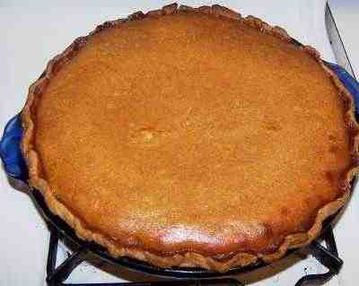 | September Tasting Table  Thank you to the following folks for their tasty offerings and to all those who did not sign the sheet. Members who donate food may now receive a ticket for the raffle. | 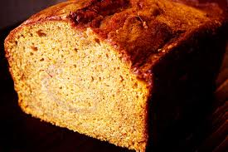

Name | Item | Name | Item
Scott | Starfruit | Coronel | Maja blanca mais
Johnston | Cherry cobbler | Lohn | Melon
Lee | Avocado | Bob & Becky | Olives
Payne | Key lime cheesecake, ham, potato casserole | Levesque | Carambola, apple pie
Shigemura | Chicken tamale pie, cheesecake w/blueberries | Sawada | Chicken fried rice
Orr | Cabbage, apple salad and bread | Davies | Turkey meatballs, ziti
Ferreira | Sweet potato casserole | Sweet | Key lime pie
Newcombe | Carambola and yogurt | Novak | Chocolate cake, 6 gallons of juice
Vega | Rice and beans | Latimer | Brownies
Yuko t. | Lemon cake | Lavallee | Croquet from yucca
Krotz | Orange cranberry cake | Hartzler | Coconut almond cake
Clarke | Chicken, potato stuffing | Schavey | Rice cake
DeWitt | Loaded potato salad | Premraj | Samosa
Mcdaniels | Fried tofu | Aguiree | Goat cheese mashed potatoes
Crossman | Cajun organic zucchini | Novak | Banana bread w/choc chips

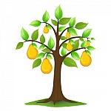 | September Plant Exchange  Members who donate plant(s) may now receive a raffle ticket. Please remember to sign the sheet when picking up your plants. | 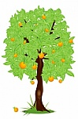

Plant | Donor | Winner
Loquat | Bob Heath
Surinam cherry | Bob Heath
Chaya spinach | Bob Heath
Chaya spinach | Bob Heath
Moringa (3) | Scott
Red lady papaya (11) | Vega | McAveety (1)
Roselle (3) | Vega
Potato (2) | Vega
Moringa (8) | Branesky
Orange passion fruit | Novak | Branesky
Orange passion fruit | Novak | Porter
Orange passion fruit (2) | Novak
Pink guava | Novak | Provencher
Pink guava | Novak | Male
Black pepper (piper betel) | Novak | Haack
Black pepper (piper betel) | Novak | Gambani
Black pepper (piper betel) | Novak | McAveety
Black pepper (piper betel) (4) | Novak
Red sugar cane | Novak | Smith
Red sugar cane | Novak
Tikal guava | Gerstein | Orr
Yellow passion fruit | Gerstein
Mango | Orr
Papaya | Orr
Holy basil | Davies | Smith
Papaya | Payne | Ponticos
Red papaya | Ferreira
Fig celeste | Ferreira
Avocado | Yuko T.
Cilantro | Yuko T. | Merceron
Malabar spinach | Hartzler | Niklas
Loquat | Hartzler | Davies
Malabar spinach basella alba | Krotz
Loquat | Krotz
Pineapple | Premraj | Provencher
Pineapple | Premraj
Cuban mangosteen | Provencher
Lilly pilly | Provencher
Texas ebony | Provencher

Pictures of the buffet from September’s meeting. Each meeting has a delicious feast of ethnic dishes, fresh local fruits from our members, fresh juices, and desserts. It just can’t be missed!

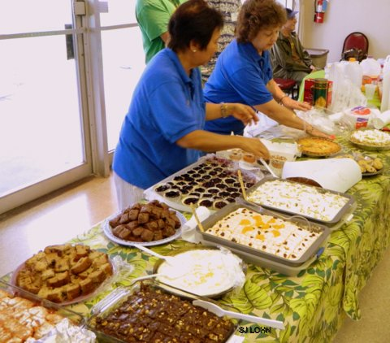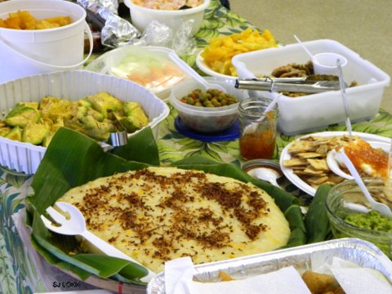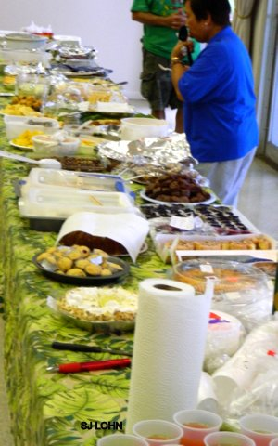

________________________________________________________________________
Pumpkins

Florida’s hot, humid climate makes growing pumpkins tricky. The heat makes plants produce less female flowers, so there is less fruit. Years of research have led to identification by University of Florida experts of several heat tolerant varieties. They can be used for decoration, carving, or cooking. Most are small, but eye-catching. The varieties include red Cinderella, the flat Long Island Cheese, green Jarrahdale, Jack Be Little, Baby Boo, and Munchkin.
Florida farmers are diversifying more today, and adding a pumpkin patch is fun for families. The “U-pick” market is especially popular. Up north, pick your own pumpkin patches are a very popular autumn tradition. 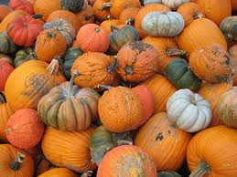
Another type of pumpkin, the calabaza, is popular in Latin American cuisine, is native to hot climates, and is proving suitable for Florida growers. Even winter squashes have varieties that appear suitable for Florida, especially in the northeast counties. An acorn squash called Carnival produces well, and stores up to 4 months after harvest. Butternut squash is showing potential as well.
Commonly considered vegetables, squashes and pumpkins are actually fruits, members of the gourd family. Some varieties of pumpkin, such as Atlantic Giant, can weigh over 1,600 pounds!
In Topsfield, Massachusetts, the annual Topsfield Fair has a yearly contest to see who can grow the biggest pumpkin. Howard Dill of Nova Scotia set a world record in 1979 with a 438 pound pumpkin. The now famous “Dill’s Atlantic Giant” pumpkin seed spread through the community of giant pumpkin enthusiasts and the annual hunt for the biggest fruit was on. The contest, called the All New England Giant Pumpkin Weigh Off, began in 1984, with the winning pumpkin weighing in at 433 pounds. The winner that year received $100. The contest became so popular, and the fruits so large, a minimum weight of 300 pounds was established. Many world records have been set with these monstrous curburbits. The record weight had been set in 2007, a crushing 1,689 pounds, but that was shattered this year with another unbelievable record weight of 2009 pounds, more than 1 ton! The winner received $5000, plus $10,000 for breaking the one ton mark!
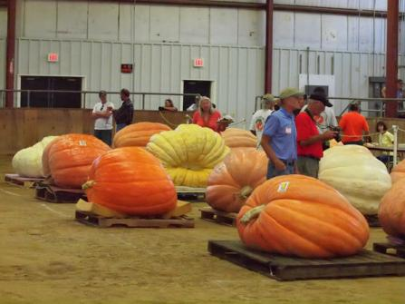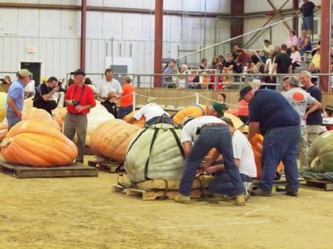
Pictures from previous years of the giant pumpkins at Topsfield Fair.

For more information on pumpkin growing in Florida, check the web article below.
http://news.ufl.edu/2005/10/20/pumpkins/

Check this website for very interesting pictures, history, and information about the Topsfield Fair and the pumpkin contest.
www.topsfieldfair.org/giantpumpkins.php
_________________________________________________________________________________________________________________________
Plant Festival Information

The USF Fall Plant Festival is an important fundraiser. Members are invited to attend, to assist in the sale, to sell fruiting plants, to enjoy the camaraderie and to visit other exhibits.

We need volunteers to help on Friday, Saturday and Sunday.

Setup – Friday, October 12: Our participation will begin around 2:00 PM Friday afternoon. We need volunteers to help raise tents, set up tables, and to unload and arrange plants.

Saturday, October 13 & Sunday, October 14 : The USF Botanical Garden will open at 7 AM for our final preparations. Vehicle traffic will be one way – in the front gate and out the side gate. The front gate will close to traffic at 8:30 AM on both Saturday and Sunday. The gates will open to the public starting at 10 AM on both days.

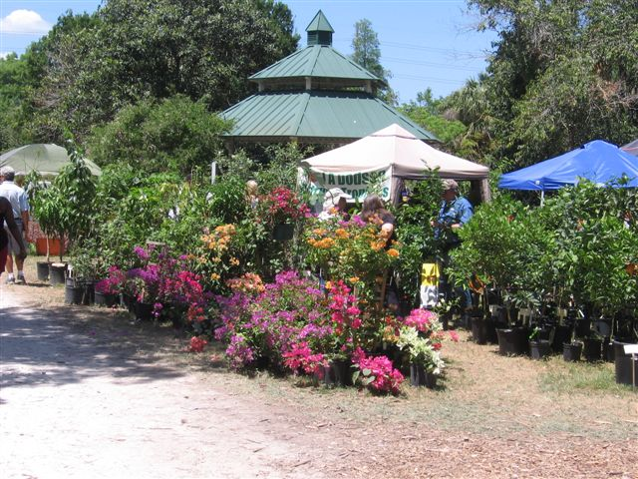On Saturday the Sale ends at 4 PM. On Sunday the Sale ends at 3 PM.

Guidelines for selling fruiting plants:
- Each member selling plants must submit a manifest listing their plants and prices. This manifest must be given to a designated member for verification.
- Each plant must have a label with the name of the plant, the price and the seller’s initials.
- Please note that members cannot sell citrus plants, non fruiting plants or herbs.
- Sellers are responsible for their plants and if unable to be there both days of the Sale, they should ask a member to handle their plants for them.
- Sellers should not lower the prices of their plants without advising the designated member before changing the price on the manifest.
- Members selling plants should be willing to help unload and load Ray’s truck and help with the setup and breakdown of the sales area (if physically able).
- When the Sale is over on Sunday afternoon, sellers will inventory their unsold plants, enter on their manifests the number of plants that remain unsold and then submit their manifests to the designated member. Members should then remove their unsold plants.
- We would like members to follow these guidelines to avoid misunderstanding, confusion and errors.

______________________________________________________________________________________

Notes

For contributions to the newsletter, notes on what you are growing, successes, failures, pictures, etc. we would love to hear what’s going on with fruit growers all through the Tampa Bay area, send to bdprovencher@tampabay.rr.com

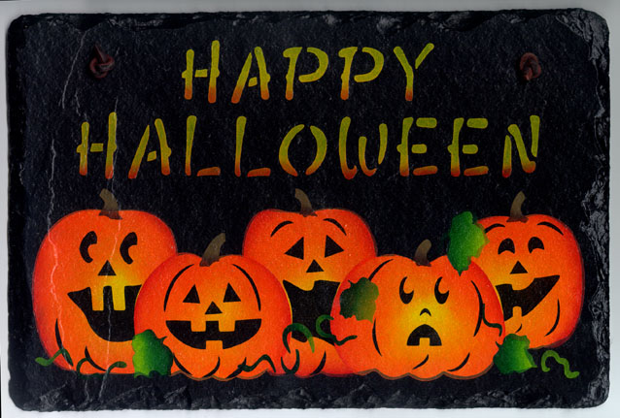
Boo!
______________________________________________________________________________



