Upcoming Programs and Events

November 11: Propagation Workshop and Cold Protection
This workshop was a great success last year, and we look forward to another very informative session. In addition to grafting and air layering members will be available to answer questions. We will also enjoy our fabulous tasting table, plant raffle and farmers’ market. Members are invited to contribute to the tasting table.

December 9: Holiday Social: Please Note: The festivities start at 1 P.M. instead of our regular meeting time of 2 P.M.

January 13, 2013: Dr. William Castle – specializes in Horticulture Science at UF’s Citrus Research and Education Center in Lake Alfred and is a member of UF’s Institute of Food and Agricultural Sciences. Topic: Pomegranates.
______________________________________________________________________________

New Members

Sharon Allen Zephyrhills Michelle Durivou New Port Richey
Tina & Kelsie Buller Wesley Chapel Candy Doyle Tampa
Rosendo Fernandez Tampa Matt Jacobson Brandon
Harriet Gord-Noghani Lithia Shirley Johnson Tampa
Ashley Hamid-Nozelle Riverview Thomas Moscarillo St. Petersburg
Lara &Stephane Labastie Seffner Maria Oster Tampa
Joyce Paisner St. Petersburg Maria Peas Tampa
Andy & Eda Randazzo Wesley Chapel Raphael Talavera Tampa
Stephanie Weber Tampa _____________________________________________________________________________________

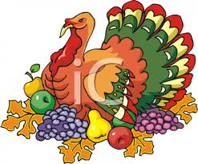

______________________________________________________________________________

PLEASE NOTE –IMPORTANT INFORMATION REGARDING THE NOVEMBER BUS TRIP.

There will be two buses to accommodate all members who wish to attend this outing.
One bus will be leaving from Falkenburg Road at 7:00 am and the other bus will be leaving from Disabled American Veterans Hall, 4801 37th Street North, in St Petersburg at 6:30 am. The St. Petersburg bus will travel to Falkenburg Rd after picking up those members who choose to board the bus at DAV Hall. The bus will then proceed to Falkenburg Rd to pick up the remainder of members, who could not fit on the first bus.
Directions to DAV Hall - Going South on Hwy 275, exit on 54th Ave N- head West approx.10 blocks to 37th Street N- turn left after 6 blocks, you will cross a bridge, the DAV Hall will be on your left.
From Pasco County use US 19 South to 54th Ave N, turn right and go 3 blocks, turn left on 37thStreet N, go over the bridge and parking is on your left.
If you wish to board the bus at DAV Hall, be there before 6:30 am as the bus will leave at 6:30 sharp.
Direction for Sheriff’s Office parking lot, 2310 N. Falkenburg Rd. – Heading south on I-75, take Exit 260 onto Dr. Martin Luther King Jr. Blvd. E. Go 0.8 miles and turn left onto Falkenburg Rd. N, then go 1.2 miles, cross a railroad track. The parking lot will be on the right side of the road.

Bring a sack lunch and snacks. The club will provide water.
For questions and information on available bus seats contact Sally Lee (813)335-1865 or yukyee@aol.com,
or contact Paul Branesky (727)515-6073
__________________________________________________________________________________________________________________________
What’s Happening

by Paul Zmoda

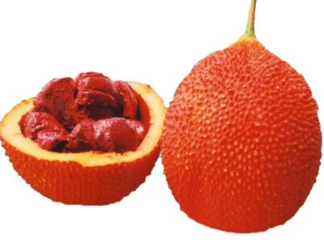 Cooler weather is coming; our plantings always look their best just before the winter freezes come along. We’re getting some nice Gac fruits – full and heavy. Our oriental persimmons are ripening more and more every day. They are sweet, juicy and seedless. The fruit-eating animals have noticed them as well, so I have been trapping in earnest.
One dwarf Cavendish banana put out a nice flower bud, but it’s too late in the year to expect ripe fruit from it. Our very first Atemoyas were delicious. I’ll bring their seeds to our next meeting. The seedlings from hybrid fruits, such as these, can produce some variable and interesting fruits later on if anyone is interested in planting some. The Soursop has been blooming sporadically, but no fruit set yet. These large flowers must be hand pollinated here.
One of our screech owl nest boxes was colonized by honey bees after the young owls left around April. The bees increased in such numbers that they could not all fit inside at night. The “blob” of bees clinging to the nest box entrance grew larger and larger each day. I sensed that they would swarm, and they did. I missed witnessing their departure by only one hour. How I wished to see that happen.
New plantings: starfruit, two avacadoes, and lots of vegetables in the garden, such as peas, lettuce, arugula, basils, and broccoli.

______________________________________________________________________________________________
_________________________________________________________________________________________________________________________
Plant Festival

Thank you to all the members who donated their time to help with this event. The weather was perfect for this outdoor plant festival. Members enthusiastically shared their knowledge of fruiting plants with the public. Rose Terenzi collected 17 new memberships and several members reactivated their memberships. 602 cups of fruit juice were served to the thirsty crowd. Many stopped to view our scarecrow, Tutti-Fruitti Carmen Scareanda.

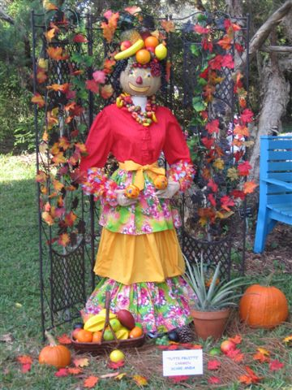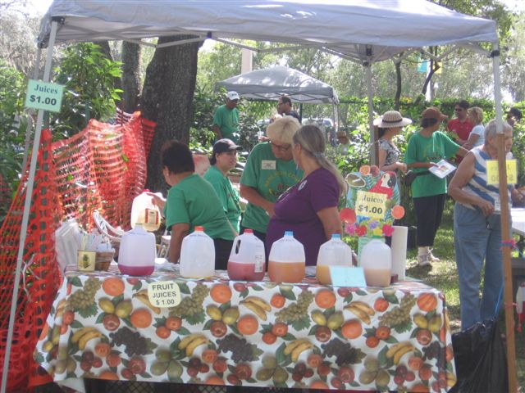
Miss Carmen Scareanda The juice table, with many tropical fruit flavors to try.

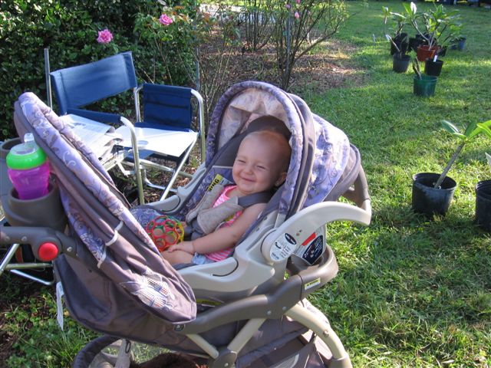
Smile is the word, Baby! The USF plant sale is fun for all ages.

------------------------------------------------------------------------------------------------------------------------------------------------------------------------------------------

------------------------------------------------------------------------------------------------------------------------------------------------------------------------------------------
- Fruit Stuffing

The holidays are upon us! It’s time for thinking about what we will make for our holiday meals. Stuffing is a very popular accompaniment to the star protein component of the meal, but stuffing recipes also can be fabulous side dishes, or even the main entrée themselves any time of the year. The recipes below all use various fruits, including mango, coconut, lemon, pineapple and apricot, as well as more traditional fruits like raisins, tomatoes and cranberries. There is even a low carb, no bread recipe. While it’s true they wouldn’t have had these tropical flavors back at our country’s first Thanksgiving feast, we can surely enjoy them today.

Mango and macadamia stuffing
Chef: Christine Simpson

3 tablespoons butter 1 small onion, finely chopped
1/4 cup macadamia nuts, chopped 3 slices bacon, sliced into fine strips
1 large ripe mango, peeled and chopped 10 fresh sage leaves, sliced
1 cup of bread crumbs (use day old bread)
Melt butter in a frying pan. Add the onion and cook gently without browning.
Add the macadamia nuts and bacon. Cook until lightly browned.
Place mixture into a bowl and add the mango, sage and breadcrumbs. Season with salt and pepper to taste.

Low Carb Mushroom Stuffing – No Bread!

3 cups of chopped mushrooms, your choice of variety
1 cup of cubed zucchini
½ cup of chopped onion
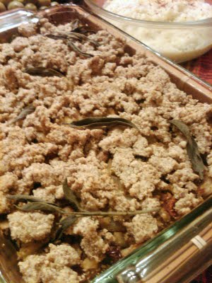1 cup of chopped sweet red pepper
1 cup of chopped celery
½ cup of chopped sundried tomato
½ cup almond meal
¼ cup of chopped sage
Salt and pepper to taste
Olive oil

Topping:
½ cup almond meal
¼ cup coconut oil
Zest of lemon

Brown the onion and celery in a pan and set aside. Brown mushrooms; when liquid becomes substantial, push the mushrooms to the side of the pan and add the sundried tomatoes to the center of the pan, allow them to cook in the liquid and soak it up. Set aside. Brown the zucchini, then add the red pepper and allow to cook until just tender. In a large bowl, mix up the cooked ingredients along with the sage, almond meal, salt and pepper. Pour into baking dish.
Mix topping ingredients in food processor, and crumble across the top. Garnish with sage sprigs if desired.
Bake at 350 for 25 minutes. From www.glutenfreehippie.com

Sausage, Fig & Cranberry Stuffing

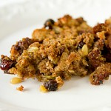Yield: 6 to 8 servings
Prep Time: 30 minutes
Cook Time: 45 minutes
Total Time: 1 hour 15 minutes

Ingredients:
¾ cup large-diced dried figs, stems removed
¾ cup dried cranberries
½ cup Calvados or brandy
¼ cup (4 tablespoons) unsalted butter
1½ cups diced onions
1 cup (½-inch-diced) celery (about 3 stalks)
12 ounces pork sausage, casings removed (sweet, mild or hot - your preference)
1½ tablespoons chopped fresh rosemary leaves
3 tablespoons pine nuts, toasted
3 cups herb-seasoned stuffing mix
1½ cups chicken stock
1 egg, beaten
1 teaspoon kosher salt
½ teaspoon freshly ground black pepper
Preheat oven to 325 degrees F. Butter a 9x13 casserole dish; set aside. Place the dried figs and cranberries in a small saucepan and pour in the Calvados and ½ cup of water. Bring the mixture to a boil over medium heat, then lower the heat and simmer for 2 minutes. Remove from the heat and set aside. Meanwhile, melt the butter in a large (12-inch) skillet over medium heat. Add the onions and celery and sauté until softened, about 5 minutes. Add the sausage, crumbling it into small bits with a fork, and sauté, stirring frequently, for 10 minutes, until cooked and browned. Add the figs and cranberries with the liquid, the chopped rosemary, and pine nuts, and cook for 2 more minutes. Scrape up the brown bits with a wooden spoon. Place the stuffing mix in a large bowl. Add the sausage mixture, chicken stock, egg, salt and pepper and stir well. From Barefoot Contessa Back to Basics.

Wild Rice, Fruit, and Pecan Stuffing

1/2 tablespoons olive oil 3 large celery stalks, finely chopped
1 cup finely chopped onion 1 garlic clove, thinly sliced
1 1/2 cups wild rice 2 cups low-salt chicken or turkey broth
1 bay leaf 1 teaspoon kosher salt plus more
3/4 cup (3 oz.) pecans 1/2 cup dried cranberries
1/4 cup (about 3 oz.) dried apricots, coarsely chopped 1/4 cup (about 2 1/2 oz.) golden raisins
Freshly ground black pepper
1/2 cup (about 4 oz.) fresh cranberries, thinly sliced
1 1/2 cups thinly sliced small celery stalks (from celery heart)
1/2 cup celery leaves from celery heart, coarsely chopped
Heat oil in a large saucepan over medium heat. Add chopped celery and onion; cook, stirring occasionally, until softened and almost translucent, about 8 minutes. Stir in garlic; cook, stirring often, until fragrant, about 2 minutes.
Add wild rice; stir for 1 minute. Add broth, bay leaf, 1 tsp. salt, and 1 1/2 cups water; increase heat and bring to a boil. Reduce heat to medium-low, cover, and simmer for 30 minutes. Note: Cooking times for wild rice vary from brand to brand by as much as 30 minutes, so follow the package directions.
Uncover, stir, and continue cooking, uncovered, stirring occasionally, until liquid is absorbed and rice is tender, 20–40 minutes.
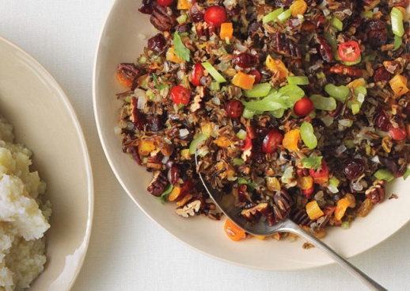Meanwhile, preheat oven to 325°. Spread out pecans on a rimmed baking sheet. Toast until fragrant, 5–7 minutes. Let cool; coarsely chop. DO AHEAD: Can be made 1 day ahead. Store nuts airtight at room temperature.
Let stuffing cool, then cover and chill. Rewarm over medium heat, adding water by tablespoons if too dry, before continuing.
Discard bay leaf. Stir in dried cranberries, apricots, and raisins. Let sit, covered, for 5 minutes.
Season rice to taste with salt and pepper.
Fold in pecans, sliced cranberries, and sliced celery into mixture. Garnish with celery leaves.
Recipe by Sara Dickerman on http://www.bonappetit.com

Photo by Christopher Testani

Pineapple bread stuffing

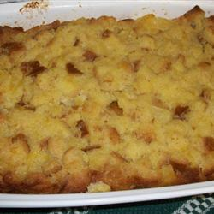
½ cup margarine
2 cups finely diced pineapple
1 cup white sugar
5 slices of white bread, cubed
4 eggs

Preheat oven to 350. Grease a 9” baking pan. In a mixing bowl, cream margarine and sugar. Beat in the eggs one at a time, then add the pineapple and bread cubes.
Bake at 350 for one hour. Let sit for a few moments to firm up before serving. From http://allrecipes.com

___________________________________________________________________________

Florida Tropical Fruit Ripening Schedule

Below is a chart for the times that various tropical fruits ripen in Florida. This chart is from the website for the Tropical Fruit Growers of South Florida (TFGSF). Check their website for more information on this hard-working organization promoting the minor fruit crop industry in Florida. TFGSF was started in 1987 by Fruit and Spice Park director Chris Rollins (we know him!) Get information on fruits, recipes, videos, and sign up for their newsletter. www.tropicalfruitgrowers.com

pink = peak of season.
yellow = early/late/limited availability
 | Jan | Feb | Mar | Apr | May | Jun | Jul | Aug | Sept | Oct | Nov | Dec
Annona
Avocado
Banana
Caimito
Dragon Fruit
Guava
Jakfruit
Longan
Lychee
Mamey Sapote
Mango
Papaya
Passion Fruit
Sapodilla
Starfruit
Copyright ©2012 Tropical Fruit Growers - All Rights Reserved

______________________________________________________________________________________

Notes

For contributions to the newsletter, notes on what you are growing, successes, failures, pictures, etc. we would love to hear what’s going on with fruit growers all through the Tampa Bay area, send to bdprovencher@tampabay.rr.com







