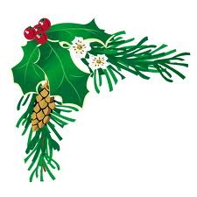 2012 Holiday Social

Please join us for the annual RFCI Holiday Social.

Sunday, December 9, 2012
1:00 P.M.
Tampa Garden Club
2629 Bayshore Blvd.
Tampa, FL 33629

Please bring a covered dish (salads, vegetables, desserts, etc.)
The Club will provide the turkeys, ham, tableware and drinks.
Please bring an item to donate to the free raffle (such as, plants, small
gifts - perhaps an item you received but can't use).
Several volunteers are needed to help set up.
If you are available to help, please arrive at the Tampa Garden Club about 11:00 A.M.

______________________________________________________________________________
Upcoming Programs and Events

January 13, 2013: Dr. William Castle – specializes in Horticulture Science at UF’s Citrus Research and Education Center in Lake Alfred and is a member of UF’s Institute of Food and Agricultural Sciences. Topic: Pomegranates.

RFCI Horticulture Display at the 2013 Florida State Fair: February 7-18.
We need members to volunteer to man the club’s exhibit. A volunteer signup sheet will be available at the December and January meetings.
______________________________________________________________________________

November Propagation Workshop

November meeting: The annual propagation workshop was attended by a large number of members. Anyone wanting to learn about air layering and grafting should attend this event. These methods of propagating are the best for perpetuating the best individual plants and trees of the best varieties. The methods are demonstrated live at this workshop. This year, Paul Zmoda demonstrated his method of Air layering. Grafting demonstrations were given by Jerry Amyot, Jimmy Lee and Charles Novak.
_____________________________________________________________________________________
What’s Happening

by Paul Zmoda

I love a good avocado as I know many members do too. A perfectly ripened one is delicious and good for you nutrition-wise. They contain potassium, lutein, folate, anti-oxidants, vitamins A, C, and E, and varying amounts of monounsaturated fats. These are the “good” fats which play an important role in moderating blood cholesterol levels. I enjoy these fruits’ creamy insides spread on freshly baked bread or crackers. A well-made guacamole in easily appreciated also.
I have had poor luck getting avocado trees to survive here at Flatwoods Fruit Farm. Subfreezing weather and/or way too much rainfall usually kills them in short order. Imagine my delight to see some excellent specimens for sale at our recent fall fundraiser in the University of South Florida Botanical Gardens. Many of these trees available were of a group of new cultivars out of Texas that were advertised as being extra cold hardy – some surviving down to 14 degrees Fahrenheit! I had no problem paying full price at the beginning of the sale so I could pick out the nicest trees.
With the recent loss of our large oak trees on the west side of our house which happens to be high and well-drained, I have the perfect planting place and success is anticipated. From a selection of a half dozen varieties, I chose “Fantastic” and “Brazos Belle”. My only concern is that the introduced ambrosia beetle might kill them in the future before I can harvest the fruits. That would be a shame.

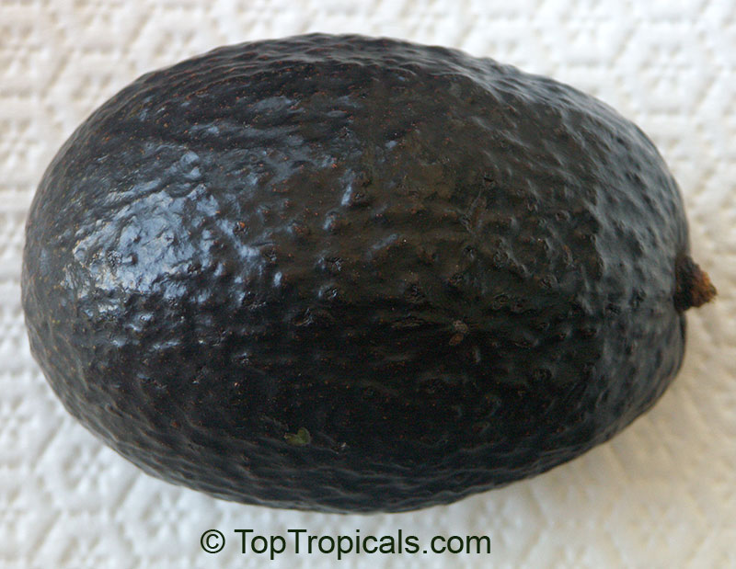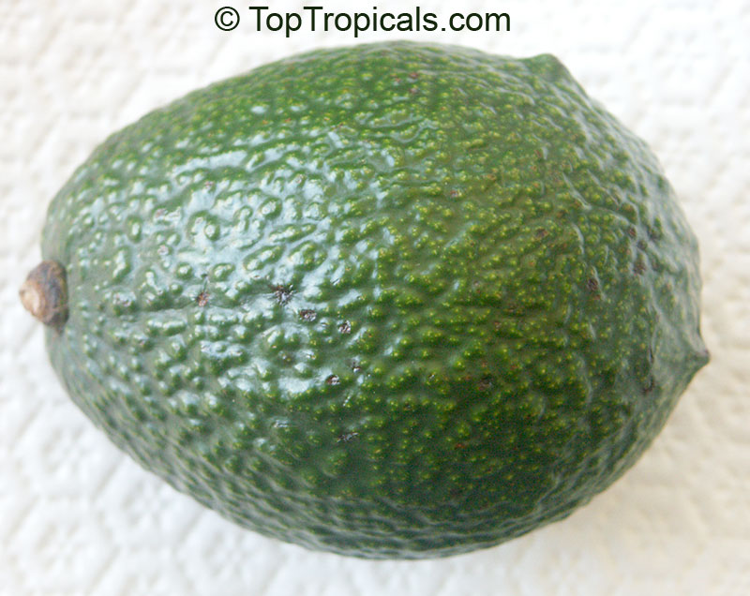
Brazos Belle Fantastic

New plantings: peas, Chinese vegetables, and real dandelions from New Jersey and Pennsylvania to use in salads later.

____________________________________________________________________________________
Growing Figs in Florida

Figs (Ficus carica) have been cultivated in the Old World for at least 5,000 years, and were brought to the New World in 1575 by Spanish Explorers. Initial attempts to grow figs in the New World were met with failure due to the lack of a special fig wasp (Blastophaga psenes) that was required to pollinate the fruit. This problem was remedied by importing the wasp. However, the fruit of these fig cultivars had open "eyes" or ostioles (opening at the fruit apex) and were often attacked by other unwanted insects as well as a variety of diseases. Research by scientists led to the development of varieties of figs with closed eyes that did not require pollination. There now are at least 100 varieties of figs, but very few are grown in the southeastern states. The fig is a member of the Mulberry family. 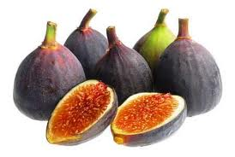
Figs come from dry, Mediterranean climates, and Florida’s humid climate can lead to diseases, and the rain can cause the fruit to split. Another problem has to do with the temperatures. Trees are hardy to 15 degrees, and need very minimal cold hours to set fruit, however without sufficient cold conditioning, heavy damage will occur to the limbs and trunk when a Florida freeze does occur. Figs are often killed back to the ground each winter by a cold snap, and re-emerge as a shrub each year, never attaining the height and girth of those trees grown in areas with a proper and gradual autumn drop in temperatures.
The wood of figs is often more pithy than woody, and decays rapidly. When injured it will release milky latex. The fruit of a fig is unique and is derived from a hollow peduncle that becomes fleshy and forms a structure called a synconium. The unfertilized ovaries provide the resin-like flavor associated with fruit of fig.
There are four types of figs -- Caprifigs, Smyrna, San Pedro and common types, which are recommended for Florida. Caprifigs produce staminate (male) flowers and are useful only as a source of pollen. Smyrna bears only pistillate (female) flowers and requires a caprifig for pollination. San Pedro has pistillate flowers and bears two crops, one on leafless wood requiring no pollination and the other borne on new wood that requires pollination. Fig cultivars recommended for Florida belong to the common types of fig and are parthenocarpic; fruit develop without pollination. Smryna and San Pedro types will not bear fruit in Florida because of the absence of Caprifigs and a wasp pollinizer (Blastophaga psenes). Because the common types of fig do not require a wasp pollinizer, the best cultivars have a closed ostiole to minimize rotting by preventing the occurrence of insects or rain water inside the fruit. The following are good choices for Florida.
Brown Turkey (Brunswick, Eastern Brown Turkey, Harrison, Lees Perpetual, Ramsey, Texas Everbearing): This cultivar is probably the most popular fig in the southeastern United States. A small crop of fruit in the spring (called breba fruit) ripens in July followed by the main crop one month later. The fruit is medium-large in size, has bronze skin and amber pulp. The fruit has a small-to-medium ostiole and is good fresh or processed.
Celeste (Blue Celeste, Celestial, and Little Brown Sugar): This cultivar is probably the second-most common fig in the southeastern United States. Celeste is fairly cold hardy, and the fruit is small to medium in size and purplish-bronze to light brown in color. Celeste has a closed eye and begins ripening in early July. Celeste is good fresh or processed.

Figs perform best in locations with full sun all day. Fig trees often shade out competing vegetation below the tree canopy. These trees should not be confined to a small landscape. The trunk and major limbs, if not shaded, can experience sun scald, which can be minimized by applying white latex paint. The root system of fig trees can extend well beyond the tree canopy.
In Florida, bare-rooted fig plants can be planted during the dormant season, from December to late February. Container-grown plants can be planted any time of the year provided they receive irrigation. Irrigation is required for fig trees during the establishment year. During that period, a fig tree should receive 10 gallons per application at least three times a week.
Fig trees do not require pruning to be productive. Pruning may be a waste of effort since the tree will freeze to the ground.
Fig trees are a moderately sustainable crop, but suffer from a number of animal and disease pests. Fig tree roots are a favorite food of birds, gophers, rabbits and squirrels, which also feed on the fruit. Root knot nematodes can also be a limitation for fig trees planted in sandy soils, but are not usually a problem in fertile or loamy soils. Organic amendments or mulches reduce nematode damage. A number of insects and diseases can attack fig fruit if the cultivar is one with an open eye.
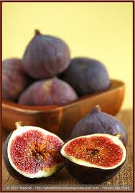 The most common disease of fig in the southeastern United States is the fig rust (Cerotelium fici). Fig rust turn leaves brown, can cause defoliation and premature ripening of the fruit and decreases cold tolerance. This disease can be controlled by a 5-5-50 Bordeaux spray (copper sulfate, lime and water) applied every two to three weeks. Other fig diseases include Botrytis cinerea (fungus), Cercospora leaf spot fungus (Cercospora fici), which causes branch terminals to turn black and die. Thread blight (Pellicularia koleroga) results in necrosis of stems and matted foliage. Botryosphaeria dothidea (fungus) causes necrosis of leaves and stems. Rhyzopus stolonifer (smut) causes fruit drop of cultivars with an open eye. Fusarium spp. and Aspergillus niger are fungus that attack ripe fruit.
Although many diseases attack figs, most figs are grown in homeowner settings and do not receive pesticide sprays. The most common insect pests are mealy bug, three-lined fig borer and ants. The application of insecticide is seldom warranted. Please contact your County Extension Agent for spray recommendations.
Nutritional Value: Figs are high in dietary fiber and are a rich source of magnesium and potassium. They are also relatively high in vitamins A, B, and C and low in calories, about 50 calories each. One large raw fig, approximately 65 grams is 77.5 percent water, yields .8g protein, .2g total fat, 23mg calcium, .4mg
Iron, 50 IU vitamin A, 2.1g dietary fiber, 3.8mcg folate, .3mg niacin, and 1mg vitamin C. Fresh figs must be fully ripe when picked.
For more information on growing figs, see Publication #HS27 at http://edis.ifas.ufl.edu/mg214
______________________________________________________________________________

Christmas Pudding

The Christmas carol “We wish you a Merry Christmas” made figgy pudding famous when the carolers within the song demanded this Christmas delight, and refused to leave until they got some! One must assume figgy pudding must be very good indeed to have such a reputation. The history of figgy pudding goes back to England in the 1500’s under such names as fygeye, or figge, or crustade. It was traditionally served as a Christmas treat. Figgy pudding may be baked, steamed in the oven, boiled, or even fried. It often contains alcohol (very important for those cold carolers singing at your door), or is served with a flaming alcoholic sauce.
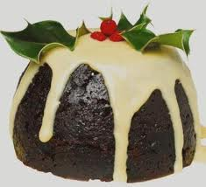Christmas Plum Pudding – a traditional English recipe
2 cups soft bread crumbs
2 cups chopped suet
1 cup chopped figs
1 cup chopped citron
1 cup cleaned currants
1 teaspoon salt
1 teaspoon nutmeg
6 eggs
1/2 cup brandy
1/2 tablespoon lemon rind
Mix ingredients; pour into buttered mold; cover and steam four hours; bake in oven one-half hour. Serve with Wine Sauce.
Wine Sauce
1/2 cup butter
1 cup powdered sugar
wine, brandy or vanilla
Cream butter; add sugar by the teaspoon, and beat until light and creamy. Flavor with the liquor and serve.

Figgy Pudding Recipe – Non Alcoholic Version, Easy to Prepare

Prep Time: 15 minutes, Cook Time: 1 hour
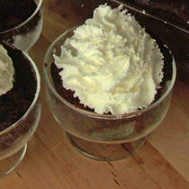Yields: 12 servings

½ cup (one stick) butter at room temperature
2 eggs
1 cup molasses
2 cups (about 1 pound) dried, finely chopped figs
½ teaspoon grated lemon peel
1 cup buttermilk
½ cup chopped walnuts or macadamia nuts
2 ½ cups all purpose flour
½ teaspoon baking soda
2 teaspoons baking powder
1 teaspoon salt
½ teaspoon ground cinnamon
¼ teaspoon ground nutmeg
Whipped cream for garnish

In an electric mixer, cream the butter until fluffy. Add the eggs and the molasses, and beat again. Add the figs, lemon peel, buttermilk and nuts. Blend for 1 minute. Add the flour, baking soda, powder, salt, cinnamon, and nutmeg, and blend well.
Grease and flour an 8x4 inch soufflé dish and pour in the batter. Bake at 325 degree F. oven for 1 hour, or until a toothpick inserted in the center comes out clean. Serve with whipped cream as a garnish.
(From the Frugal Gourmet Celebrates Christmas, by Jeff Smith)

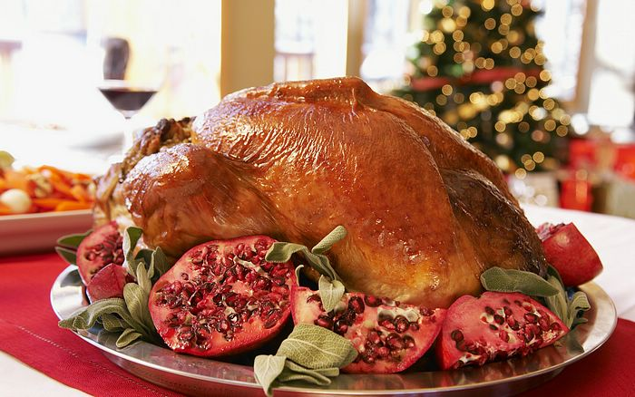 | November Tasting Table  Thank you to the following folks for their tasty offerings and to all those who did not sign the sheet. Members who donate food may now receive a ticket for the raffle. | 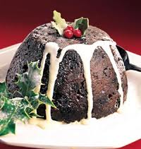

Name | Item | Name | Item
Scott | Pineapple | Vega | 5 layer dip
Lee | Jackfruit, custard buns | Johnston | Cherry cobbler
Kirby | Codfish spinach salad | Whitfield | Salad
Sawada | Vege gratin | Shigemura | Cheesecake w/blueberries & kiwi
Orr | Bread | Latimer | Brownies & cookies
Reddcliffe | Ambrosia salad | Sweet | Pecan pie
Kathryn  Tammy | Lemon pie | Branesky | Papaya salad
Novak | Apple cake, pasta/ham salad, juices | Campani | Pumpkin bread
Conradt | Papaya | Ferreira | Sweet potato casserole
Lavalette | Fruit cake | Schavey | Waldorf
Clarke | Baked chicken, potato stuffing | Black | Curry couscous
Smith | Papaya | Mcaveety | Banana bread
Crossman | Chips, pretzels, juices

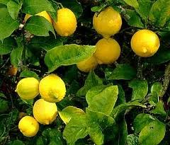 | November Plant Exchange  Members who donate plant(s) may now receive a raffle ticket. Please remember to sign the sheet when picking up your plants. | 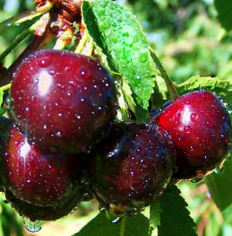

Plant | Donor | Winner
Red sugar apple | Bob Heath
Surinam cherry | Bob Heath | Latimer
Chaya spinach | Bob Heath
Chaya spinach | Bob Heath
Kei apple | Novak | Greig
Kei apple | Novak | Lohn
Guava | Novak | Reddcliffe
Dragonfruit cutting | Brandt
Passionfruit | Vega | Haack
Oregano | Musgrave | Tom M.
Plumeria | Musgrave | Porter
Oregano | Musgrave | Mccullough
Oregano | Musgrave | Ferriera
Longan | Musgrave
Kei apple | Payne | Payne
Canna bulbs | Orr
Cherry | Orr | Oliver
Christmas ornamental | Orr
Moringa 2 | Scott
Papaya | Sweet | Haack
Cherry tomatoes | Lohn
8 yellow passionfruit | Clarke
Hot pepper planter | Clarke
Aloe vera | Lavallelle
White sapote 2 | Smith
Brogdon avocado 2 | Smith
Cranberry hibiscus | Vidoric
Chaya | Vidoric
Florida lettuce | Vidoric
Bromeliads | Aguire

________________________________________________________________________________
Local Events of Interest

December 8th – 11am – 7pm Sugar Cane Harvest, cane grinding syrup making, BBQ, and more. FREE.
Crowley museum & Nature Center 16405 Myakka Rd. Sarasota. 941-322-1000. http://crowleyfl.org

January 26th – Kumquat Festival. Plant sale, arts, crafts, FREE. Dade City. www.dadecitychamber.org

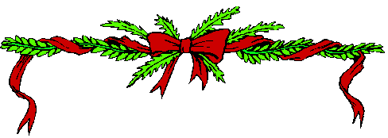
____________________________________________________________________________________________

Notes

This is to all the members that went on the bus trip especially Bus number one. Some members that bought plants at Excalibur exited the bus in Tampa. Someone picked up a plant that belonged to another member. If you have a plant that belongs to another please bring it to the Meeting DEC. 9, 2012. It was dark, and everyone was in a hurry to get their plants. Again if you have a plant that has someone else’s name on it, bring it to the meeting.
Thanks RFCI President Paul Branesky

Need a gift for someone special: How about the Tampa Bay RFCI cookbook?
Cost to members: $7.00 each

For contributions to the newsletter, notes on what you are growing, successes, failures, pictures, etc. we would love to hear what’s going on with fruit growers all through the Tampa Bay area, send to bdprovencher@tampabay.rr.com


______________________________________________________________________________



