Upcoming Programs and Events

January 13, 2013: Pomegranates. Cindy Weinstein, President of the Florida Pomegranate Association and a pomegranate grower.

RFCI Horticulture Display at the 2013 Florida State Fair: February 7-18.
February 10: Citrus Celebration at the Florida State Fair.

Calling all Volunteers: We need your help during the month of February. February is a big month for our club and for the Tampa Bay area because we welcome the Florida State Fair.
RFCI Florida State Fair Exhibit:
We need volunteers to man this year’s display at the Florida State Fair, February 7-18. In return, you will receive admission tickets to the Fair. We will have a volunteer signup sheet at the January 13th meeting.

Citrus Celebration at the Florida State Fair
On Sunday, February 10th, we will be hosting the 12th Citrus Celebration at the Florida State Fair. This event has been very popular with the public because it gives them the opportunity to sample many varieties of citrus. Please plan to help. A signup sheet will be available at the January meeting.
This year, it is critical for members to donate citrus fruit (as many varieties as possible). Our main sources for fruit in the past are no longer available. If you have citrus to donate (or know of someone who will donate fruit), please contact Paul Branesky (727)341-2605, Sally & Jimmy Lee (813)982-9359, or any Board member.
We also need volunteers to help prepare the fruit for sampling. A signup sheet will be available at the January 13th meeting, or you may contact one of the members listed in the above paragraph. Volunteers will receive admission tickets to the Fair. Look for more information in the February newsletter.


____________________________________________________________________________________

New Members

Betti Mu Lutz Du Nguyen Gibsonton

_____________________________________________________________________________________
What’s Happening

by Paul Zmoda

Happy New Year to all readers!

Weather forecasts say the expected winter El Nino phenomenon will be weakened substantially, giving us average to slightly below average temperatures with average rainfall. We’ll see!
I’ve covered my mini greenhouse before December with its annual wrap of polyethylene sheeting. Adding a heat source inside on extra cold nights should keep the in-ground mango and red mombin trees protected. I always place potted plants inside with them for extra protection, and why not? It stays nice and toasty in there during the days.
Our only surviving, large, white sapote tree (casimeroa edulis), courtesy of members Tony and Connie Ferreira, began blooming by Thanksgiving, and by mid-December is setting a large amount of fruits. If all goes well, we could be eating a most delicious fruit this spring. 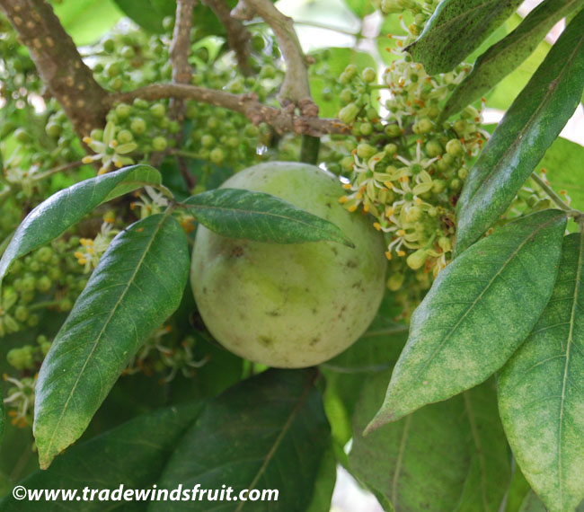Up to softball size, heavy and precious, the fruits taste like lemon custard, and have a similar color and texture. This tree is in the Rutaceae family, same as citrus. They are so closely related that the giant swallowtail butterfly will choose tender leaves of white sapotes for its larval food plant, just as they do for many citrus trees. This particular caterpillar is nicknamed “the orange dog”. Its protective coloration mimics a bird dropping, some brown, some white. What predator would want to eat that?
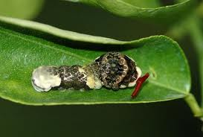

New plantings: radishes, peas, cilantro, onions, broccoli, herbs.

____________________________________________________________________________________

______________________________________________________________________________

Pictures from the December Social

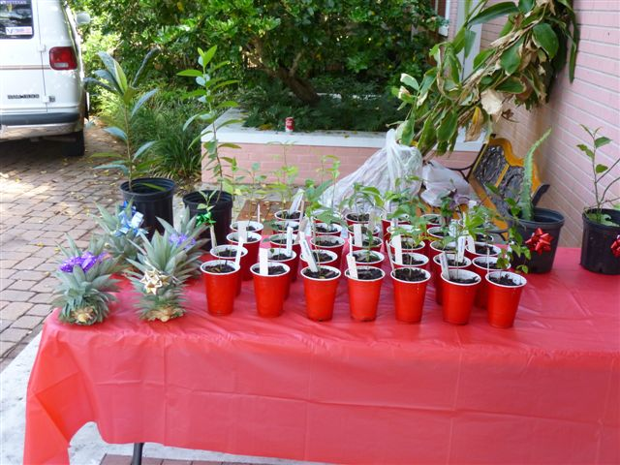




Bitter Melon
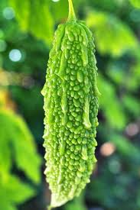 Momordica charantia or bitter melon, bitter gourd or bitter squash in English, is a tropical and subtropical vine of the family Curcurbitacae, widely grown in Asia, Africa, and the Caribbean for its edible fruit, which is among the most bitter of all fruits. Its many varieties differ substantially in the shape and in the bitterness of the fruit. Bitter melon originated in India, and it was carried to China in the 14th century. The fruit has a distinct warty exterior and an oblong shape. It is hollow in cross-section, with a relatively thin layer of flesh surrounding a central seed cavity filled with large, flat seeds and pith. The fruit is most often eaten cooked when it is still green, or as it is beginning to turn yellow. At this stage, the fruit's flesh is crunchy and watery in texture, similar to cuke, chayote, or green bell pepper, but bitter. The skin is tender and edible. Seeds and pith appear white in unripe fruits; they are not intensely bitter and can be removed before cooking. The young shoots and leaves of the bitter melon may also be eaten as greens. As the fruit ripens, the flesh (rind) becomes tougher, more bitter, and too distasteful to eat. On the other hand, the pith becomes sweet and intensely red and can be eaten uncooked in this state. It’s a popular ingredient in some Southeast Asian salads. When the fruit is fully ripe, it turns orange and mushy, and splits into segments which curl back dramatically to expose seeds covered in bright red pulp.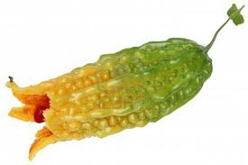 Bitter melon is very popular throughout South Asia. It is often used in Chinese cooking for its bitter flavor, typically in stir fry (often with pork), in soups, and also in tisanes. It has also been used in place of hops as the bittering ingredient in some Chinese and Okinawan beers. In Northern India, it is often prepared with potatoes and served with yogurt on the side to offset the bitterness. In North Indian cuisine, it is stuffed with spices and then cooked in oil. In Southern India, it is mixed with grated coconut, and considered a medicinal food for diabetics. Other popular recipes include preparations with curry, deep fried with peanuts or other ground nuts, or used in a soup with fried onions and other spices. In the Konkan region of Maharashtra, salt is added to finely chopped bitter gourd and then it is squeezed, removing its bitter juice to some extent. After frying this with different spices, the less bitter and crispy preparation is served with grated coconut. In Pakistan and Bangladesh, bitter melon is often cooked with onions, red chili powder, turmeric powder, salt, coriander powder, and a pinch of cumin seeds. Another dish in Pakistan calls for whole, unpeeled bitter melon to be boiled and then stuffed with cooked ground beef. Bitter melon is a significant ingredient in Okinawan cuisine, and is increasingly used in mainland Japan. It is popularly credited with Okinawan life expectancies being higher than the already long Japanese ones. In Indonesia, bitter melon is prepared in various dishes, stir fried, cooked in coconut milk, or steamed. In Vietnam, raw bitter melon slices consumed with dried meat floss and bitter melon soup with shrimp are popular dishes. Bitter melons stuffed with ground pork are served as a popular summer soup in the south. It is also used as the main ingredient of "stewed bitter melon". This dish is usually cooked for the Tet holiday, where its "bitter" name is taken as a reminder of the poor living conditions experienced in the past. In the Philippines, bitter melon may be stir-fried with ground beef and oyster sauce or with eggs and diced tomato. The dish pinakbet, popular in the Ilocos region of Luzon, consists mainly of bitter melons, eggplant, okra, string beans, tomatoes, lima beans, and other various regional vegetables altogether stewed with a little bagoong-based stock. In Nepal, bitter melon is prepared as a fresh pickle called achar. For this, the bitter gourd is cut into cubes or slices and sautéed covered in oil and a sprinkle of water. When it is softened and reduced, it is minced in a mortar with a few cloves of garlic, salt and a red or green pepper. It is also sautéed to golden-brown, stuffed, or as a curry on its own or with potatoes. In Trinidad and Tobago, bitter melons are usually sautéed with onion, garlic and scotch bonnet pepper until almost crisp.
Chichi Wang, contributor to Serious Eats, an online epicurean website, writes the following:
“Bitter melon would be at the top of my list of underappreciated vegetables that take some getting used to. Though most of the squash or melon we eat possesses a light and sweet flavor, there is nothing mild about bitter melon. True to its name, the squash is unabashedly bitter, with an acerbic taste that leaves your tongue and the roof of your mouth dry. The exterior of the melon is riddled with wart-like bumps; the interior resembles any other melon with a cluster of foamy seeds in the center. The cooked texture of bitter melon, like that of zucchini, is palatable, albeit uneventful. Why, then, eat such an offensively flavored melon? Precisely because its bitterness, at times almost unbearable, is unique and memorable. Cuisines in so many cultures find ways to counter the bitterness of the fruit with spicy, sweet, or savory components. ”
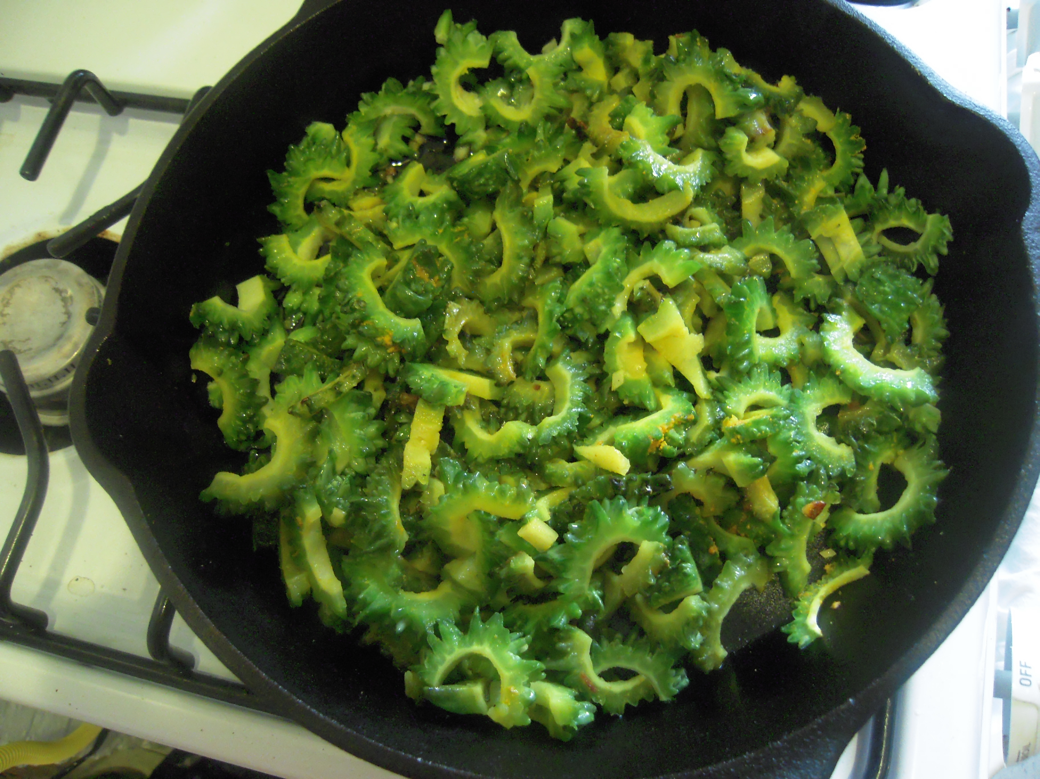

To select bitter melons that are on the mild side of bitter, look for whiter or more yellowed exteriors that contain deep red seeds inside. The more immature the squash, the greener and more bitter it will be. Though you can stir-fry almost anything spicy, savory, and sweet with the squash, pair the vegetables with at least one savory component, such as fermented black beans or belacan (fermented shrimp paste), as well as something spicy, such as bird's eye chilies or jalapenos. Adding a few teaspoons of sugar to the stir-fry helps tame the bitterness of the squash. Bitter melon has a powerful reputation as a medicinal plant as well, especially for diabetic applications. It contains a chemical that has an insulin affect and helps with blood sugar. People with certain liver, kidney, skin diseases, and even HIV/AIDS may benefit from its use. On a hot summer's day, Chinese cooks will allude to the "cooling" quality of the squash. Medicinal properties aside, stir-fried melon is a refreshing dish that's worth looking into, even if it takes an acquired palate to appreciate. Bitter melon comes in a variety of shapes and sizes. Pictured below are some of the many varieties.

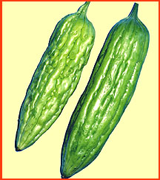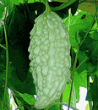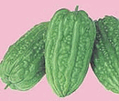

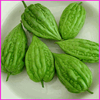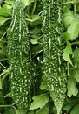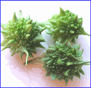

For more information on this unusual fruit check out the following resources:

www.seriouseats.com
Recipes, cooking tips.

www.bittermelon.org
National Bitter Melon Council. Become a member to get all kinds of information on bitter melons.

www.thaitable.com
Recipes, cooking tips.

www.evergreenseeds.com
Seeds of many varieties of bitter melon, from all over the globe.

www.kitazowaseed.com
Seeds of many varieties of bitter melon, other Asian vegetables.

 | December Plant Exchange  Members who donate plant(s) may now receive a raffle ticket. Please remember to sign the sheet when picking up your plants.

Plant | Donor | Winner
8 White sapote | Novak
9 Surinam cherry | Novak
12 yellow passion fruit | Novak
Purple elephant ear | Novak
Red Papaya | Ferreira
Cuban mangostein | Shobert
Black Avocado | Andrews
Oregano | Weekley
Chili | Weekley
8 Heliconia | Barth

Local Events of Interest

January 26th – 9 am – 5 pm Kumquat Festival. Free. Devoted to all things Kumquat. Sample pies, cookies, ice cream. Entertainment. Downtown Dade City, Route 301. www.dadecitychamber.org

January 9 – 10 am. Free. Growing Fingerling Limes, Ruth Nowland of Harris Citrus Nursery talks on growing these tiny Australian fruits that have burst into the garden and food scene. Riverview Civic Center, 11020 Park Drive, Riverview, 813-727-6567.

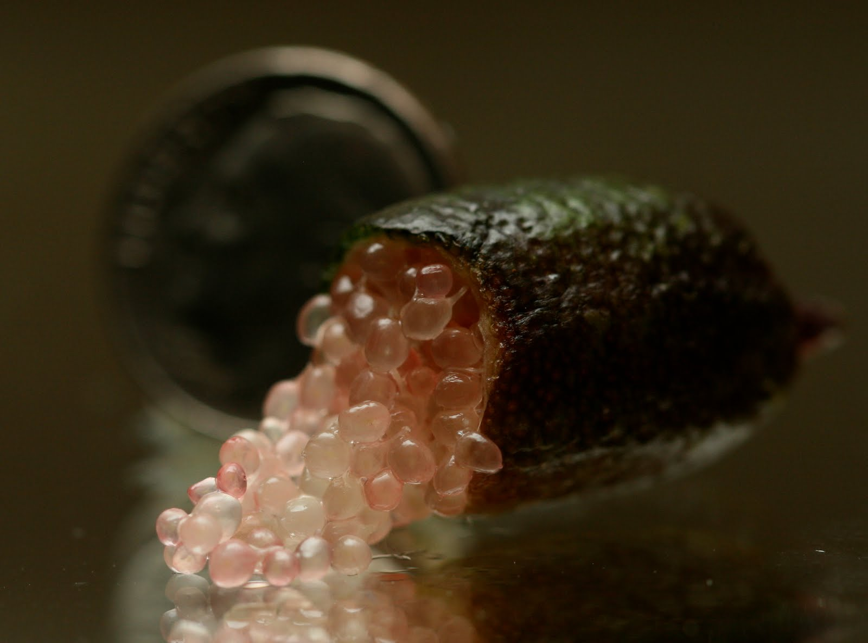
Fingerling Lime

January 23rd – 2 pm. Free. Dr. Hort, noted columnist speaks on selecting, fertilizing, and caring for citrus trees. Call, or go online to register. Garden Club of St. Petersburg, 500 Sunset Drive S, St. Petersburg. 727-582-2603 www.pinellas.ifas.ufl.edu

____________________________________________________________________________________________

Notes

For contributions to the newsletter, notes on what you are growing, successes, failures, pictures, etc. we would love to hear what’s going on with fruit growers all through the Tampa Bay area, send to bdprovencher@tampabay.rr.com


______________________________________________________________________________



