Upcoming Programs and Events

Note: No February meeting at the Tampa Garden Club

February 7-18: RFCI Horticultural display at the Florida State Fair. Thanks to members who have volunteered to spend time at the exhibit talking with the public about the Rare Fruit Council and the
fruits grown by members.

February 10: Citrus Tasting Event at the Florida State Fair
Sunday, February 10, 2013, from 8:00 A.M. to 4:00 P.M.
The date of the annual Citrus Celebration event is fast approaching! If you have citrus fruit to donate or know someone who will donate fruit, please contact Jimmy and Sally Lee (813) 982-9359 or (813)335-1865, or Paul Branesky (727)515-6073. We need as many varieties of citrus as possible for the public to sample. 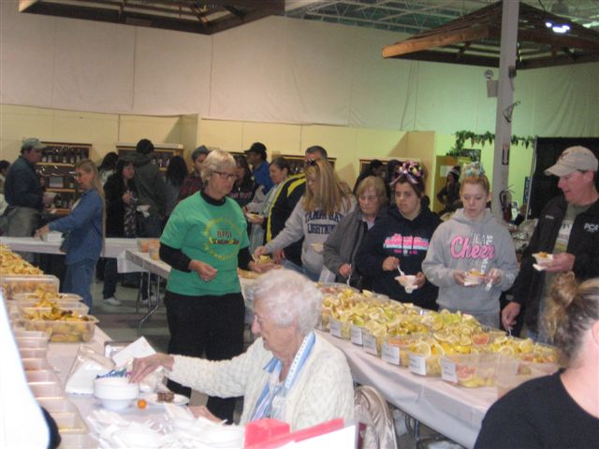We can also use rare and tropical fruits for sampling and for display. The fruit will need to be picked and labeled by variety. If you live in Pinellas County and would like to drop the fruit off at Paul Branesky’s home please contact him for information and directions. In the Seffner area contact Bill Vega (813) 300-7597. In the Thonotosassa area contact Jimmy and Sally Lee.

Last year’s citrus table

Citrus Celebration – Calling all volunteers
Thanks to all of you who have signed up to help with this event. Please plan to arrive at the Florida Center Building between 8:00 A.M. and 8:30 A.M. on Sunday, February 10th. We will be very busy cutting up the fruit as we begin offering samples to the public at 10:00 A.M. If you have questions or need information, please contact Sally Lee or Paul Branesky (see above paragraph for phone numbers).

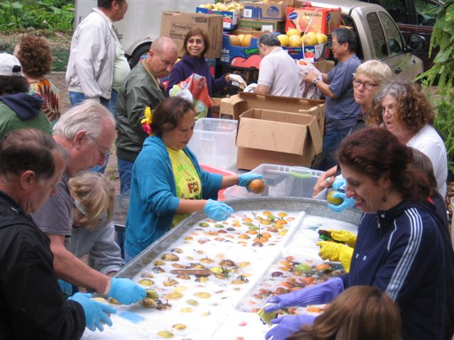 Last year’s fruit washing at Jerry Amyot’s home.

Fruit Washing Party – Saturday, February 9, 2013, 9:00 A.M.
Members who signed up to help wash the citrus fruit on Saturday morning, February 9, please plan to arrive at Jerry Amyot’s home (3410 Blueberry Hill Dr., Plant City) at 9 A.M. Please bring a side dish, salad or dessert.

Directions to Jerry’s home
From I-4 take Exit 22 (Park Road)

Turn south onto Park Road and continue south about 5 miles.
Note: Just past the Plant City Stadium, Park Rd. turns west. Don’t turn-
continue south on Jim Johnson Rd. You will pass the Sweetbay Warehouse.

Turn right on Jap Tucker Road. (just past the curve)
Note: Before getting to Trapnell Rd. you will cross Sparkman Rd.

Turn left ontoTrapnell Road E. Go about 0.8 miles.

Turn left onto Blueberry Hill Drive and follow the road to Jerry’s house.

In case you get lost, here’s Jerry’s number: (813)716-1068, or call Sally (813)335-1865.
_____________________________________________________________________________

Important Notes

Tampa Bay RFCI Board of Directors Election
The list of candidates will be published in the March newsletter. The Board of Directors will be elected by a majority vote of the membership present and voting at the March 10 meeting.

Membership dues: Beginning April 1 membership dues for new memberships and renewals will increase to $20 a year, single or family membership.
_____________________________________________________________________________

New Members

Rabbi Haim & Rubisa Rachelle Levi Lutz

Frank Tintera Tampa Welcome back

_____________________________________________________________________________________
_____________________________________________________________________________________

What’s Happening

by Paul Zmoda

Recently I have begun a new chapter in my life by quitting my “day” job. As a professional micro-biologist for over 30 years, I felt it was time to move on to success on my own terms. In the laboratory, I have personally analyzed over 1.5 million bacterial cultures, isolating the pathogens in patients’ specimens, testing them against batteries of antibiotics to determine how to effectively treat infections. This is a very gratifying field in which I gave a large portion of my life. It always made me feel good knowing I could make a difference in peoples’ lives.
Now I can concentrate on my horticultural endeavors without the pesky obligations of a regular job getting in the way!

New plantings: Grapevines, and more vegetables, and nine White Sapote grafts in three different cultivars.



_____________________________________________________________________________________

Pomegranates – The Perfect Dooryard Tree
Cindy Weinstein

January’s meeting provided an enlightening discussion on Pomegranates by Cindy Weinstein, grower of pomegranates, and president of the Florida Pomegranate Association.

Pomegranates are the perfect dooryard tree, and have a long history in human culture around the world. It is believed the Biblical “desert apple” fruit that Eve ate that fateful day in history, was actually a pomegranate, as no apples as we know them today existed then. Pomegranates have long been a symbol of fertility, wealth, and prosperity, and are associated with many myths and traditions in various cultures. The Arabian Peninsula is where pomegranates were first discovered. From this desert region, pomegranates have been introduced throughout the world.
There are thousands of pomegranate varieties, and more than 500 cultivars, with about 110 varieties being grown in Florida. They come in colors ranging from white/clear, pink, red, purple, and black. Flavor can be sweet to tart, neutral to acid, and seeds can soft or as hard as stone. The scientific name for pomegranate is Punica granatum, of the Punicaceae family.
Pomegranates are very hardy, able to handle temperatures down to 14 degrees. They can take heat, cold, and wind, but not standing water, not even a high water table. If the water table is high enough to reach the plant’s roots, there can be problems. The plant must go dormant in winter in order to produce. The heaviest bloom period occurs in the spring, after the plant breaks dormancy, which in Florida, is in the months of March and April.
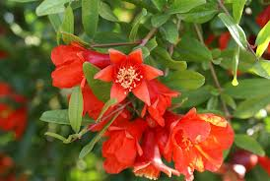 Spring is a good time to plant them. Plant in full sun. Use plenty of compost to prevent nematode damage, and water regularly until established. They will grow in a variety of soils, as long as they have good drainage. Raised beds will work well. Pomegranates grow fast, setting flowers and fruit as young as two years of age. In just three or four, the tree will be good sized and begin serious production. Fruit is set on two year old wood. Plants are hermaphrodite, having both male and female flowers.
Dormancy is the best time to prune. During the first two years, keep the plant trimmed well to form a sturdy structure. Fruits are heavy and need strong branches to hold them. Keep the main branching structure to 7-9 main branches.
There are some diseases of pomegranates to watch for. Cercospora, a leaf fungus, can defoliate the tree, causing black spots on the leaves. Spray copper fungicide in the spring.
Botryosphaeria, another fungus, attacks the fruit, working from the inside to the outside of the fruit, destroying it.
Root rot, Fusarium, can kill the plant, keeping the roots drier will help to prevent this fatal disease. Alternaria, a bacteria on the fruit, causes damage both inside and outside of the fruit. Humidity can worsen this problem.

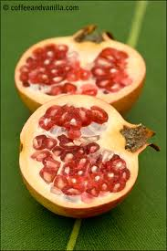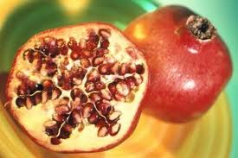

Pomegranate information:

Florida Pomegranate Association, membership, information on becoming a grower.
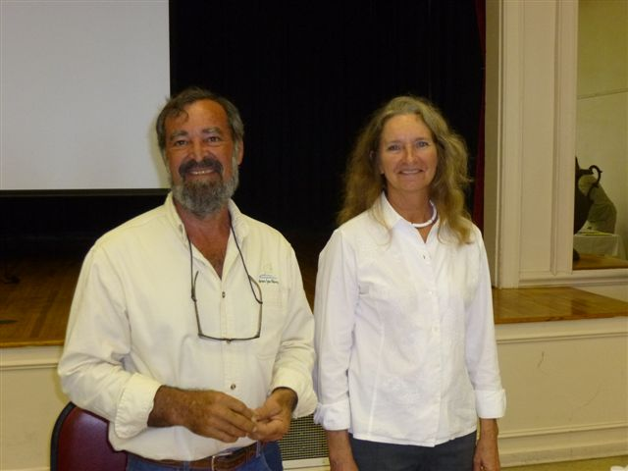
Cindy and David Weinstein of Green Sea Farms
And the
Florida Pomegranate Association
6360 Johnston Road, Zolfo Spring, Fl 33890
greenseafarms@yahoo.com

flpomegranate@gmail.com
863-604-3778

Loads of information on pomegranates, video clips, meeting information, data on the Pomegranates for Now project in Florida.
http://www.crec.ifas.ufl.edu/extension/pomegranates/

Article on pomegranates becoming a new crop in Florida from University of Florida Gainesville. http://news.ufl.edu/2011/06/01/pomegranate/
University of Florida article on Pomegranates. http://edis.ifas.ufl.edu/mg056
See the January 2012 RFCI Newsletter for an article on How to eat a Pomegranate.

Diagram of Pomegranate Fruit

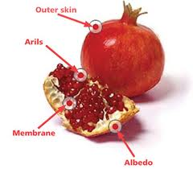

_____________________________________________________________________________________
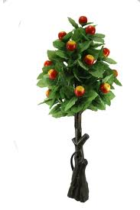 | January Plant Exchange  Members who donate plant(s) may now receive a raffle ticket. Please remember to sign the sheet when picking up your plants.

Plant | Donor | Winner
Chaya spinach | Heath | Johnson
Papaya | Vega | Whitfield
Papaya | Vega | Andrews
Cilantro | Novak
Bell pepper | Branesky
Yellow passion fruit | Novak | Baker
Java plum | Andrews
Surinam cherry | Novak | Ed ?
Suriname cherry | Novak | Greig
Kei apple | Novak | Otto
Dragon fruit | Gerstein | Bigelow
Calamondine | Saceda-Bigelow | Male
Puchu | Saceda-Bigelow | Orr
Kumquat | Saceda-Bigelow
Podocarpus | Saceda-Bigelow
Surinam cherry | Brandt
Sugar cane | Brandt | Niklas
Yucca stems | Zmoda
Cranberry hibiscus | McClelland
Papaya | Sweet
Cardamom | Black | Durivou
Fig | Payne | Summer
Water cress | Davies | Whitfield
Loquat | Orr
Carambola | Mathews
Salvia | Allen
Garlic chives | Allen
Sugar palm | Provencher | Niklas
Cuban mangostein | Provencher | Niklas
Cuban mangostein | Provencher | Durivou
Cuban mangostein | Provencher | Oliver
Santol | Provencher | Shorbert
Santol | Provencher | Krotz
Organic rabbit poo | Grossman

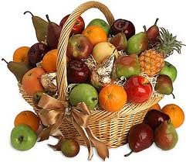 | January Tasting Table  Thank you to the following folks for their tasty offerings and to all those who did not sign the sheet. Members who donate food may now receive a ticket for the raffle.

Name | Item | Name | Item
Baker | Lemon/pomegranate cake | Vega | Chicken fricassee
Scott | Fresh pineapple | Golden | Tomato and cuke salad
Branesky | Sweet potato salad | Branesky | Sweet potato pie
Branesky | Orange juice | Lohn | Cookies
Gerstein | Olives | Bigelow | Spinach quiche
Otto | Mocha cake | Clarke | Bakes chicken, turkey quiche, zucchini bread, trifle cake
Latimer | Cookies | Newcombe | Carambola chocolate
Grossman | Steamed organic cabbage | Phillips | Pasta salad w/tomatoes, cuke
Novak | Fresh fruit platter, pineapple upside cake, fruit juices | Kirby | Stew okra
Davies | Meatballs and penne | Orr | Salad, cake, bread
Payne | Jello salad | Schavey | Pecan snack mix, orange cranberry bread
Dickey | Raspberry bars | Whitfield | Salad
Rooks | Cookies | Hartzler | Deviled eggs
Zmoda | Gac fruit | Kischuk | Papaya

Local Events
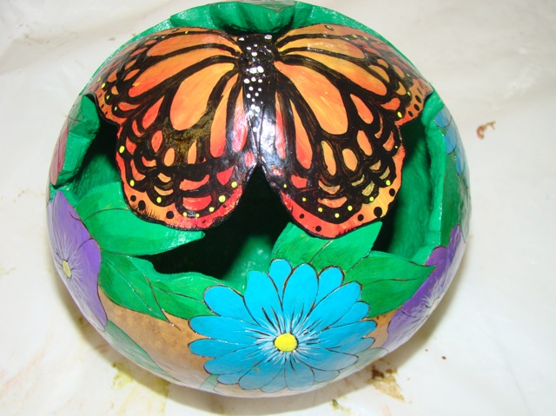
Interested in Gourds? Feb. 22 – 24, 9-6 Fri. & Sat., 9-4 Sun. Florida Gourd Society holds its Show. Gourd art, crafts, demos, auctions. Azan Shrine Center, 1591 W. Eau Gallie Blvd, Melbourne www.flgourdsoc.org ____________________________________________________________________________________________
______________________________________________________________________________________________

Notes

If you would like to contribute to the newsletter, send your pictures or writings to bdprovencher@tampabay.rr.com
It’s always interesting and helpful for other gardening members to what people are growing, where they can a good deal on something, or even to share a funny picture. We’d love to hear from you.

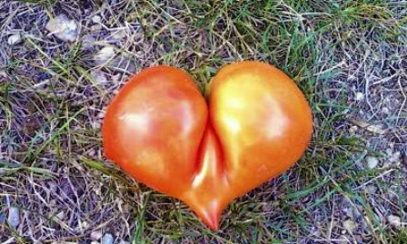

Happy Valentine’s Day!

______________________________________________________________________________



