Upcoming Programs and Events

April 13-14: USF Botanical Garden Spring Plant Festival, April 13 - 14.

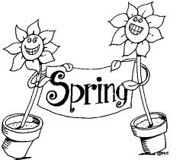We will need club members to help with this event. It is an important fundraiser for the club. Members are invited to attend, help with set up on Friday, to assist in the sale on Saturday and Sunday, to donate or sell fruiting plants, to enjoy the camaraderie and to visit other exhibits.

If you plan to sell plants, please note that members cannot sell citrus, non-fruiting plants or herbs. Members selling plants must submit a manifest listing their plants and prices. Manifests will be available at the March 10 meeting. Plants must have a label with the name of the plant, the price and the seller’s initials.

There will be more information at the March meeting and in the April newsletter.
If you have questions: Jimmy & Sally Lee (813) 982-9359.
USF Botanical Garden website: http://gardens.usf.edu/

____________________________________________________________________________
New Members

________________________________________________________________________________________________________________________

____________________________________________________________________________________
What’s Happening

by Paul Zmoda

Tools

Your horticultural tools are important for getting the job done correctly, easily, and precisely. As a tool-using primate, I have a collection of tools which I appreciate and use often. I take good care of them so they will last as long as possible.

Planting tools
I found a TrueTemper, straight handled spade, invaluable for digging holes. If the cutting edge is kept sharpened, it will cut through sod, as well as impeding roots, with ease. For smaller jobs, a small, pointed mason’s trowel – kept razor sharp – is great for lifting seedling vegetables, and preparing their ultimate growing sites. It is ideal for cutting weeds below ground level.

Pruning tools
I cannot do without a few pairs of quality anvil hand pruning shears. I get mine of A.M. Leonard Co. A belt holster is useful for carrying them around. The oldest set is used for cutting roots so the newest sets can remain undamaged by sand. A strong set of branch loppers will handle larger diameter branches. You can find a nice set at Sears for about thirteen dollars. Hand saws are needed for even larger branches. I use a tri-edge curved blade piece. For banana growers, I have found TrueTemper’s two sided hand saw invaluable. One side has course teeth for quickly cutting down large, spent plants. The other side has fine teeth, which make removing fruiting branches a breeze.

Grafting tools

I can’t do without ‘em. I use an Italian made folding knife which is ideal for slicing off buds when bud grafting. It also prepares cleft and whip grafts. I use a small, folding jack knife for lifting bark flaps as well as girdling when air layering. Another hand pruner is used for all related work.

Other tools
I like a long, serrated bread knife to slice pot-bound roots before planting. I have a few sets of Joyce Chen kitchen scissors. These have short blades, and are very sturdy. They are useful for harvesting and manicuring all sorts of flowers, fruits and vegetables, as well as delicate root pruning such as when repotting bonsai specimens. When it comes to hand pollinating, nothing beats a small, soft artist’s brush for transferring pollen. You’d be surprised how fruit set is improved.

New plantings: Italian drying tomatoes, napa cabbage, cucumbers,

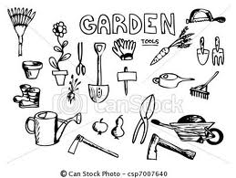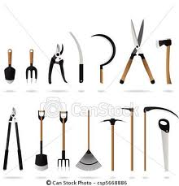

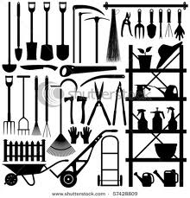

_____________________________________________________________________________________________

______________________________________________________________________________

_________________________________________________________________________________________________

________________________________________________________________________________________
Local Events of Interest

_______________________________________________________________________________________________

Notes

Looking for seeds, plants, or supplies, or want to share the same with other members? Got pictures, stories, or information you would like to share about your fruit growing experience? Send input to bdprovencher@tampabay.rr.com



