Upcoming Programs and Events

May 12: Gene Joyner of Unbelievable Acres Botanic Garden, West Palm Beach. Topic: Insects, Diseases and Environmental Problems of Florida Tropical Fruits.

June 9: Member Fran Grossman. Topic: Organic Gardening

Brevard Rare Fruit Club Invitation: Members have been invited to attend the Brevard Tropical Fruit Club’s Picnic on Saturday, July 27, 2013. The picnic will be held in an “air conditioned room” at the Kiwanis Island Park Community Center – 951 Kiwanis Island Park Road, Merritt Island, FL.
This multi-club picnic (Brevard Tropical Fruit Club, Tampa Bay Rare Fruit Council, Manatee Rare Fruit Council and the Tropical Club of Central Florida) will be held from 10am to 2pm. Hamburgers, hotdogs and drinks will be provided. Please bring your favorite side dishes, salads, casseroles or desserts.
There will be tours available in the morning and afternoon, but not between 11:30am and 2pm.
These locations are only 5 minutes apart and 20 minutes from the pavilion.

- Toppy Feil’s (18 acres) 550 W. Hall Rd., Merritt Island, FL. (2 hour tour).
- Jerry Hunt’s (6 acres) 125 W. Crisafulli Rd., Merritt Island, FL. (1 hour tour)
- Shaye and Celia Williams (2 1/2 acres) 5900 N. Tropical Trail, Merritt Island, FL. (1 hour tour)
This event is free, and drive yourself. Merritt Island is on the east coast, about 2 – 2 ½ hours from the Tampa area.
Please let Sally Lee know before May 27 if you will be attending this joint club picnic. Also, advise Sally which yard tours you are interested in so arrangements can be made to schedule the tours.
Phone: (813) 982-9359 e-mail: yukyee@aol.com
____________________________________________________________________________________

New Members

Esperanza Peer Tampa Stephanie Dauber Tampa
Cindy Ryan Plant City Keith & Denise Williams Plant City

_____________________________________________________________________________________
What’s Happening

by Paul Zmoda

By now we can relax and enjoy our gardens now that frosts are no longer a threat. Although there is still weeding, mulching, watering, trimming, etc. to be done, please find time to sit outside and watch things grow. I prefer sunset to enjoy the scenes, although I hear dawn is nice also.
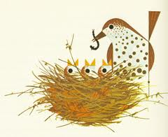
Your birdhouses should be occupied by now with our melodious insect-eaters. When their young are growing, expect to see a great interest in devouring plant-eating pests. A bird-bath will help attract birds of all sorts and will usually hold their attention long enough for you to identify them with help from a bird guide book. I have several. Identifying birds by just their songs takes practice, but is quite rewarding.
I grafted a nice Chinese persimmon and an avocado. After obtaining a truckload of potting soil, I potted up over one hundred seedlings, mostly tea trees, olives, carambolas, loquats, and elderberries.
I made my first ever batch of sauerkraut from our beautiful, sweet cabbages. It turned out nicely.
April 6th was the annual homemade wine competition at Ybor City’s Festa Italiana. I was pleased to earn a second spot for my IL primo semi sweet white wine. We had a great time there.

New plantings: yuzu citrus, papaya, chayote squash, mango, hot peppers, and a grafted white sapote.

____________________________________________________________________________________

Pictures from the USF Plant Sale

April USF Botanical Garden Plant Festival: “Thank You” to everyone who helped with the Plant Sale. We served over 900 cups of juice to the public! The weather was fabulous, and as you can see in the picture below, the crowd was huge! The display table was absolutely beautiful! See the pictures on the following pages.

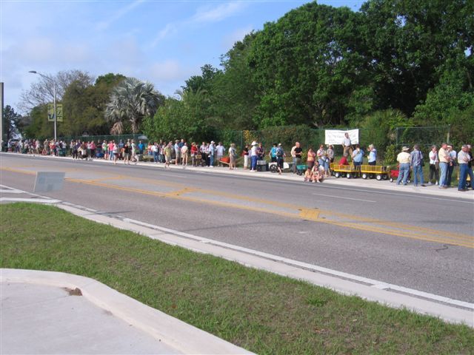
Loooong admission lines to USF Plant Festival

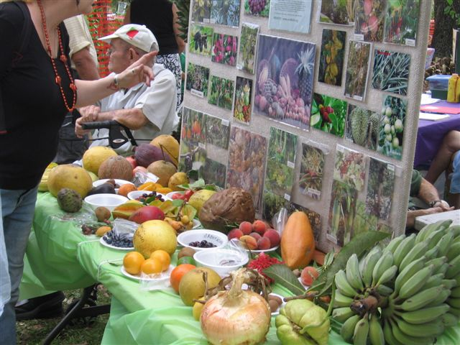

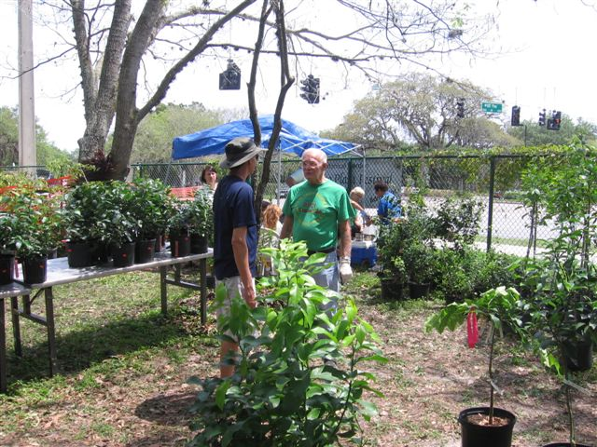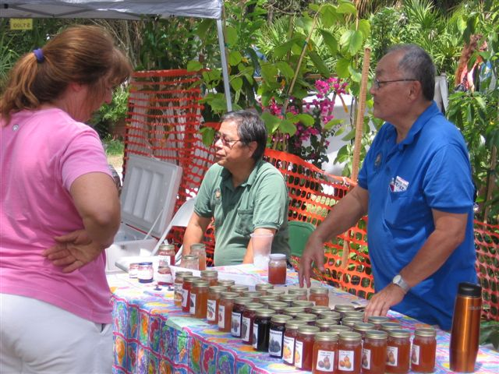

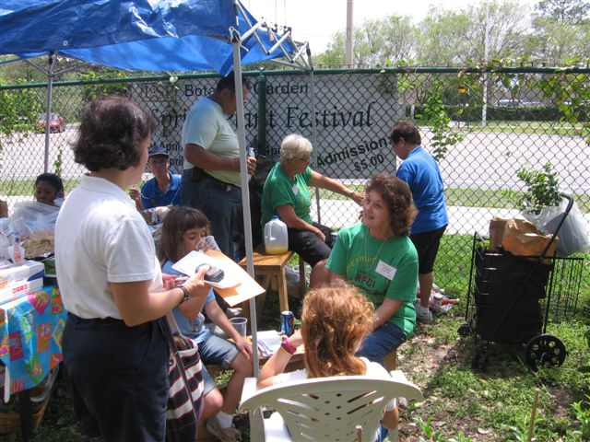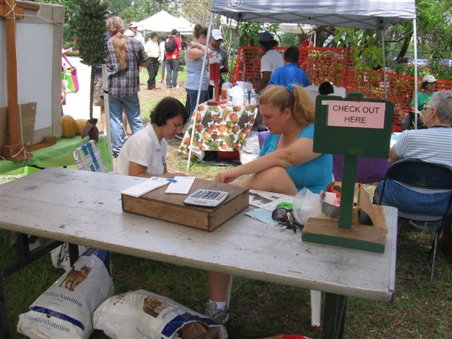

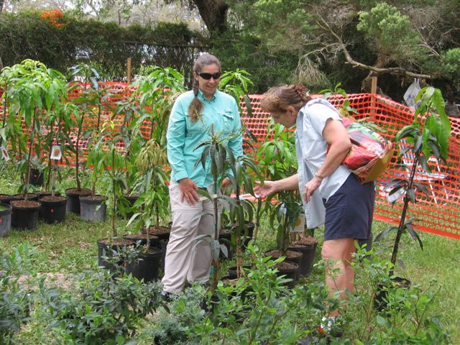

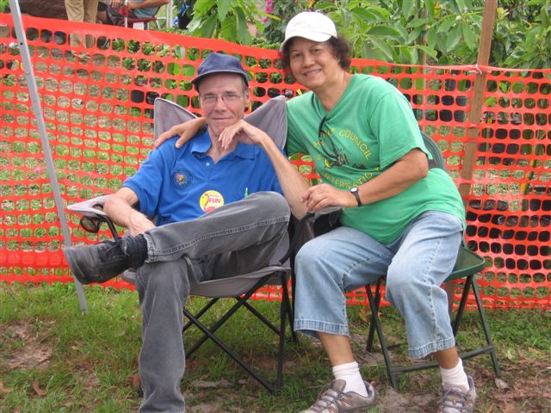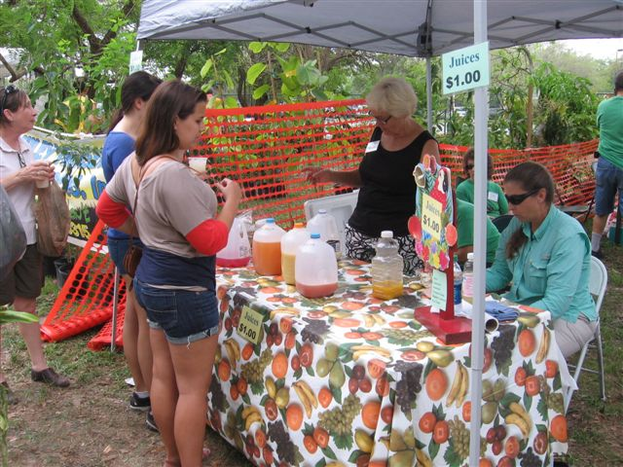

______________________________________________________
Medically Safer Grapefruit


Grapefruit lovers can soon rejoice. University of Florida’s researcher and breeder Fred Gmitter, says that a new hybrid of grapefruit should be in large-scale production 5 – 7 years from now. This new variety will have very low levels of the organic chemical compounds that cause the “grapefruit juice effect”, where eating the fruit can have adverse reactions with certain drugs. There are more than 85 drugs that can interact with regular grapefruit, 43 of those having serious side effects, and the number is growing. Certain cholesterol-lowering statins, cancer drugs, heart medications, and even antibiotic medicines are among the drugs that can react with grapefruit. Furanocoumarins are the chemicals in the grapefruit responsible for this problem. The new grapefruit hybrid, known for now as UF914, has levels of these compounds at only a fraction of those found in regular grapefruit. This variety is a cross between the pommel and red grapefruit. It’s also seedless, larger, juicier, sweeter, and less bitter than other grapefruits, which is also winning over grapefruit lovers and those who previously didn’t like grapefruit.
_____________________________________________________________________________________________

Harvesting
The following very interesting facts are selected from a two-part series entitled “Modern Marvels -Harvesting”, shown on the History Channel in March.
How we harvest our crops has changed dramatically with the development of technology, science, and machinery. Development of machinery, robotics, and science has changed the way food is gathered and processed. Global positioning systems and computer programming has allowed operators of some equipment to operate machines in the field without even being in the driver’s seat. Hand harvesting is still the best method for some crops, but modern technology has replaced much of the labor and cost involved in harvesting. Modern crop harvesting has also saved the backs and muscles of those who work hard to hand harvest crops or assist machinery in more modern harvesting techniques.
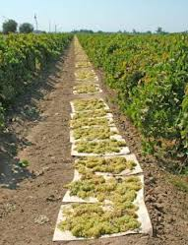
- Raisins, instead of laborious hand-picking, are harvested utilizing a “continuous tray” technique. The grapes are mechanically shaken off the tree by a machine that also funnels the collected grapes onto a piece of paper that is ¼ of a mile long! The grapes then spend several weeks drying on the paper before being finally collected as dried raisins.
- Raisins were so popular with troops during World War II, the price jumped from $48 per ton to $312 per ton in 1946.

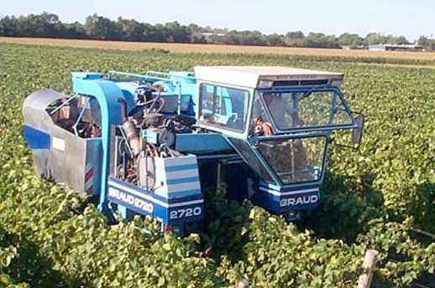
- Harvesting wine grapes has changed little over thousands of years. Hand harvest is still the preferred method of gathering the bunches as the fruit is so delicate. Machines are more likely to damage the fruit, causing loss of juice which would reduce the quality of the wine. However, the ergonomics of all the bending and lifting of the fruit laden bins caused 60% of laborers to report persistent back pain. Lowering the weight of the bins from 57 pounds on average down to 46 pounds reduced pain problems in workers by 80%.
- (additional side note) In France, a grower reported an entire year’s crop was stolen by 2 thieves who entered his field in the night of a full moon and in just a few hours using a modern harvester (like the one in the picture) stole 30 tons of Cabernet Sauvignon grapes. He did not have insurance on the crop. (Decanter.com: Sept. 30, 2010, story by James Lawrence).
- Prior to machine assisted harvesting, lettuce took a high toll on workers, with the constant bending and lifting. Today, with the help of machines designed specifically for the task, 5 million pounds of iceberg can be harvested in a week.
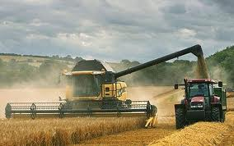
- The McCormick reaper, developed in 1831, was pulled by an animal, and could harvest 12 acres per day of grain, an enormous improvement over the use of hand tools such as the sickle. Later, threshers were added to the machine to remove the grain from the stalks, resulting in the first combine. With the advent of first steam, then fuel powered engines, 1 man and 1 machine easily replaced 5 men and 40 horses. Today, the modern combine is a pleasure drive, with push button controls and an air-conditioned cab.
- To harvest rice with machinery, the fields are drained of water, allowing the machine to navigate the field without sinking in the mud. In just 10 hours, 6 tons of clean rice can be harvested. Rice is still harvested by hand in third world countries where this crop is essential to survival. It takes 80-100 workers to work 2.5 acres of harvested rice by hand.
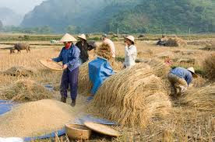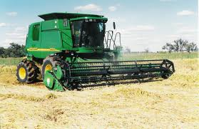
- Up to 60% of the cost of olives involves the costs incurred harvesting them. Today, a machine that is somewhat reminiscent of a porcupine with a shaker arm covered in fiberglass rods, vibrates the canopy at 250rpms, moves 3 miles per hour, harvests the fruit, releases it onto padded belts, passes it by an air blast to separate the leaves out, and deposits it into bins. The machine gets about 80% of the crop, whereas hand-harvest will get 95%, but is economically worth the difference.
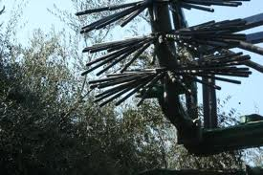
- Today, thick-skinned varieties of tomatoes, capable of withstanding the rigors of mechanical harvest, are bred to ripen all at once so that 50 tons of them per hour can be harvested by machine. The entire plant is lifted up, passes through a 4” gap where the fruit is separated from the rest of the vine. The vine is mulched and returned to the field. Color sensors in the machine with photo electric cells distinquish the ripe and unripe fruit. Unripe ones are ejected from the machine.

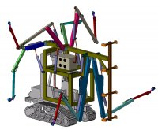
- Robotics have been designed to harvest citrus fruits. Futuristic machines with mechanical arms reach for the fruit, spinning it free of the branch, and placing it in a bin. Brazil can produce oranges so cheaply that this is threatening Florida’s Citrus industry. Florida’s Department of Citrus is researching how to reduce costs of harvest by using canopy harvesters and shakers, shake and catch, and trunk shakers. These methods may reduce costs by 20 to 50% over hand harvesting. Future groves will need to be designed to accommodate the machinery, such as the width of the rows, and the spacing of the trees.

- Technology exists also that can identify superior fruit by odor and sugar content, seperating it off the conveyor belt to be labeled as “premium”, commanding a higher price. Sensors can also detect freeze damage on oranges by sensing the gas emissions of the fruit.
________________________________________________________________________________________ Local Events of Interest
It’s blueberry season!!! Go to www.pickyourown.org/FLwest.htm to find blueberry farms near you. There are dozens of listings covering farms in our local counties!! This website also has information on canning and freezing, supplies and resources, recipes, books, and recommendations on having the best picking experience.

Pasco County’s 3rd Annual Blueberry Festival runs April 26 4 – 9pm, 27 8am -9pm, 28 8 am – 5pm At the Rotary Pavilion between Suncoast Parkway and Hays Rd. on State Road 52, Hudson, Florida. Dinners, entertainment, lots of kiddy activities, free admission. www.pascoblueberryfestival.com

Manatee Rare Fruit Council Annual Plant & Tree Sale. Sunday, May 19, 10 – 4, at the Manatee Civic Center located at the corner of US 41/301 and Haben Blvd. in Palmetto.
_____________________________________________________________________________________
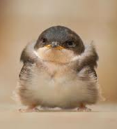
Notes

For contributions to the newsletter, notes on what you are growing, successes, failures, pictures, etc. we would love to hear what’s going on with fruit growers all through the Tampa Bay area, send to bdprovencher@tampabay.rr.com

______________________________________________________________________________



