Upcoming Programs and Events

August 11th: Dr. Tanaka will give an intriguing talk entitled “The ancient wisdom of folk remedies illuminated by 21st Century science”.
September 8th: Adam Shafran on Eugenias and Annonas. Adam spoke about Jaboticabas last year.

October 12th and 13th: USF Botanical Garden Plant Sale.
November 10th: Propagation Workshop.
December 8th: Holiday Social at 1pm
____________________________________________________________________________________

New Members

Alan Kloman St. Petersburg Bob Young Largo

Sarah Palm St. Petersburg
_____________________________________________________________________________

Membership and Newsletter Update


Note: As of this month’s newsletter, Bryon Provencher has taken over the membership duties for the Club. Any questions or issues concerning your membership should be directed to him. Please use the NEW return address on the back page of the newsletter to send any correspondence, dues payments, etc.
To report a missed newsletter, please contact bdprovencher@tampabay.rr.com.

Important: Check your Newsletter address label for your membership renewal date. Membership
is $20 per year.

_____________________________________________________________________________________

What’s Happening

by Paul Zmoda

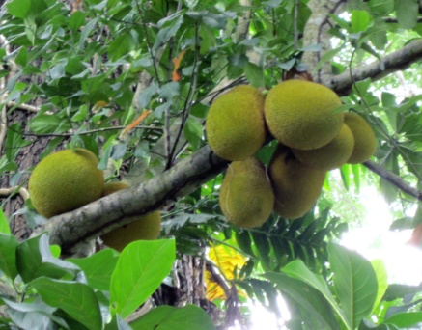
I got to travel to Puerto Rico for the first time. Mid-June is a nice time to visit and we found many fruits ready to taste. Within an hour of landing at San Juan’s airport I tasted a small passionfruit growing on a fence at the car rental lot. Nice, like apricots. From the fourth floor of our parking garage, I could see a large breadfruit tree loaded with fruit higher than our level. Tropical almond trees (Terminalia catappa) are everywhere along the highways. I collected lots of their fruits and cracked some open for a taste, and brought some back to grow. Large iguanas were prevalent lounging around the hotel’s golf course near which I collected a full bag of small mangoes. These we ate in our rooms and with the hotel’s breakfast where their juice selection included acerola and passionfruit. Yum!
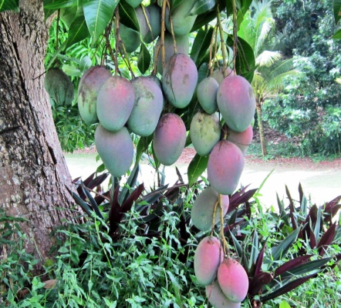
We visited Luisa’s aunts and cousins all across the island, some of which gave us bags of local, seedless, delicious oranges and mangoes. Sitting on a central Ponce bench after a trolley tour, along comes a street vendor with a handful of quenepas still attached to their branches. We quickly pounced and purchased the lot, and enjoyed them later. Similar to lychees in that you split open the thin skin and eat the flesh surrounding the single seed, quenepas, (melicoccus bijugatus), are green and more tart, but equally appealing.
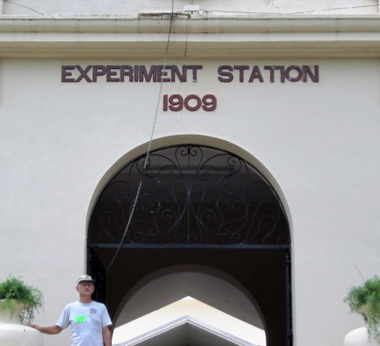
Just prior to a day’s trip, I walked the hotel grounds. I found a hedge of cocoplums – some fruits were ripe to snack on – pleasant and refreshing. Then we drove to Mayaguez. I had been looking forward to this day for a long time, for we were to visit the USDA Tropical Agriculture Research Station. This place collects and grows germplasm of ornamentals and fruit bearing plants from all over the tropical world. Along the many paths were huge specimens of jackfruit, oil palms, garcinias (such as mangosteen), coffee, rambutan, baobab, lychee, langsat, and so much more.
I was not able to view the whole compound, but I was able to pick up fallen fruit and bite into sound ones to enjoy, and compare the different flavors present in each.
On the way, we stopped to purchase fruit from street vendors. I had my eye on a large mango the size of a beef heart. Pink-yellow, melting soft, and aromatic, it was everything the tropics represents in a fruit so delicious. What a great trip!!!
Back home, we picked guavas, dragonfruit, and lots of grapes for winemaking.
Photos provided by Paul Zmoda.

New plantings: Chinese Mulberry (Che), yardlong beans, and passionflowers.
_______________________________________________________________________________________________

 | July Plant Exchange  Members who donate plant(s) may now receive a raffle ticket. Please remember to sign the sheet when picking up your plants.

Plant | Donor | Winner
Pineapple | Vega
Eggplant | Vega
Hot pepper | Vega
Chayote | Vega
Biriba | Novak | Shobert
Rosemary | Scott | Waller
White guava | Gerstein
Long green pepper | Gerstein
Dragon fruit | Zmoda | Dickey
Fleishman pomegranate | Sweet | Dana
Cloud pomegranate | Sweet
Starfruit | Musgrave
Curry tree | Newman | Provencher
Rollina | Ferreira | Heath
Red papaya | Ferreira | Shobert
Chaya spinach | Heath
Soursop | Duncan
Tapioca | Orr | Mccullough
Orangeberry | Provencher | Orr
Santol | Provencher | Fran
Santol | Provencher | Dana
Parmenteria edulis | Provencher | Haack
Parmenteria edulis | Provencher | Mccullough
Mango | Dickey | Ferreira
Mexican red papaya | Conradt
Lippia dulcis | Stark
Ginger | Rosak | Provencher
Purple beauty berry | Provencher

 | July Tasting Table  Thank you to the following folks for their tasty offerings and to all those who did not sign the sheet. Members who donate food may now receive a ticket for the raffle.

Name | Item | Name | Item
Vega | Pasta | Coronel | Bibingka
Novak | Apple nut cake | Barth | Mango cupcakes
Shigemura | Nuta (Japanese long onion, miso, vinegar | Sawada | Veg yakisoba, pina colada cake
Rivera | Watermelon | Gerstein | Olives
Scott | Watermelon | Zmoda | Cactus ragout
Shobert | Miracle fruit, garcinia aristata | Latimer | Brownies
Sweet | Chocolate oatmeal cookies | Wayman | Strawberry tree berries
Ferreira | Sweet potato casserole | Kirby | Caribbean salt fish
Amyot | Banana muffins | Nguyen | Curry chicken
Stark | Banana walnut raisin bread | Hartzler | Deviled eggs
Davies | Ziti and meatballs | Orr | Pasta salad, bread
Clarke | Baked chicken, turkey, breads

_________________________________________________________

July Fruit Tasting Table

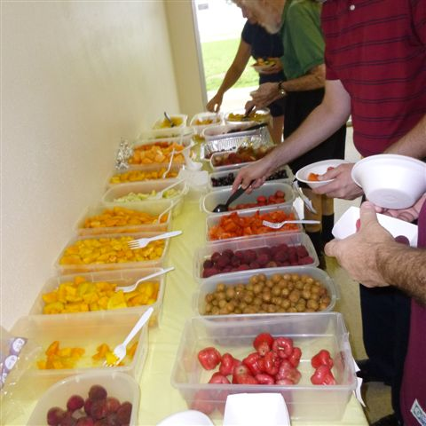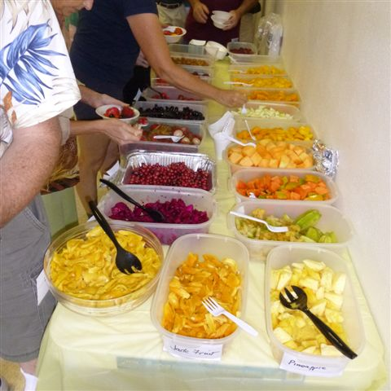
What we learned about Planting after Andrew
Chris Rollins

Chris Rollins of the Fruit and Spice Park in Homestead spoke at July’s meeting about the devastating effects of Hurricane Andrew on the Park, and the important things we learned about planting trees. Here are a few key points from his talk.
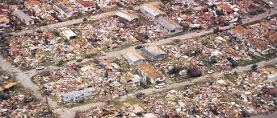
In 1992, Hurricane Andrew tore through the Homestead area. Much of the Fruit and Spice was destroyed in this powerful storm that was deemed the strongest hurricane to hit Florida in thirty years. Trees were torn apart or pulled right up out of the ground. This disaster provided an opportunity to look at how plants were installed in the limestone layered soil, and to examine how the Park could be redesigned, and how replacement plants could be installed better.
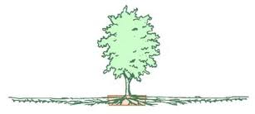
In the old days, you could go to any corner store in South Florida and get dynamite. Dynamite was a staple back then, especially for anyone planting trees in the limestone layer present in that area. Geologically, south Florida consists of a thin layer of soil on top of limestone. In order to accommodate the standard root ball, holes were blasted into the limestone with the dynamite, and the trees were then planted in these holes. However, trees that were not planted in these blasted holes had nowhere to go to spread their roots except across the thin layer of soil, creating an enormous, shallow, root mat, rather than a root ball. This sturdy mat proved to be beneficial.
During the restoration of the Park after the hurricane, it was discovered that those trees who sat upon the thin soil fared much better than those set into the blasted holes. The trees planted in the holes were unable to flex and were more likely to snap. These trees most likely could not be saved. However, although the trees sitting on top of the limestone may have tipped over, the entire tree and roots were intact, and could therefore be stood upright again.
Trees that were moved as part of the redesign could weigh up to 35,000 pounds! Cranes were used to relocate them to a new location in the Park. Today, the Park’s design and location of trees utilizes this new knowledge to hopefully make surviving a major hurricane much more likely for many of the plants and valuable trees.
________________________________________________________________________________________________________________________________
_____________________________________________________________________________________________

A Tribute to Bob Heath
It was back on December 3, 1978 in the Community Room of the Tampa Federal Savings and Loan building on 56th Street in Temple Terrace, that Bob and Theresa Heath met with Judson Newcombe and Bill Lester to form the Tampa Bay Chapter of the Rare Fruit Council. Only about one dozen other individuals were present at that first meeting.
The second meeting was held in a member’s home, where the meetings were held for 3 years. As the group was growing quickly, more space was needed, and the group moved to the County Extension office in Seffner. Then a house was purchased in Thonotosassa, where the group met for several more years. After the group outgrew the home, they located to the USF campus for their meetings. Most recently, the group moved to the Tampa Garden Club Building where they still meet today.

Note: The above historical facts were provided by member Verna Dickey from an article she wrote in June 2008, about the history of the Club as it was told to her by Judson Newcombe.
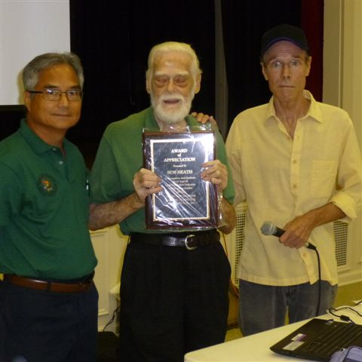

At July’s meeting, founding member Bob Heath of the Tampa Bay chapter of RFCI received a plaque for his timeless 35 years of dedication to the Club.

Thank you Bob for inspiring all of us to pursue our adventurous spirit and experience the delights of tasting and growing rare and unusual fruits.

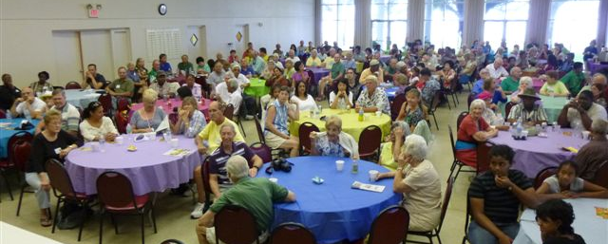
And just look at the Club now!!!

This poem appeared in a newsletter dated March of 2006.
An Ode to Bob Heath
By Rowdy O’Smith

I have seen what is beneath
The hearts of men with great relief.
How wondrous is their compassion
To sustain lives in every fashion.
Especially the sweet fruit of the vine
So all could dine on bread and wine.
Such men are blessed forever more,
regardless of what may be in store.
Dear Lord, bless their flesh and bone,
for they are as rare as a precious stone.
Their time is spent growing rare fruit,
For it’s their rarity that makes each a beaut.
And then to folks these trees bequeath.
Just ask the man named Robert Heath.

Note: Raoul (Rowdy) O’Smith was a long time member who admired Bob for his dedication to the Club and his boundless sharing of knowledge with so many others. Raoul passed away in November 2009.
______________________________________________________________________________________

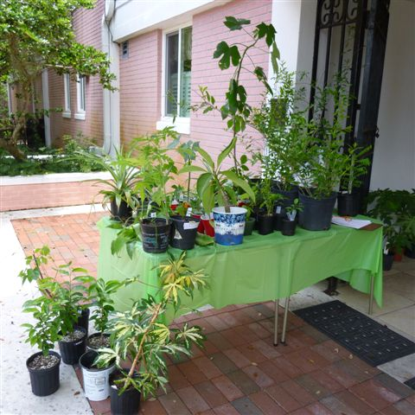
July’s Plant Raffle Table
____________________________________________________________________________________

_____________________________________________________________________________________

Notes

If someone was lucky enough to go to the Picnic on July 27th, and has pictures or information about the event that they would like to share, please send them to bdprovencher@tampabay.rr.com

Getting to that scrumptious buffet table at each meeting will be much easier now. Each table will have a number that will randomly be called, allowing all tables access to the buffet table in an organized manner. This should make the dining experience more pleasant.






