Upcoming Programs and Events

January 11th - Mike and Laura Gilkison will speak on Beekeeping. The Gilkisons are creators of cypress structures for bee hives. They would like to teach others how to raise bees and sustain the Florida bee population. Pollination will also be discussed.

February 5 - 16th - The Florida State Fair! We will be having our annual Citrus/Fruit Celebration at the Fair. If you know of anyone with some extra fruit they would like to share, or if you would like to help with the display, or any other part of this fun event for the Club, please contact Sally Lee at yukyee@aol.com or 813-982-9359.

______________________________________________________________________________
George Michael RIEGLER
Obituary

92, a life-long resident of Land O'Lakes, FL, passed away Dec. 9, 2014. He was born June 28, 1922 to Grace and Mike Riegler (the first permanent settler of Lutz). He graduated from Hillsborough High School in 1941. He was an Army Air Corps veteran of World War II where he flew a P-47 on 27 missions in the Battle of the Bulge before his plane was shot down. He broke two legs when parachuting but landed in friendly territory. He earned a purple heart and numerous other medals. During his lengthy recovery, he visited his sister, Elizabeth (MacManus, now deceased), at Florida State College for Women in Tallahassee and met his first wife, Shirley Pelaez (now deceased). They married Feb. 23, 1947 and had three children. George was a citrus grower and a life-long lover of plants and fruits. After a major freeze in 1963, he worked in crop insurance, cold storage, and construction. He married Elaine Sarrasin Oct. 27, 2002. He was a member of MacDill Active Reserve Unit until he retired as a Captain. He was a member of the First United Methodist Church of Lutz since 1947. He served on its Board of Trustees as Chairman for 20 years. He was a member of the Rare Fruit Council. He is survived by his wife, Elaine; son, Michael (Linda); daughters, Karen (Bill) Bryan, Elaine (Frank) Bartolotti; stepson, Ken Sarrasin; 11 grandchildren; 10 great-grandchildren; 2 sisters, Ann (Dick) Avriett, Gloria Herms; and many nieces and nephews. A memorial service will be held Saturday, Dec. 13, at 2 pm with a visitation prior at 1 pm at the First United Methodist Church of Lutz, 960 Lutz Lake Fern Rd. In lieu of flowers, the family requests donations be made to ECHO (Educational Concerns for Hunger Organization), 17391 Durrance Rd, North Fort Myers, FL 33917.
Published in the Tampa Bay Times on Dec. 11, 2014

____________________________________________________________________________________

What’s Happening

by Paul Zmoda

December 13th found myself and some other members of our RFCI at a memorial service for a long time member, Mr. George Riegler, who passed away December 9th. We also lost an essential long term member in April - Mr. Robert Heath. We have mourned the death of several Club members over the years.
I've planted fruit trees in the names of these folks and call them my memorial trees.
George loved to travel. On one of his expeditions to Costa Rica, he returned with seeds of a fruiting street tree - an Australian Lilly Pilly. He gave one seedling to me and it is now huge. Bob Heath gave me a tiny loquat seedling and it is flowering now, for the first time, in the year of his passing.
I have other memorial trees planted in remembrance of other essential members of RFCI who have influenced my life, and I urge you to do so also. It's a kind gesture which shows respect to those who contributed to our goal of growing fruit for all to enjoy.

_____________________________________________________________________________

Pictures from the 2014 Holiday Social







______________________________________________________________________________

Super Fruits

Got New Year's resolutions to better your life? Fruits can help! Many of them are so nutrient rich they are called "super foods". Following are some excerpts from web articles on how these fruits can benefit your health.
Superfruits to add to your daily health regime.

Acaí Berry Açaí actually deserves some of the hype it gets, thanks to weapons grade antioxidant levels that clobber other Superfruit rivals like blackberries, strawberries, and blueberries. However, because this tiny berry hails from Brazil, it's not easy to find fresh. Try powdered açaí berry in a smoothie. This an easy way to get Açaí fruits into your diet, but it also helps mask the tart, sometimes bitter taste.

Apples America's favorite fruit is a secret Superfruit, thanks in part to its red or green color. Apples are a great fiber source, but the skin contains quercetin, an antioxidant that packs antihistamine and anti-inflammatory power, and therefore may help protect you from heart disease and possibly allergic reactions.

Avocados Packed with monounsaturated fat and fatty acids, avocados can help lower LDL (bad cholesterol) levels while raising the amount of good cholesterol in your body. The healthy fats in avocados also promote the absorption of other carotenoids—especially beta-carotene and lycopene—which are essential for heart health.

Banana This Superfruit is loaded with potassium, which can lower your blood pressure, and is one of the best sources of Resistant Starch, a healthy carb that fills you up and helps to boost your metabolism.

Blackberries These tart and tasty gems rank in the top 10 for antioxidant power, according to the USDA, and they are specifically rich in polyphenols, the same family of antioxidants found in green tea, which may help prevent cardiovascular disease, cancers, and osteoporosis. Blackberries are also number one for fiber: One cup delivers one-third of your daily target of 25 to 35 grams a day.


Blueberries Your go-to Superfruit for brain function and memory. Several studies link high flavonoid levels in blueberries with a better memory, and regular consumption may help keep your brain functioning well as you age, new research suggests. Blueberries are also rich in manganese, which plays an important role in your metabolism, which can help keep you slim and energized.
Cantaloupe Consider cantaloupe your secret weapon for smooth, younger-looking skin. It gets its Superfruit status thanks to Vitamin A and its derivatives, which boosts cell reproduction, making it a natural exfoliator, according to Glassman.

Cherries Cherries are the unsung heroes of the Superfruit world. They owe their deep red color to an antioxidant called anthocyanin, which can reduce inflammation and lower triglyceride and cholesterol levels.

Citrus All citrus, from limes to tangerines, are chock-full of vitamin C, fiber, and small amounts of other nutrients and disease-fighting chemicals. It's the C that makes citrus a Superfruit, because this vitamin counters the effects of sun damage, regulates oils glands, and can even prevent age spots. Eat just one medium orange, then you'll already have your reached recommended daily intake of vitamin C, which keeps your immune system humming. This familiar sweet fruit is also a great source of fiber, potassium, calcium, folate, and other B vitamins.
Cranberries These tart little berries are Superfruits, but especially for women. They may prevent urinary-tract infections, and might help fight a far scarier disease: ovarian cancer. According to a new Rutgers University study, cranberries can boost the effectiveness of chemotherapy drugs used to fight ovarian cancer and may slow the growth of some cancer cells. Another study found that people who drink a glass of unsweetened cranberry juice each day raise their HDL, or good cholesterol, by 10%.

Dragonfruit A study analyzed the seeds and found there to be a bounty of essential fatty acids, which we need, but can't be made by our body. In fact, 50% of the seeds were made up of an essential fatty acid, oleic acid, which helps lower bad cholesterol and raise good cholesterol.

Grapefruit Grapefruit is a Superfruit, but more for your heart than your weight. A grapefruit a day—particularly the ruby variety—can help keep heart disease at bay by lowering cholesterol, according to several studies. The redder your fruit the better; they contain higher levels of antioxidants.


Grapes What makes grapes a Superfruit? A powerful antioxidant called resveratrol, which promotes a healthy heart. Researchers have also found that compounds found in grape seed extract seem to help slow Alzheimer's disease (at least in mice) and can clobber head and neck cancer cells grown in the laboratory. Forget bleaching your teeth, as the malic acid in grapes naturally breaks down stains and discolorations on teeth. Snack on grapes that are just ripe, because the acid declines as the fruit ripens.

Kiwi If you've got digestive gripes, then kiwi is your Superfuit. In one study, 41 people who had irritable bowel syndrome (IBS) consumed two kiwis a day for six weeks and reported a reduction of symptoms compared to those who didn't. One theory: Kiwi, especially the skin, is high in fiber and pre-biotic complex carbohydrates.

Papaya This tropical fruit is bursting with vitamin C – just one cup gives you more than you need each day. On top of this, papaya is also a good source of vitamins A and E, two powerful antioxidants that may help protect against heart disease and colon cancer.
Pineapple Not only does pineapple add juicy sweetness to your meals but it also contains bromelain, a digestive enzyme that helps break down food to reduce bloating.

Plums Plums may help keep anxiety at bay. Plums contain an antioxidant called chlorogenic acid, which, according to French researchers, is linked to decrease in anxiety-related behaviors in mice.

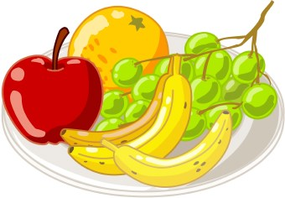
Pomegranates Pomegranates deserve their Superfruit status. The juice from this gorgeous fruit beat red wine to win first place in a list of beverages ranked by antioxidant levels in a University of California, Los Angeles study. However, if you are set on fresh pomegranate over juice, wait for winter; the fruit is at its best between September and February.

Pumpkin This squash is overflowing with beta-carotene, which combined with potassium may help to prevent high blood pressure. If making homemade pumpkin pie is too much trouble, try tossing the seeds into salads, soups, etc.

Raspberries Fiber is not something that these berries are lacking; just half a cup would give you 4 grams. You'd also get 25% of your recommended intake for vitamin C and manganese too!

Strawberries Strawberries are bursting with vitamin C; just a cup full and you've already reached your recommended daily intake. They are also an excellent source of folic acid, which can help protect your heart. They whiten your teeth naturally! Crush a strawberry to a pulp, then mix with baking soda until blended. Spread the mixture onto your teeth and leave on for 5 minutes. Reapply once a week.

Tomatoes Tomatoes pack a sought-after antioxidant called lycopene, which is rarely found in other Superfruits, and they're high in vitamin C, potassium, and fiber, and super-low in calories.

Watermelon Watermelon is packed with lycopene; in fact just one cup has more than twice as much compared to fresh tomato. At just 40 calories per cup, it's also a source of vitamins A and C. You needn't limit yourself to eating watermelon alone; grill and then toss with feta and fresh mint.

Refer to the following web link for more details on the above fruit benefits.

http://www.health.com/health/gallery/0,,20606331,00.html

Coconut

The fruit of one of our favorite palm trees deserves attention in its own right. Here are the top 10 health benefits of coconut oil that have been experimentally confirmed in human studies. Check this web article for lots more details and references.
http://authoritynutrition.com/top-10-evidence-based-health-benefits-of-coconut-oil/


1. Coconut Oil Contains a Unique Combination of Fatty Acids With Powerful Medicinal Properties
Coconut oil has been demonized in the past because it contains saturated fat. In fact, coconut oil is one of the richest sources of saturated fat known to man, with almost 90% of the fatty acids in it being saturated. However, new data is showing that saturated fats are harmless. Many massive studies that include hundreds of thousands of people prove that the whole “artery-clogging” idea was a myth. Coconut oil contains a lot of medium chain triglycerides, which are metabolized differently and can have therapeutic effects on several brain disorders.

2. Populations That Eat a LOT of Coconut Are Among The Healthiest People on The Planet
Coconut is kind of an “exotic” food in the Western world, primarily consumed by health conscious people. However, in some parts of the world, coconut is a dietary staple that people have thrived on for many generations. The best example of such a population is the Tokelauans, which live in the South Pacific. They eat over 60% of their calories from coconuts and are the biggest consumers of saturated fat in the world. These people are in excellent health, with no evidence of heart disease.
Another example of a population that eats a lot of coconut and remains in excellent health is the Kitavans.

3. Coconut Oil Can Increase Your Energy Expenditure, Helping You Burn More Fat
Bottom Line: The medium chain triglycerides in coconut oil have been shown to increase 24 hour energy expenditure by as much as 5%, potentially leading to significant weight loss over the long term.

4. The Lauric Acid in Coconut Oil Can Kill Bacteria, Viruses and Fungi, Helping to Stave Off Infections
Almost 50% of the fatty acids in coconut oil is the 12-carbon Lauric Acid. When coconut oil is enzymatically digested, it also forms a monoglyceride called monolaurin. Both lauric acid and monolaurin can kill harmful pathogens like bacteria, viruses and fungi. For example, these substances have been shown to kill the bacteria Staphylococcus Aureus (a very dangerous pathogen) and the yeast Candida Albicans, a common source of yeast infections in humans.

5. Coconut Oil Can Kill Your Hunger, Making You Eat Less Without Even Trying
The fatty acids in coconut oil can significantly reduce appetite, which may positively affect body weight over the long term.

6. The Fatty Acids in Coconut Oil Are Turned into Ketones, Which Can Reduce Seizures
The MCTs in coconut oil can increase blood concentration of ketone bodies, which can help reduce seizures in epileptic children.

7. Coconut Oil Can Improve Blood Cholesterol Levels and May Lower Your Risk of Heart Disease
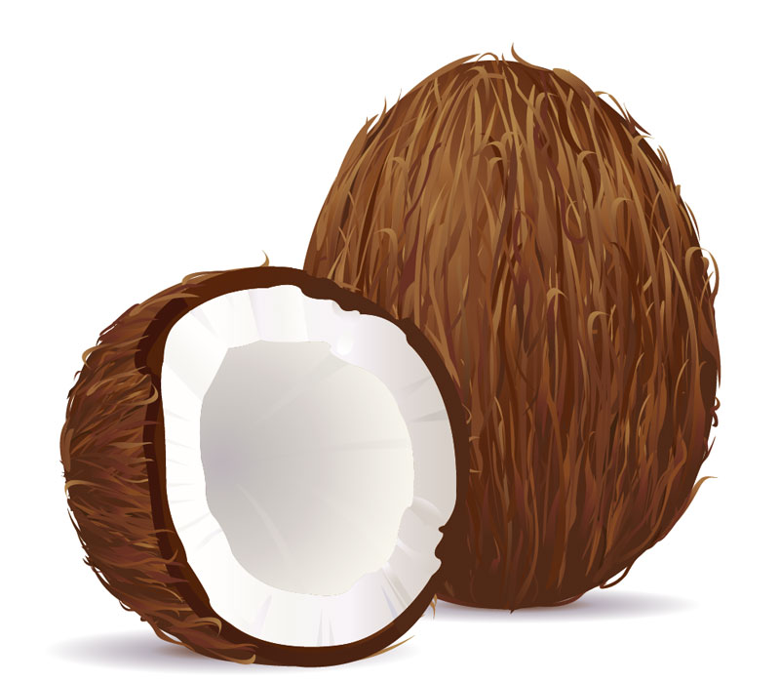
Coconut oil is loaded with saturated fats, which actually do not harm the blood lipid profile like previously thought. The fatty acids and breakdown products in coconut oil can kill harmful pathogens, potentially helping to prevent infections. Studies in both humans and rats show that coconut oil improves important risk factors like Total, LDL and HDL cholesterol, which may translate to a reduced risk of heart disease.

8. Coconut Oil Can Protect Hair Against Damage, Moisturize Skin and Function as Sunscreen
Studies on individuals with dry skin show that coconut oil can improve the moisture and lipid content of the skin. Coconut oil can also be very protective against hair damage and one study shows effectiveness as sunscreen, blocking about 20% of the sun’s ultraviolet rays. Another application is using it like mouthwash in a process called oil pulling, which can kill some of the harmful bacteria in the mouth, improve dental health and reduce bad breath.

9. The Fatty Acids in Coconut Oil Can Boost Brain Function in Alzheimer’s Patients
Alzheimer’s disease is the most common cause of dementia worldwide and occurs primarily in elderly individuals. In Alzheimer’s patients, there appears to be a reduced ability to use glucose for energy in certain parts of the brain. Studies support these findings and medium chain triglycerides are being intensively studied as potential therapeutic agents in Alzheimer’s disease.

10. Coconut Oil Can Help You Lose Fat, Especially The Dangerous Fat in Your Abdominal Cavity. This is the most dangerous fat of all and is highly associated with many Western diseases. A study in 40 women with abdominal obesity, supplementing with 30 mL (1 ounce) of coconut oil per day lead to a significant reduction in both BMI and waist circumference in a period of 12 weeks. Another study in 20 obese males noted a reduction in waist circumference of 2.86 cm (1.1 inches) after 4 weeks of 30 mL (1 ounce) of coconut oil per day. These people aren’t adding exercise or restricting calories. They’re losing significant amounts of abdominal fat simply by adding coconut oil to their diet.
___________________________________________________________________________

Local Happenings

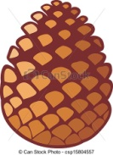
Many of you had asked when TBRI would be having an open house. If Dr. Tanaka's talk had left you wanting to learn more about pine cone extract research, then this is a great opportunity to learn more about this important research.
TBRI is having a Cell-ebration on Wednesday, January 7th from 5pm to 6pm, 10900 Roosevelt Blvd. N, St. Petersburg, Fl 33716, 727-576-6675, www.tbri.org. Please RVSP at their website or call.
________________________________________________________

___________________________________________________________________________________

Notes

If you change your address or email, or are missing a newsletter, or need a badge, contact the editor at bdprovencher@tampabay.rr.com, or at the address on this page.

Member and pineapple expert, Ian Greig reminds us it now time to plant your pineapple crowns NOW , and pineapple suckers in January, to get fruit in July 2016. It takes time, about 18 months to get fruit!


___________________________________________________________________________________



