Upcoming Programs and Events


April: No regular Club meeting. See you at the USF Plant Festival!
April 12 - 13: USF Botanical Garden Spring Plant Festival.
We will need club members to help with this event. It is an important fundraiser for the club. Members are invited to attend, help with set up on Friday, to assist in the sale on Saturday and Sunday, to donate or sell fruiting plants, to have fun, and to visit other exhibits.
See additional information on page 29.

May 10: Club member Ian Greig on Plant Reproduction
______________________________________________________________________________

Welcome New Members
Elsa Soto Safety Harbor
Miriam and Karl Hoekstra Safety Harbor
_______________________________________________________________________

Here are the Tampa RFCI Board members for the coming year!

President: Fred Englebrecht
Vice President: Paul Branesky
Vice President: Tom Schaefer
Program Chairman: Tom Schaefer
Treasurer: Sue McAveety
Secretary & Raffle: Edward Niklas
Newsletter & Membership: Denise Provencher
Tom Scott
Jerry Amyot
Jim Porter
Mark Flotaz
Jim Lee

______________________________________________________________________________

The speaker for March, who was scheduled to discuss fertilizers, unexpectedly could not make the meeting, so here is a reprint of Toppy Feil's discussion about fertilizer and its history, and mycorrhizae, and also some information on measuring fertilizer.
_____________________________________________________________________________________________

How Trees and Plants lived before Fertilizer

By Toppy Feil

Long-time grower of tropical fruit, and member of the Brevard RFCI, Toppy Feil, gave a lecture on how trees and plants survived and thrived before the use of chemical fertilizers. He offered many tips we can all benefit from knowing about.
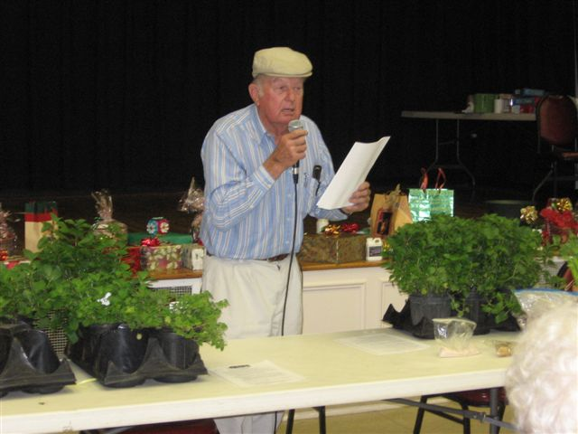
There has been chemical fertilizer as we know it for only the last 100 years. Before that, trees and plants had to survive and receive nutrition from what was available in, or on, the soil, in the air, or brought in by wind and rain, or even volcanic activity. Plants have learned to adapt to their surroundings and thrive on what is readily available to them. Chemical fertilizers have attempted to imitate what nature has done on its own for millions of years.
I have trees that sometimes do not do well, so I spray fertilizer and minor nutrients on the leaves. An old fellow once told me about this, and recommended that it be done at the end of the day. That way the dew will help the plant to take in the nutritional boost all night. Application during the day would allow it to dry too quickly and only be available to the plant for a short time. Plus, leaves close their pores in the daytime to prevent moisture loss. The pores are open at night and can readily absorb the moisture and nutrition. This is helpful during drought as well.

Mycorrhizae. I first read about mycorrhizae in the National Geographic magazine. (Mycor, meaning fungus, and rhiza, meaning root, defines the mutually beneficial relationship between the two.) The article explained the misconception people have about the lush growth in the rainforest, and how many people incorrectly believe this growth was due to fertile, nutrient-rich soil. But, the opposite is true. The soil layer in the rainforest is often only 6-8” deep, and mostly made of fallen leaves. There are no minor nutrients available for plants to feed on. It was discovered that mycorrhizae fungi on the roots of the trees and plants helps them to grow. A combination of the fallen leaf debris and the mycorrhizae make the perfect fertilizer. It is said that if the plant has the correct mycorrhizae on the roots, it can grow well on 40% of needed water and nutrients.
Sometimes, this lack of the correct mycorrhizae is the reason seedlings and young trees fail. There are many kinds of mycorrhizae, some are good for one plant or tree, but not another. For example, lychees do not like the mycorrhizae that live oaks like, and avocadoes do not like to grow where citrus have grown, because of the different mycorrhizae. Every plant needs the right kind of mycorrhizae fungi to grow well.
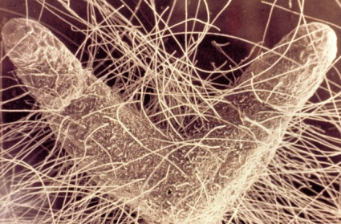
When I first joined the Rare Fruit Club, I learned of a good example of this situation. In Africa there was a newly planted mango plantation, but the trees were not doing well. Mango experts came in to advise them, and millions were spent for advice, but nothing was helping. Finally, an old African mango farmer told them how to correct the situation. Soil from around the farmer’s best growing mangoes was applied around the tree roots of the struggling trees at the plantation. The mycorrhizae that was missing from the newer plantings, but that was present around the farmer’s thriving trees, was now present in the soil of the new trees, and corrected the problem. The farmer had had to learn how to make his mangoes thrive in order to make a living, and he had learned this simple fact about the soil.
When planting my trees, I simply dig the hole and put in water and a little bit of the mycorrhizae, and some fine dirt. Stir this to make a consistency of pea soup, and make sure there are no air pockets around the roots. For more information on mycorrhizae, check www.mycorrhizae.com
Other tricks:
Another trick for good fruit yield is to prune a major limb each year off a fruit tree. A common practice among old-time African mango growers, this method can increase yield by 3-4 times. Also, don’t throw out the fruit and leaf waste from the trees. Put it back under the tree where it will become fertilizer.
A friend planted a coconut palm, but it wasn’t doing well. He put ocean water on it and it thrived. For millions of years, coconut palms have adapted to the salt water near the shore where they grow, and need it to thrive.
Other folks I know also use good old-fashioned methods for fertilizing, such as horse and rabbit manures, especially around bananas. Grass clippings can be used, or ground-up plant material that may be available from your county, or local tree service. Old metal can work too. I know folks who have buried old pieces of iron around iron loving plants, such as avocadoes. As the metal decayed, it provided iron to the plant.
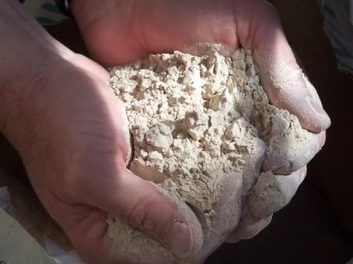
Azomite. AZOMITE® is a mined natural mineral product that is an excellent anti-caking agent and a unique re-mineralizer for soils. For over sixty years crop and livestock producers have used this exceptional material to improve livestock and plant growth. The material contains a broad spectrum of over 70 active minerals and trace elements. It can be used in certified organic production. Some of our chapter’s members have tried it, and it seems to help, although we aren’t sure how it will affect our plants yet. There are 3 ways Azomite is available, fine enough to go through a sprayer, course, for hand distribution, and in a slow release form. I like the fine Azomite, so I can spray it on the leaves and ground. For more information on Azomite, check www.azomite.com
Fertilizer numbers. The first number in fertilizer preparations is the nitrate that makes the above ground parts grow. This number is usually a higher number. It can wash out with 6” of rain, and may need to be applied a little more often. The second number is for phosphate, and that makes the roots grow. This is usually a low number. Phosphate does not leach out of the soil; it can actually build up in the soil. The third number is potash, and that makes blossoms and strong limbs. This is important for flowering and fruiting plants and trees. You’ll want to look for a higher number of potash for your flowering and fruiting plants and trees. Potash got its name from “pot ash”, referring to the ashes under the pot in the fireplace. Ash has been used as a nutritional element for a long time. Potash does leach out of the soil, and may need to be applied more often. There are 2 kinds of potash. Muriate of potash is mostly salt or chlorine, and is good for palms. Sulphate of potash has very little chlorine or salt. It costs more, but is good for fruits that do not tolerate salt well, like lychees. I wasted a lot of money on my fruits, as much as $600 for 1000 pounds of chemical potash, trying to imitate original potash. I now get natural ash and charcoal from the burning of old orchards, and cleared land for housing projects. It’s free most often, and is available in truck loads. This is real potash, as plants have utilized since the beginning of time.

How to figure out measuring fertilizer by pounds.

All fertilizer labels have 3 numbers. The first is the amount of nitrogen (N), the second is the amount of phosphate (P₂O₅), and the third is the amount of potash (K₂O). These numbers are the primary nutrients of nitrogen, phosphorus, and potassium. This label, is a national standard, and will be the same on all bags of fertilizer, and is known as the fertilizer grade.
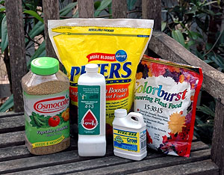
So, a bag of 10-10-10 fertilizer means it has 10 percent nitrogen, 10 percent phosphate, and 10 percent potash.
Fertilizer grades are made by mixing two or more nutrient sources together to form a blend, that is why they are called "mixed fertilizers." Blends contain particles of more than one color. Manufacturers produce different grades for the many types of plants.
You can also get fertilizers that contain only one of each of the primary nutrients. Nitrogen sources include ammonium nitrate (33.5-0-0), urea nitrogen (46-0-0), sodium nitrate (16-0-0), and liquid nitrogen (30-0-0). Phosphorus is provided as 0-46-0 and potash as 0-0-60 or 0-0-50.

To calculate nutrient content.
To calculate the pounds of nitrogen in a 50-lb bag of 10-10-10 fertilizer, multiply 50 by 0.10. Do the same for calculating the amounts of phosphate and potash. A 50-lb bag of 10-10-10 contains a total of 15 lbs of nutrients: 5 lbs nitrogen, 5 lbs phosphate and 5 lbs potash. The remaining weight is filler, usually sand or granular limestone.

Another example: 50-lb. bag of 8-0-24 fertilizer.
To calculate the pounds of nitrogen: Multiply 50 by .08, which equals 4.
To calculate the pounds of phosphate: There is no phosphate in this bag of fertilizer.
To calculate the pounds of potash: Multiply 50 by .24, which equals 12.

Result: This 50 pound bag of 8-0-24 fertilizer contains a total of 16 lbs of nutrients: 4 lbs nitrogen, 0 lbs phosphate, and 12 lbs potash. This would leave us with 34 lbs of filler.

The best way to select a fertilizer grade is to have your soil tested. The soil test report will recommend a fertilizer grade for your use. The report also comes with a management note that provides guidelines for supplementing nitrogen for lawn and garden crops.
Your local extension office is one resource for soil testing. Test results will show nutrient levels in your soil samples and offer recommendations based on your planned use for the area.
Visit the following website for more information. http://soilslab.ifas.ufl.edu
The page for Extension soil testing will have necessary forms, information on fees, sample containers, and types of testing available.
_____________________________________________________________________________________
____________________________________________________________________________________

What’s Happening

by Paul Zmoda

This installment of "What's Happening" marks twenty three years that I've written for our Rare Fruit Council on a monthly basis. I've learned so much since I started and I hope you have too. My sincere thanks go to all my fruit growing colleagues who readily share their knowledge, our very capable editor, Denise Provencher, for translating my old school scribbles, and all of you reader/members who give me a reason to share what we all learn about growing fruits on a daily basis.
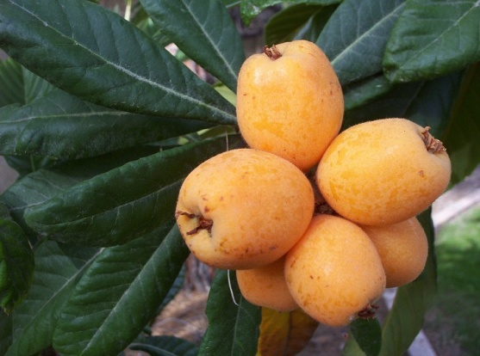
I spoke too soon in the last newsletter regarding having no frost. Well, wouldn't you know it - just after my deadline, we had one. On Thursday morning, Feb 19th, we experienced what was bound to occur - frost! A light freeze though at 29 degrees. Luckily nothing was killed - just some leaf damage here and there.
Loquats are in full, fruiting glory as I write. Bill Vega brought some to the March meeting that were so sweet; I intend to graft that one so I can grow it myself. Speaking of grafting, this may be the best time of year to practice this horticultural art. My un-named plum and a selection of native Chickasaw plum are currently budding out nicely on their Ceylon Peach rootstocks. I've also topworked some white sapote scions onto my large tree to have different pollen and fruit available later.
My "Brazos" blackberries are flowering like crazy, but I'm having a devil of a time trying to control a fungus which ruins them before the berries set. Gene Joyner advises spraying with copper and I do this often so we'll see if that is effective this year.

New plantings: a seedling Pyracantha tree, sunflowers, and lots more vegetables including pole beans, Swiss chard, arugula, broccoli, mustard, cassava, cilantro, tomatoes and more.
______________________________________________________________________________

More information about the USF plant sale and guidelines for members: Things get pretty busy at the Sale! Here are some guidelines to help keep things running smoothly:

1) Basic snacks and water will be provided to working members. You may also bring your own.
2) Members who work a full day or a total of 8 hours over the 3 days receive a Rare Fruit T-shirt.
3) Members who work a total of 8 hours over the three day festival event will be entitled to a discount on plants brought in by Ray Green.
- Ray Green plants may be tagged for your purchase after 2:30pm on Sunday. The tagged plants must be left in place until all the remaining plants are loaded, then the member may show Tom the plants and pay for them. Please do not move the plants before paying Tom, as this will cause errors in the inventory.
- If a member wishes to buy a Ray Green plant before 2:30 Sunday, then the listed price will apply.
4) If you plan to sell plants, please note that members cannot sell citrus, non-fruiting plants or herbs.
- Members can only bring plants they have raised themselves - not ones purchased from another source.
- It is also helpful to inform buyers whether the plant you are selling is a grafted named variety or if you raised it from a seedling.
5) Members selling plants must submit a manifest listing their plants, quantity, and prices. Plants must have a label with the name of the plant, the price and the seller’s initials.
- A member cannot change the price or give away plants until AFTER the manifest has been completed and checked by a board member.

Those who require tickets can call Fred (727)943-2104 or Tom
at (813)777-0019 so that we can mail them.. Tom Schaefer will be in the person in charge, if you have problems getting into the sale, call him to certify you are with the RFCI group, and get a ticket.
USF Botanical Garden website: http://gardens.usf.edu/

 | March Tasting Table  Thank you to the following folks for their tasty offerings and to all those who did not sign the sheet. Members who donate food receive a ticket for the plant raffle.

Name | Item | Name | Item
Lee | Strawberries, chocolate candy | Krutz | Grape salad
Hartzler | Deviled eggs | Lohn | Carambola
Stark | Carambola | Schuster | Dried carambola
Coronel | Maja corn | Payne | Salad
Nguyen | Chicken | Davies | Herbed chicken
Newcombe | Salad | Dexter | Strawberry pie
Young | Chips | Chinnery | Chicken
Clarke | Mac n' cheese, coleslaw | Campani | Cole slaw
Latimer | Brownies | Wolff | Broccoli with culantro
Male | Veggies | Whitfield | Star fruit
Amyot | Persimmon bread with pecans | Mcaveety | Banana bread
Zmoda | Loquats | Kischuk | Coconut tapioca

Notes

This is your newsletter! It's about our members and what they are doing concerning fruits. If you would like to share photographs, recipes, experiences with fruits you are growing, or anything fruit related, or ask a Club expert a question, submit material to the editor at bdprovencher@tampabay.rr.com. When space is available, items will be put into the newsletter.

Available 6 curry leaf trees - 5' to 10', - must pick up - call Arnold Stark at 813-753-8857.
Also: Lillian and I have had a request from the Sataf Park, site of the Israel Fruit Tree Garden, for cuttings of different varieties of figs and pomegranates. They have an extensive planting of Middle Eastern figs, among other fruits, and would like to expand their plantings. They will handle the importation. If you have unusual varieties, and can provide cuttings, please send me a list via e-mail (alsofaac@aol.com), or you may call me - Arnold Stark at 813-753-8857. (Web search for Israel Fruit Tree Garden for more info on restoring this important historical Biblical garden.)
_______________________________________________________________________________________

________________________________________________________

Local Events

PLANT SALE: Lavoy Exceptional Center’s Agriculture Program (4410 W Main St, Tampa, FL 33607)
When: Saturday, April 11th, 8am to 1pm or until sold out. The plant sale will be held on the bus-ramp of Lavoy Exceptional Center. Please come and support the special students and the CTE Ag program at Lavoy Exceptional Center, as we sell plants to raise money to…well…grow more plants! We will have a wide variety of plants. Plants are priced far below retail. We plan to start selling at 8am, but if you arrive early you can purchase plants, we will just be working on setup, so customer service will be spotty before 8am. Cash preferred, checks accepted if there is a Lawson or license number on them. Any non-sufficient funds checks will be met with a fee.
Loguat Festival: April 4, 2015 – 9:00 – 2:00 – Market off Main – 6214 Lincoln St, New Port Richey Our big event is almost here. Mark your calendars, and join us for this one-of-a-kind celebration. In the meantime, please spread the word about Loquats and the festival.
Green Thumb Festival: April 25 & 26th, 9-4, Walter Fuller Recreation Center, St. Petersburg, environmental and horticultural exhibits, vendors, every kind of plant imaginable. Free mulch, plant auction, free butterfly plants, kids' activities, food, much more. 727-893-7441.
Florida Blueberry Festival: April 11m 10am - 8pm, April 12 10am - 6pm. Blueberries, produce, delectable edibles, music, beer garden, wine bar, artisans, more! 201 Howell, downtown Brooksville, 352-754-4173.

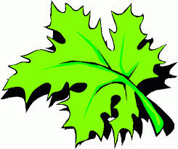 | March Plant Exchange  If you win a plant in the raffle, please remember to sign the sheet when picking up your plants.

Plant | Donor | Winner
Papaya | Black
Native plum | Zmoda
Stark | Cranberry hibiscus | Oliver
Meyer lemons | Davies
Tomatoes | Nguyen | Stark
Banana | Porter
Dragon fruit | Porter
Thai ginger | Provencher
Russian kale | Mcgee
Purple Russian tomato | Coogan
Papaya | Wolff
Cuban oregano | Wolff
White sapote | Premraj | Kischuk

_____________________________________________________________________________________

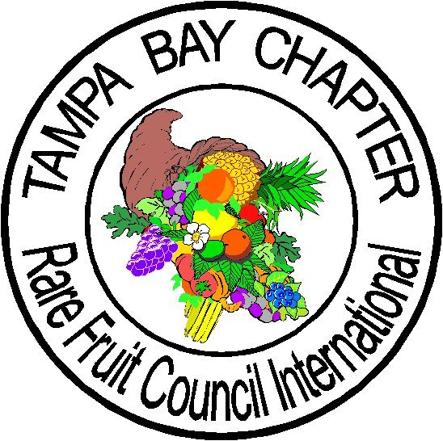
The objectives of The Tampa Bay Rare Fruit Council International:
To inform the public about the merits and uses of fruits common to this region and encourages the cultivation, collection, propagation and growth of fruits that are exotic or unusual to west central Florida. The club also encourages the development of new fruit varieties, cooperating with local and foreign agricultural agencies.
_____________________________________________________________________________________



